Tab 1

DETECT: Deception Tracking Through Eye Cues Technology Design Document
AAI Solution Team Members:
Adam Bawatneh (Project Manager)
Brian Conn (Scrum Master & Frontend Developer)
Jeffrey Chang (Frontend Developer)
Muzamil Shamsi (Database & Frontend Developer)
Soham Ganguly (ML Engineer & Lead Full Stack Developer)
John Economou (Research & Backend Developer)

Course: Senior Design Project
Date: 11/25/2024
Sponser: Richard Leinecker
Email: Richard.Leinecker@ucf.edu

2. Table of Contents
Course: Senior Design Project 1
2. Table of Contents 2
3. List of Figures 5
4. Executive Summary 7
5. Introduction 8
5.1 Project Motivation 8
5.2 Objectives 9
6. Background and Literature Review 10
6.1 Existing Lie Detection Techniques 10
6.1.1 Non-Verbal Lie Detection Methods 10
6.1.2 Eye Movement Patterns in Deception 12
6.2 Existing Eye-Tracking Technologies 14
6.3 MediaPipe Overview 17
7. Project Overview 20
7.1 System Architecture 20
7.2 Technologies Used 21
7.3 Potential Applications 21
8. Project Management and Team Coordination 23
8.1 Team Structure and Roles 23
8.2 Project Planning and Scheduling 24
8.3 Communication Tools and Meetings 24
8.4 Progress Monitoring and Roadblocks 25
8.5 JIRA Setup and Agile Development 26
8.5.1 Product Backlog 27
8.5.2 Sprint Backlog 37
8.5.3 Milestone Chart 42
8.6 Documentation and UML Diagrams 44
8.6.1 Class Diagram
New one: 45
8.6.2 Sequence Diagram 46
8.6.4 Block Diagram 47
8.6.5 Peer Review of UML Diagrams 47
9. Research and Data Collection 48
9.1 Initial Research 49
9.1.1 Existing Lie Detection Techniques 49
9.1.2 Eye-Related Cues in Deception Detection 51
9.2 Tech Stack 54
9.2.1 Database 54
9.2.2 Backend 55
9.2.3 Frontend 57
9.2.4 Runtime Environments and Frameworks 59
9.2.4.1 Webassembly 59
9.2.4.2 PyScript 63
9.2.4.3 PyScript vs. WebAssembly 67
9.2.4.4 Bun 70
9.2.5 Hosting 73
10. Eye Tracking Implementation 75
10.1 Gaze Detection Using MediaPipe 75
10.1.1 Setting up MediaPipe Face Mesh 75
10.1.2 Estimating Gaze from Tracked Coordinates 79
10.1.3 Implementation of Smoothing Algorithms 84
10.1.4 Versions and their Improvements 93
10.1.2.1 Version 1: The Foundation 93
10.1.2.2 Version 2: Enhanced Precision and Flexibility 94
10.1.2.3 Version 3: Contours, Maps and Linear Transformations 94
10.2 Optimizations for Real-Time Performance 96
10.2.1 Model Optimization and Lightweight Inference 96
10.2.2 PyQtGraph Integration for Enhanced Real-Time Performance 98
10.2.2.1 Overview and Motivation for PyQtGraph Integration 98
10.2.2.2 Replacing Matplotlib for Real-Time Visualization 100
10.2.2.3 Performance Metrics and Comparison 102
10.3. Fixes and Features 104
10.3.1 Time Synchronization Issues 104
10.3.2 Landmark Position Adjustments 105
10.3.3 X and Y Coordinate System Fixes 106
10.3.4 Modular File Structure 107
10.3.5 Usage of JSON for Configuration 107
10.3.6 Vectorization of Iris Location 108
11. Deterministic Gaze-Based Analysis 109
11.1 Core Analysis Methodology 109
11.2 Backend Processing Pipeline 110
11.3 Sensitivity Settings 110
12. Data Modeling and Documentation 111
12.1 Data Visualization 111
12.1.1 Real-Time Graphs 111
12.1.2 Graphical Representations of Gaze Patterns and Animation 116
12.2 Metrics Calculation 120
12.3 Testing and Results 123
12.3.1 Testing 123
12.3.2 Results and Analysis 126
13. Web Development and Porting 129
13.1 Migration Approach 129
13.1.1 Initial Considerations 129
13.1.2 The Big Solution 131
13.1.3 Setting Up the Web Application 133
13.1.4 The Big Port 134
13.1.4.1 Webcam Integration 135
13.1.4.2 Facial Landmark Detection with Mediapipe.js 136
13.1.4.3 Affine Transformation with Mediapipe.js 137
13.1.4.4 Real-time Graphs and Data Modeling 141
13.1.5 Expanding Capabilities: Custom Video Uploads 146
13.2 Go-chi for Efficient and Secure Backend Development 148
13.2.1 User Login Authentication Implementation 149
13.2.2 WebSocket Implementation 150
13.3 Frontend Design Prototype 151
13.3.1 General Page Layout Design 151
13.3.2 Login/Register Page 156
13.3.3 Live Video Modal 156
13.3.4 Video Upload Modal 158
14. Conclusion and Future Work 159
14.1 Summary of Achievements 159
14.2 Challenges Faced 159
14.3 Future Directions 160
15. References 161

3. List of Figures
Figure 6.1.1: Six Universal Microexpressions and Their Facial Features ...………………………..…….11
Figure 6.1.2: Eye Movement Directions According to NLP Theory ..........................................................13
Figure 6.2.i: Tobii Pro Spectrum ……………………………………………………………….…………15
Figure 6.2.ii: Tesla Eye Tracking………………………………………………………………………….16
Figure 8.6.1: Class Diagram ………………………………………………………………………………45
Figure 8.6.2: Sequence Diagram…………………………………………………………………………..46
Figure 8.6.4: Block Diagram………………………………………………………..……………………..47
Figure 9.1.1: Timeline of the Evolution of Lie Detection Techniques ……………………………………50
Figure 9.1.2: Pupil Dilation ……………………………………………………………………………….52
Figure 9.2.2: Go Demo…………………………………………………………………………………….57
Figure 9.2.4: Bun vs Dino vs npm…………………………………………………………………..…….72
Figure 10.1.1.i: Official MediaPipe Face Mesh Landmarks…..…………………………………………..77
Figure 10.1.1.ii: Eye-based Coordinate Vectorization…..………………………………………………...77
Figure 10.1.2: Eyelid-Carthal Vector vs Eye-Nose Vector Systems…………………………………..…..80
Figure 10.1.3.i: Savitzky-Golay Filter vs Moving Average Filter………………………………………...86
Figure 10.1.3.ii: Practical Usage of Moving Average Filter……………………………………………....88
Figure 10.1.3.iii: Sample Application of Savitzky-Golay Filter………………………………………..…90
Figure 10.2.2.2: 2D Graph Visualization with PyQt…………………………………………………..…101
Figure 10.2.2.3: Percentage Improvement of PyQtGraph Over Matplotlib……………………………...103
Figure 12.1.1.i: Real-Time Gaze Tracking with Nose Vector Coordinate System…………….………...114
Figure 12.1.1.ii: Real-Time Gaze Tracking with Nose Vector Coordinate System…………….……..…115
Figure 13.3.1.i: Gaze Tracking Model Frame…………………………………………………………....125
Figure 13.3.1.ii: Smoothing Model Frame Output……………………………………………………….126
Figure 13.3.2.i: Overall Model Accuracy Comparison………………………………………………..…127
Figure 13.3.2.ii: Detailed Accuracy Per Tester and Model………………………………………………128
Figure 14.1.4.1: Webcam Landmark Detection on Web………………………………………………....135
Figure 14.1.4.3: Landmark Detection…………………………..………………………………………..139
Figure 14.1.4.4.i: Graph.js Demo……………………...…………………………………………………142
Figure 14.1.4.4.ii: D3.js Demo………………………...…………………………………………………145
Figure 14.3.1.i: Synthwave Theme Layout………………………………………………………………152
Figure 14.3.1.ii: High Contrast Light and Dark Theme Layout.…………………………………………153
Figure 14.3.1.iii Dashboard page on Mobile device (Pixel 7)...................................................................155
Figure 14.3.2: Login/Register Page………...……………………………………………………………156
Figure 14.3.3: Video Page Modal…………………………………..……………………………………157
Figure 14.3.4: Video Upload Modal (before and after adding Video).......................................................158

4. Executive Summary
DETECT (Deception Tracking through Eye Cues Technology) is a real-time, web-based deception detection system built around the analysis of gaze behavior using eye-tracking technology. Developed by a team of six senior Computer Science students at the University of Central Florida, DETECT offers an innovative, non-invasive alternative to traditional lie detection methods, which are often intrusive, unreliable, and ethically problematic.
The system leverages MediaPipe’s FaceMesh on the frontend to extract raw gaze coordinates (x, y) in real time. These coordinates are transmitted via WebSocket to a Go-based backend for further analysis. DETECT’s analysis is built on a deterministic algorithm, replacing the originally planned Hidden Markov Model (HMM) approach. The current model calculates deception indicators by measuring gaze dispersion (variance) and sudden directional shifts (acceleration). These features are normalized using a predefined Min-Max strategy that adapts over sessions to user-specific behavior, ensuring consistent and personalized scoring. An optional sensitivity multiplier allows tuning the strictness of detection thresholds, making the system adaptable to different environments and use cases.
The full-stack architecture comprises an Astro-based frontend, a Go backend, and a PostgreSQL database, all hosted on a Digital Ocean VPS using Docker containers for deployment efficiency. Both development and production environments are deployed on a single droplet for centralized management and low-latency performance. A WebSocket-driven pipeline supports seamless real-time communication between client and server.
Development has followed Agile methodologies using JIRA for sprint planning and tracking, with all code version-controlled through GitHub. The team has implemented three major iterations of the gaze tracking algorithm, improving from a 45% accuracy baseline using a moving average filter to over 80% accuracy using Savitzky-Golay filtering and affine transformations to account for head movement.
DETECT is now a functionally complete and deployable solution, designed not only for its immediate use case but also as a research platform for future enhancements. These may include advanced eye cues such as pupil dilation, blink rate, or speech-based analysis. The system is also prepared for integration with IRB-approved studies to validate its effectiveness on real participants, positioning DETECT as a scalable and ethical advancement in the field of deception detection.

5. Introduction
The DETECT project aims to revolutionize lie detection technology through the application of artificial intelligence (AI) and eye-tracking. The AAI Solution team is focused on developing an AI-driven system that analyzes specific eye-related cues, such as pupil dilation, gaze, and blink rate, which correlate with potential deceptive behavior. The project combines behavioral analysis and cutting-edge machine learning techniques to offer a non-invasive and real-time solution for detecting deception.

5.1 Project Motivation
Lie detection has long been a crucial component in various fields, including law enforcement, corporate security, education, and human resources. Traditional methods, such as polygraph tests, rely heavily on physiological responses like heart rate and sweating, which can be intrusive and are often criticized for their lack of reliability. Moreover, these methods raise significant ethical and privacy concerns, limiting their acceptance and widespread use.
Recent advancements in artificial intelligence and eye-tracking technologies present a unique opportunity to overcome these limitations. AI algorithms can process vast amounts of data with high accuracy, while eye-tracking provides a window into subtle, involuntary eye movements that may indicate deception. By leveraging these technologies, DETECT seeks to develop a system that not only enhances the accuracy of lie detection but also ensures it is non-invasive and can deliver results in real time.
The motivation behind DETECT is multifaceted. Firstly, there is a growing demand for more reliable and ethical lie detection methods that respect individual privacy. Secondly, the potential applications of such technology are vast, ranging from enhancing security protocols in sensitive environments to improving the recruitment processes in human resources by providing deeper insights into candidate behavior. Additionally, the team is driven by the challenge of integrating sophisticated AI models with real-time eye-tracking data to create a seamless and effective detection system.
Furthermore, the societal impact of improved lie detection cannot be overstated. In law enforcement, accurate lie detection can aid in investigations and reduce the reliance on unreliable witness testimonies. In corporate settings, it can enhance security measures and ensure integrity within organizations. In education, it can be used to promote honesty and trust among students and faculty. By addressing the shortcomings of existing technologies, DETECT aspires to set a new standard in the field of deception detection, fostering a safer and more transparent society.

5.2 Objectives
The primary objective of the DETECT project is to develop an AI-driven lie detection system that utilizes eye-tracking technology to accurately analyze and interpret deceptive behavior. To achieve this, the project is structured around several key goals. First, the aim is to establish a robust eye-tracking framework by implementing MediaPipe, a highly efficient machine learning library, to facilitate real-time face and eye tracking. This framework will capture detailed eye movement patterns, including pupil dilation, gaze direction, and blink rates, serving as critical input data for analysis.
Secondly, the project seeks to integrate advanced machine learning algorithms capable of correlating these eye-related cues with deceptive behavior. By designing and training these models using comprehensive datasets, the goal is to enhance the system's predictive capabilities, ensuring high accuracy and reliability. Additionally, ensuring that the system operates non-invasively and delivers results in real time is paramount. This involves optimizing the system's performance to minimize latency and maintain high accuracy across diverse environmental conditions.
Comprehensive testing and validation are also central to the objectives. Extensive testing will be conducted using standardized datasets to evaluate the system's performance metrics, such as precision, recall, and overall accuracy. This iterative testing process will inform continuous improvements and refinements to the model, ensuring that it meets the highest standards of reliability and effectiveness.
Another significant objective is the development of a user-friendly interface that allows for seamless interaction with the lie detection system. By designing an intuitive web-based application, users will be provided with real-time results through clear and accessible visualizations, such as probability graphs and gaze animations. This interface will facilitate easy adoption and practical use across various sectors.
Moreover, the project aims to explore and analyze potential applications and deployment strategies for the technology in real-world settings. Understanding the specific needs and challenges of different sectors will enable the system to be tailored accordingly, ensuring practicality and effectiveness. Finally, the groundwork will be laid for future enhancements and research initiatives that can further refine the algorithms and expand the system's capabilities, positioning DETECT as a pioneering solution in the realm of lie detection technology.
By systematically addressing these objectives, the DETECT project aspires to deliver a groundbreaking solution that not only advances the field of deception detection but also offers tangible benefits across multiple domains, ultimately contributing to a more secure and trustworthy society.

6. Background and Literature Review
The accurate detection of deception remains a significant challenge across various domains, including law enforcement, security, and interpersonal communications. Traditional lie detection methods, such as polygraph tests, have long been criticized for their invasiveness and questionable reliability. Consequently, there has been a growing interest in exploring non-invasive and technologically advanced approaches to enhance deception detection accuracy. This section reviews existing lie detection techniques, with a particular focus on non-verbal methods and eye movement patterns, thereby establishing a foundational understanding for the development of the DETECT project’s AI-driven lie detection system utilizing eye-tracking technology.

6.1 Existing Lie Detection Techniques
Lie detection techniques can be broadly categorized into verbal and non-verbal methods, each leveraging different aspects of human behavior to infer deceit. Verbal methods typically analyze the content and structure of speech, looking for inconsistencies or linguistic markers associated with lying. In contrast, non-verbal methods focus on observable physical behaviors, such as facial expressions, body movements, and eye behaviors, which are believed to reflect underlying emotional and cognitive states associated with deception (Vrij, 2008). This section delves into the various non-verbal lie detection methods, emphasizing eye movement patterns, and evaluates their efficacy based on empirical research.

6.1.1 Non-Verbal Lie Detection Methods
Non-verbal lie detection methods rely on the premise that deceptive behavior induces specific physiological and behavioral responses that can be observed and analyzed. These methods encompass a range of cues, including facial expressions, gestures, posture, and eye movements, which are thought to reveal concealed emotions and cognitive load associated with lying (DePaulo et al., 2003).
One prominent non-verbal cue is facial micro-expressions, which are brief, involuntary facial movements that can indicate genuine emotions conflicting with verbal statements. Ekman et al. (1991) demonstrated that liars often display fewer genuine Duchenne smiles and more forced or mask-like smiles compared to truth-tellers, suggesting a discrepancy between expressed and true emotions. Similarly, body language cues, such as increased fidgeting, hand movements, and posture shifts, have been associated with deceitful behavior (Markey et al., 2022). These behaviors are hypothesized to result from the cognitive and emotional strain of fabricating a lie, leading to observable signs of discomfort and nervousness.
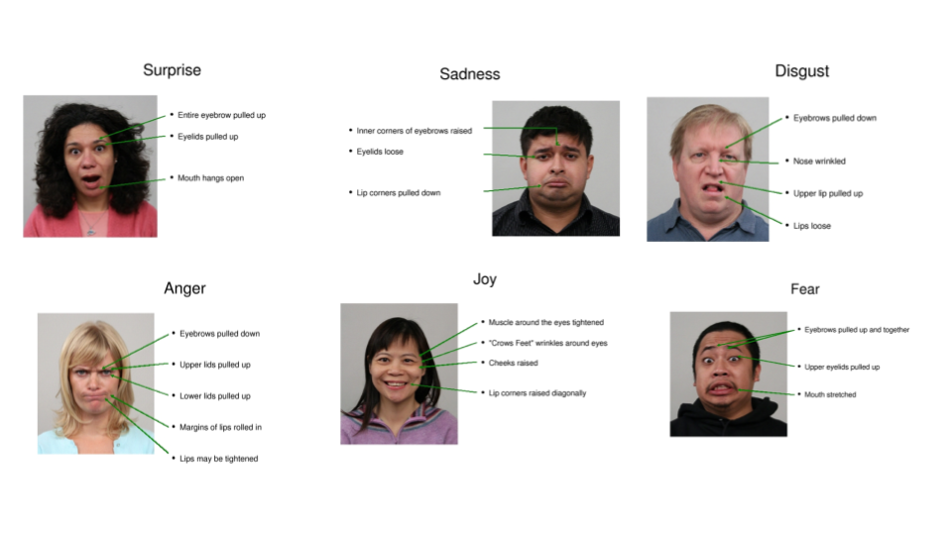
Figure 6.1.1 illustrates six universal micro expressions corresponding to basic emotions: Surprise, Sadness, Disgust, Anger, Joy, and Fear. Each microexpression is labeled with detailed annotations describing specific facial features that signify each emotion.
However, the reliability of these non-verbal cues has been a subject of debate. Wiseman et al. (2012) conducted a comprehensive study examining the validity of Neuro-Linguistic Programming (NLP) claims that specific eye movements indicate lying. Their research involved multiple experiments where participants were filmed while lying or telling the truth, and their eye movements were meticulously coded and analyzed. The findings consistently failed to support the NLP assertions, revealing no significant differences in eye movement patterns between liars and truth-tellers. This challenges the efficacy of using eye movements as a standalone indicator of deception.
Furthermore, cultural and individual differences can significantly influence the manifestation of non-verbal cues, complicating their application in diverse settings (He et al., 2024). For instance, certain gestures or facial expressions deemed indicative of deceit in one culture may be interpreted differently in another, undermining the universality of non-verbal lie detection methods. Additionally, individual variability in baseline behaviors means that non-verbal cues must be interpreted within the context of the person being observed, rather than relying on generalized indicators.
Despite these challenges, non-verbal lie detection methods continue to be an area of active research, with ongoing efforts to identify more reliable and context-specific cues. The integration of technology, such as video analysis and machine learning algorithms, holds promise for enhancing the accuracy and objectivity of non-verbal deception detection by systematically analyzing complex behavioral patterns.

6.1.2 Eye Movement Patterns in Deception
Eye movement patterns have garnered considerable attention as potential indicators of deception, both in popular culture and academic research. Neuro-Linguistic Programming (NLP) posits that specific eye movements correlate with cognitive processes associated with lying. According to NLP theory, liars tend to look up and to the right (visual construct), while truth-tellers look up and to the left (visual recall) (Bandler & Grinder, 1975). These associations are purported to reflect the internal cognitive processes involved in fabricating a lie versus recalling truthful information.
The credibility of NLP's eye movement theory is supported by its widespread adoption in various training programs and its influence on popular media portrayals of lie detection. NLP practitioners argue that eye movements are not merely random but are systematically linked to how individuals process information during deception. For example, when constructing a lie, the upward-right gaze is believed to indicate the fabrication of visual details, whereas an upward-left gaze suggests the recall of actual memories (Dilts, 1990).
Empirical support for NLP’s eye movement theory can be found in studies that initially observed consistent patterns of eye movements among participants engaged in deception tasks. Early research by Dilts (1980) indicated that specific eye directions were associated with different cognitive processes, providing a theoretical foundation for using eye movements in lie detection. Additionally, training courses and practical applications in certain organizational settings have reported anecdotal success in using eye movement patterns to assess truthfulness, further bolstering the theory's perceived validity.
However, it is essential to acknowledge that while some studies support the NLP theory, others have raised questions about its reliability and universality. Wiseman et al. (2012) conducted a series of studies to test the validity of NLP's claims regarding eye movements and lying. Their research involved controlled experiments where participants were instructed to lie or tell the truth while their eye movements were recorded and analyzed. The results consistently failed to find significant differences in eye movement patterns between liars and truth-tellers, challenging the efficacy of the NLP-based approach.
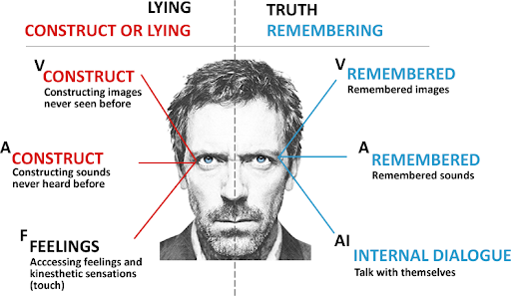
Figure 6.1.2 depicts the proposed eye movement directions associated with different cognitive processes in the NLP framework, contrasting visual recall and visual construct.
Despite these conflicting findings, proponents of NLP argue that methodological differences, such as the ecological validity of deception tasks and the precision of eye movement coding, may account for discrepancies in research outcomes. They suggest that real-world applications, where deception is often high-stakes and emotionally charged, might reveal more pronounced eye movement patterns than those observed in laboratory settings (Gray, 1991).
Moreover, recent advancements in eye-tracking technology and machine learning offer new avenues for investigating eye movement patterns with greater accuracy and sophistication. These technologies can capture subtle eye movements and analyze them in real-time, potentially uncovering nuanced behavioral indicators of deception that were previously undetectable. By integrating these advanced tools, the DETECT project aims to build upon the foundational principles of the NLP theory while addressing its previous limitations through enhanced data analysis and validation techniques.
In summary, eye movement patterns as proposed by NLP offer a promising yet debated method for deception detection. While foundational theories and some empirical studies support the association between specific eye movements and cognitive processes involved in lying, other research has not replicated these findings consistently. The DETECT project seeks to advance this field by utilizing state-of-the-art eye-tracking technologies and AI algorithms to more accurately capture and interpret eye movement data, thereby refining the theoretical and practical applications of NLP-based deception detection.

6.2 Existing Eye-Tracking Technologies
Eye-tracking technologies have advanced significantly over the past few decades, enabling the monitoring of where a person is looking. These technologies are utilized in various fields, including research, healthcare, gaming, marketing, surveillance, and accessibility. This section focuses on two types of existing eye-tracking technologies: Video-based Eye Tracking and AI Eye Tracking.

Video-based Eye Tracking
Video-based Eye Tracking is the most common form of eye-tracking technology available. This method utilizes cameras and image processing algorithms to determine eye position and movement. Typically, a camera captures video of the user's eyes, and specialized software analyzes the reflections of infrared light from the cornea and pupil to track gaze direction.
This setup usually includes a display or a screen with cameras that will track eye movements from different angles. Infrared light is often used to illuminate the eyes, advanced algorithms then interpret the captured data to derive metrics such as the gaze direction, and movements.

Some Applications
Surveillance: In security applications, video-based eye tracking can monitor crowds and detect unusual behavior by analyzing gaze patterns. This capability enhances situational awareness and helps identify potential threats in real-time.
Healthcare: Clinicians use eye-tracking technology to diagnose and monitor conditions such as autism spectrum disorders and ADHD. The Eye movement patterns provide insights into cognitive states, allowing for better-tailored therapeutic interventions.
Gaming: The integration of eye tracking technology in gaming systems allows for immersive gameplay experiences. By monitoring players’ gaze, games can adapt to where players are looking, creating dynamic environments that respond to visual attention.

Existing products
Tobii Eye Trackers: Tobii offers head and eye trackers, widely used in research and gaming.
Pupil Labs: Open-source, head-mounted eye trackers for research and real-world use.
EyeLink: Known for high precision, these trackers are often used in psychological and neuroscience studies.

Figure 6.2.i: Tobii Pro Spectrum

Artificial Intelligence Eye Tracking
AI-driven eye tracking combines traditional eye-tracking methods with machine learning and artificial intelligence, providing a more sophisticated analysis of eye movement data. By leveraging vast datasets, these systems can identify trends and make predictions about user engagement and visual attention.
AI-driven systems leverage a combination of video input and advanced data analysis techniques. Instead of merely tracking the position of the gaze, AI algorithms can learn from vast amounts of eye movement data to identify trends, preferences, and user intent. These systems often include features such as real-time analysis and feedback, enabling adaptive interactions based on user behavior.

Applications
Autonomous Vehicles: Eye-tracking technology integrated with AI is being explored for use in autonomous vehicles. By monitoring the driver’s gaze, these systems can assess alertness and distraction levels, ensuring safer driving experiences.
Security and Surveillance: AI-driven eye tracking enhances surveillance capabilities by identifying individuals in crowded settings. The technology can recognize patterns that suggest suspicious behavior, alerting security personnel to potential threats in real time.
Augmented and Virtual Reality: Eye tracking is vital in augmented reality (AR) and virtual reality (VR) systems, allowing for more immersive experiences. It enables dynamic adjustments to the virtual environment based on where users are looking, enhancing interactivity and realism.

Existing Products
Tesla: Tesla uses a cabin-facing camera and AI to track a driver's eye movements and detect inattentiveness while Autopilot is engaged.
Eyeware: software-only head and eye tracking technology for webcams and 3D sensors to advance natural connections between people and their devices.
Eye Tracking Apple Accessibility: Powered by artificial intelligence, Eye Tracking gives users a built-in option for navigating iPad and iPhone with just their eyes.
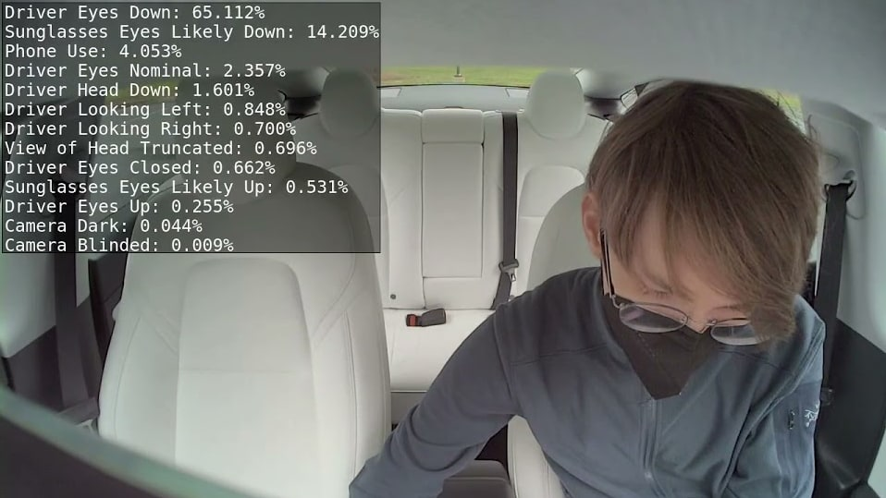
Figure 6.2.ii: Tesla Eye Tracking

Conclusion
Advancements in eye-tracking technologies, particularly video-based and AI-driven systems, have significantly transformed the understanding of visual attention and human behavior. These technologies are now applicable across various fields, including research, healthcare, marketing, and surveillance. As eye-tracking technology continues to evolve, its potential applications and benefits are expected to expand, addressing the unique needs of users across different domains.

6.3 MediaPipe Overview

Introduction
MediaPipe is an open-source, cross-platform machine learning framework developed by Google. It is designed to provide robust real-time detection and tracking solutions for various use cases, including face detection, hand tracking, object detection, and human pose estimation. MediaPipe offers a set of ready-to-use pipelines that work efficiently across different platforms such as Android, iOS, desktop, and web applications. In the context of the DETECT project, MediaPipe is employed to facilitate real-time eye and face tracking as part of the AI-driven lie detection system.
The advantage of using MediaPipe in this project lies in its ability to track facial landmarks with remarkable accuracy while maintaining low computational costs. This is essential for the DETECT system as it processes eye movements and gaze patterns in real-time to detect potential signs of deception. The MediaPipe framework simplifies complex machine learning tasks by providing pre-trained models for face and eye tracking, making it an ideal solution for integrating into the DETECT project.

MediaPipe Face Mesh
One of the core features of MediaPipe that is crucial for the DETECT project is Face Mesh. MediaPipe Face Mesh is a model capable of detecting over 468 facial landmarks in real time, which provides the foundation for tracking subtle facial movements, including eye and mouth regions, that are pertinent to the lie detection efforts. This model constructs a 3D mesh of the face using the identified landmarks, offering a highly detailed representation of facial expressions and movements.
Face Mesh operates by detecting specific points on a subject's face, focusing on critical areas such as the eyes, mouth, nose, and jawline. In the DETECT project, particular emphasis is placed on eye landmarks for tracking gaze direction, pupil dilation, and blink rates—indicators that may be associated with deceptive behavior. These facial landmarks serve as input for advanced algorithms designed to correlate specific eye movements with the potential for deceit.
For instance, MediaPipe allows the extraction of the position of the irises using landmarks such as points 468, 473, and others around the eyes. These landmarks are used to compute the vertical and horizontal movements of the eyes, which are then fed into the machine learning models for analysis. MediaPipe’s high precision in landmark detection is a key contributor to the accuracy of the DETECT system.

Facial Landmarks and their Importance
MediaPipe’s facial landmarks are integral to understanding facial dynamics and human expressions. For the DETECT project, the landmarks around the eyes (e.g., 468, 473, 475, 477 for the iris, and 33, 263 for the eye corners) are of particular significance as they allow the tracking of eye-related cues that may reveal signs of deception. These cues include eye movement patterns, gaze shifts, and changes in blink rates, all of which can be tracked through these landmarks.
Additionally, landmarks on the nose, such as points 4 and 168, provide a stable reference point for measuring eye movement relative to head position. By calculating the relative distance between the iris and the nose, head movements can be better accounted for, ensuring that eye movements are accurately interpreted in relation to the overall facial structure.
In lie detection, these landmarks enable the system to detect micro-expressions, involuntary movements that occur when a person attempts to suppress an emotional response. The subtle movements of the eyes and surrounding facial muscles can be key indicators of such micro-expressions. For example, quick upward or sideways glances may suggest cognitive load or discomfort, which could be indicative of deception. By leveraging MediaPipe’s real-time facial landmark detection, the DETECT project can capture and analyze these subtle cues efficiently.

Integration with the DETECT System
In the DETECT project, the integration of MediaPipe serves as the backbone of the eye-tracking component. The pipeline for processing video inputs starts by detecting the face and isolating key regions, particularly the eyes. Once the face and eyes are detected, MediaPipe identifies and tracks the facial landmarks in real-time. These landmarks are then used to compute eye metrics, such as the direction of gaze and blink frequency.
Using MediaPipe’s Facial Landmark Detection, the system continuously tracks changes in these metrics as the subject interacts with the system, providing real-time feedback on their gaze direction and blink patterns. The real-time processing capabilities of MediaPipe are essential for ensuring that the DETECT system operates seamlessly, without noticeable delays, which is critical for maintaining the accuracy of the lie detection model.

Eye Movements in Deception Detection
Eye movement is a widely studied area in lie detection research. The basic premise is that certain eye behaviors, such as looking away, avoiding eye contact, or rapid blinking, can be linked to cognitive processes associated with lying. The DETECT system, powered by MediaPipe, capitalizes on these behavioral indicators by capturing and analyzing eye movement data in real-time.
Through MediaPipe’s facial landmark tracking, the DETECT system focuses on extracting relevant eye movement patterns that have been associated with deception. For example, MediaPipe’s ability to track iris positions can help detect shifts in gaze direction, which may indicate cognitive stress or an attempt to fabricate information. Additionally, MediaPipe can capture subtle changes in pupil dilation, which is another marker often linked to deception as it can reflect emotional arousal or stress.
By feeding these eye movement metrics into a machine learning model, the DETECT system can assess the likelihood of deception based on predefined patterns. MediaPipe's real-time capabilities ensure that these cues are captured accurately and consistently, allowing for immediate analysis.

Landmark-Based Affine Transform and Stabilization
To account for head movements during eye tracking, the DETECT system incorporates an affine transformation based on the facial landmarks provided by MediaPipe. The Affine Transform is a technique that aligns the face into a consistent reference frame, stabilizing the video input and ensuring that the eye movements are isolated from head movements. This is particularly important in deception detection, where even slight shifts in head position can affect the interpretation of eye movements.
Using the nose and eye landmarks (such as 4, 33, and 263), an affine transformation matrix is calculated to align the face vertically and horizontally. This ensures that the eye tracking remains consistent, regardless of minor head movements. By stabilizing the facial landmarks, the DETECT system can focus more accurately on the changes in eye behavior, rather than being misled by head tilts or rotations.

MediaPipe in Other Components of the DETECT Project
Apart from eye tracking, MediaPipe is also being explored for its potential to enhance other components of the DETECT system. For example, the Face Mesh model can be extended to analyze micro-expressions around the mouth or eyebrows, providing additional cues that may contribute to the overall lie detection analysis. By capturing a more comprehensive set of facial expressions, the system can better understand the subject’s emotional state, which may further enhance the accuracy of the deception detection algorithms.
Furthermore, MediaPipe’s adaptability allows the exploration for future enhancements, such as combining body posture tracking with facial analysis, to detect even more nuanced signs of deception. These advancements could be incorporated into later versions of the DETECT system, making it an even more powerful tool for lie detection.
MediaPipe plays a pivotal role in the DETECT project by providing the necessary framework for real-time, accurate facial and eye tracking. Its ability to track 468 facial landmarks, including those around the eyes, is essential for detecting subtle cues associated with deception, such as changes in gaze direction and blink rates. By leveraging MediaPipe’s facial landmark tracking, the DETECT system is able to process video inputs in real-time, offering a non-invasive and efficient solution for lie detection. The integration of MediaPipe ensures that the DETECT project not only achieves high accuracy in detecting deceptive behavior but also paves the way for future enhancements in the field of AI-driven lie detection technology.

7. Project Overview
This project focuses on the development of an AI-powered deception detection system, utilizing eye tracking and gaze detection to assess truthfulness. The system is designed to analyze subtle changes in eye movement and gaze patterns, providing real-time assessments of deception during interviews or other interactive situations. The software is built on top of MediaPipe, a powerful machine learning framework that enables real-time face and eye tracking, and is managed through Conda for efficient environment control and dependency management. The system prioritizes accuracy, speed, and user privacy to create a reliable solution for detecting deceptive behaviors in a variety of settings.

7.1 System Architecture
The system is based on a modular architecture that integrates multiple components to deliver real-time gaze detection and analysis. The data input layer captures video feeds from cameras, feeding the data into the processing layer, where MediaPipe extracts facial landmarks and eye movement data. This data is then processed by the AI analysis layer, which applies machine learning models to detect gaze patterns that may indicate deception. A presentation layer displays results in a user-friendly interface, where users can view real-time feedback on the likelihood of deceptive behavior. The modular nature of the architecture allows for scalability and easy updates to the underlying algorithms.

7.2 Technologies Used

MediaPipe
MediaPipe is a versatile framework developed by Google that enables real-time computer vision and machine learning applications. It provides a set of customizable, pre-built models for tasks such as facial detection, object tracking, and gesture recognition. The framework is designed for efficiency, allowing developers to implement complex algorithms without extensive prior experience in computer vision. By utilizing MediaPipe for eye and facial tracking, the system can accurately assess gaze patterns and other visual cues that contribute to the deception detection process. Its modular architecture and cross-platform capabilities make it an ideal choice for integrating advanced tracking features into applications that require real-time feedback.

Conda and Python
Conda is a popular package management and environment management system that simplifies the process of managing dependencies in Python projects. It allows developers to create isolated environments, ensuring that each project has access to the specific libraries and versions it needs without conflicts. Python, a powerful and flexible programming language, is the primary language used for building the AI models in this project. Its rich ecosystem of libraries for data analysis, machine learning, and scientific computing makes it a preferred choice for developers. Together, Conda and Python provide a robust framework for managing the software environment and developing the sophisticated algorithms required for the deception detection system, enabling efficient and reliable implementation.

7.3 Potential Applications
From a purely open-source research perspective, the AI-powered deception detection system presents numerous opportunities for exploration and development across various academic and scientific domains.

Psychological Research
The system can serve as a tool for investigating the behavioral indicators of deception, enabling researchers to study the correlation between eye movement patterns and psychological states. This could lead to deeper insights into cognitive processes during truthful and deceptive communication.

Human-Computer Interaction
Researchers can leverage the system to explore how gaze detection influences user experience in human-computer interactions. By studying how users respond to visual cues from the system, insights can be gained into designing more intuitive interfaces and improving user engagement.

Communication Studies
The technology can be utilized to analyze non-verbal cues in communication, contributing to the understanding of how eye movements and gaze behavior affect interpersonal interactions. This could lead to research on cultural differences in deceptive behaviors and the role of eye contact in communication.

Educational Tools
Open-source initiatives can use the system as a training tool for teaching students about body language, non-verbal communication, and the psychology of deception. This educational application could enhance curricula in psychology, communication, and law enforcement studies.

Data Collection for Machine Learning
Researchers can use the system to gather data on gaze patterns and deception indicators, contributing to the development of more robust machine learning models. This data can be invaluable for furthering the understanding of human behavior and improving the accuracy of AI-based detection systems.

Ethical Studies
The project can also serve as a platform for exploring the ethical implications of using technology for deception detection. Researchers can study public perceptions, privacy concerns, and the impact of such technologies on societal norms.
By focusing on these open-source research applications, the system can foster collaboration and innovation, contributing to the advancement of knowledge in various fields while maintaining transparency and accessibility.

8. Project Management and Team Coordination
Effective project management and team coordination are crucial for the successful development of the AI-powered deception detection system. Utilizing Agile methodologies, particularly Scrum, the project is organized into manageable sprints, allowing for flexibility and continuous improvement. Clear roles and responsibilities are established to enhance team dynamics, supported by regular communication through daily stand-ups and planning meetings. Tools like Jira for task tracking and Discord for real-time discussions facilitate collaboration and transparency. A proactive approach to risk management is integrated throughout the project lifecycle to identify and mitigate potential challenges. Overall, this structured approach fosters a collaborative environment that enhances productivity, innovation, and adaptability, ensuring the delivery of a high-quality product.

8.1 Team Structure and Roles
Effective project planning and scheduling are essential for the success of the project. Adam Bawatneh, as the Project Manager, oversees the creation of the project plan, defining objectives, scope, and key milestones. He ensures that all necessary resources are in place and that the team understands the roadmap ahead.
Brian Conn, the Scrum Master, ensures the team adheres to the Agile methodology, breaking down the project into sprints and managing the Scrum ceremonies (e.g., sprint planning, daily stand-ups, sprint reviews). He ensures the team stays on track, facilitating task prioritization and monitoring progress.
Development is guided by Soham Ganguly, who schedules coding tasks and oversees the development timeline. Testing, handled by Jeffrey Chang, Muzamil Shamsi, and John Economou, is integrated into the project schedule to ensure features are continuously validated and issues are addressed promptly. John Economou, as the IRB Facilitator, researches approval processes with the Institutional Review Board (IRB) to ensure compliance milestones are met.
This structured approach to planning and scheduling ensures that the project stays on track, with regular reviews and adjustments as needed to manage risks and ensure timely delivery.

8.2 Project Planning and Scheduling
Effective project planning and scheduling have been crucial to the development of the AI-powered deception detection system. The project follows an Agile development framework, which emphasizes iterative progress and adaptability. This approach allows the team to respond to changes in requirements and prioritize tasks based on the system's evolving needs.
At the start of the project, a preliminary roadmap was created, outlining key milestones, including the development of the eye-tracking algorithm, the implementation of gaze and anomaly detection, and the integration of these functionalities into a web application. Each milestone was broken down into smaller, actionable sprints lasting roughly two weeks, during which specific features or components were developed and tested. This incremental approach ensures continuous progress and allows the team to assess performance regularly.
The use of JIRA for task management has been instrumental in tracking the project's timeline. It allows the team to assign tasks, monitor their progress, and adjust priorities as needed. During sprint planning meetings, the backlog is reviewed, and tasks are assigned to team members based on their availability and skill sets. These sprints also include a buffer for testing and debugging, ensuring that potential issues are addressed early.
Daily stand-ups via DailyBot on Discord allow the team to stay aligned on daily tasks, while bi-weekly sprint reviews and retrospectives held on Zoom provide opportunities to assess completed work, gather feedback, and plan for the next sprint. This regular review process ensures that deadlines are met, roadblocks are identified early, and the project remains on track.
Overall, this structured yet flexible scheduling ensures that the team can manage the complexities of development while maintaining a clear focus on project goals and timelines.

8.3 Communication Tools and Meetings
Effective communication is crucial for the successful development of the AI-powered deception detection system, and the team employs various tools and structured meeting practices to facilitate collaboration.

Communication Tools
The team utilizes Discord as the primary communication platform for real-time messaging and discussions. This allows for quick interactions and the creation of dedicated channels for specific topics, ensuring organized and focused conversations. For more formal documentation and note-taking, Confluence is employed to maintain a centralized repository of project information, meeting notes, and collaborative documents. This ensures that important information is easily accessible and well-organized for all team members.

Meetings
Zoom is used for bi-weekly sprint planning and review meetings. During these sessions, the Project Manager oversees task prioritization, while each team member presents completed work and contributes to gathering feedback to improve processes continuously.

8.4 Progress Monitoring and Roadblocks
Monitoring progress and addressing roadblocks is essential for keeping the AI-powered deception detection project on track. The team adopts a structured approach to tracking progress and resolving challenges that arise.

Progress Monitoring
To keep tabs on project status, the team utilizes Jira as their project management tool. This platform allows team members to visualize task assignments, deadlines, and overall project status. Regular updates in Jira help ensure that everyone is aware of ongoing work and project developments. Key performance indicators are established to measure progress, such as sprint velocity and task completion rates. Regular reviews of these metrics facilitate data-driven decision-making, allowing the team to identify trends and optimize workflows.

Roadblocks
Identifying and addressing roadblocks quickly is crucial for maintaining project momentum. During daily stand-ups via DailyBot, team members are encouraged to openly discuss any obstacles they encounter. This collaborative approach fosters an environment where solutions can be brainstormed, and support can be provided. If significant roadblocks arise, they are documented in Jira and escalated during sprint planning or retrospective meetings on Zoom, allowing the team to strategize on overcoming these challenges in future sprints. By actively monitoring progress and addressing issues as they arise, the team ensures that the project stays on track and can adapt to changing circumstances, ultimately leading to the successful delivery of the deception detection system.

8.5 JIRA Setup and Agile Development
JIRA serves as the backbone of project management for the development of the AI-powered deception detection system, providing a comprehensive platform for tracking progress, managing tasks, and facilitating Agile development methodologies. By leveraging JIRA's features, the team can streamline workflows and maintain a clear focus on project objectives.

JIRA Setup
The initial setup of JIRA involves creating a dedicated project space tailored to the specific needs of the deception detection system. The project is organized into various issue types, including User Stories, Tasks, and Epics. User Stories capture functional requirements from an end-user perspective, ensuring that the development team remains aligned with user needs. Epics group related User Stories into larger feature sets, providing a high-level view of progress across different areas of the project.
To facilitate task management, the team employs custom workflows that reflect the stages of development, such as To Do, In Progress, In Review, and Done. This visual representation allows team members to easily track the status of their work and understand project progression at a glance. Additionally, labels and components are utilized to categorize tasks based on features or modules, enhancing organization and enabling better filtering during sprint planning.

Agile Development
JIRA's integration with Agile methodologies significantly enhances the team's ability to adopt and implement Agile practices effectively. The team operates within sprints, typically lasting two weeks, which allows for iterative development and frequent reassessment of goals. At the beginning of each sprint, a sprint planning meeting is conducted, where the team reviews the backlog in JIRA, prioritizes User Stories based on project objectives, and assigns tasks to team members. This collaborative effort ensures that the team is aligned on priorities and understands the work required for the upcoming sprint.
During the sprint, team members update the status of their tasks in real-time, allowing for transparency and continuous progress tracking. Daily stand-ups via DailyBot on Discord provide an additional layer of accountability, enabling the team to discuss accomplishments, address any challenges, and adjust plans as necessary.
At the end of each sprint, a sprint review meeting is held to demonstrate completed work and gather feedback from stakeholders. This feedback is crucial for refining the product and guiding future development efforts. Additionally, sprint retrospectives provide an opportunity for the team to reflect on their processes, identify areas for improvement, and implement changes in the subsequent sprint.
By leveraging JIRA effectively within an Agile framework, the team can maintain a high level of flexibility and responsiveness throughout the development process. This structured yet adaptable approach not only facilitates efficient task management but also fosters a collaborative environment where continuous improvement is prioritized. Ultimately, the use of JIRA in conjunction with Agile methodologies supports the successful delivery of the deception detection system, ensuring that the final product meets user expectations and project goals.

8.5.1 Product Backlog
Key | Issue Type | Parent | Summary | Status
AAI-102 | Task | AAI-4 | CLONE - Task 3.4.4: Create Documented Video for Dataset and Upload to Drive | Done
AAI-8 | Epic |  | Epic 0: Project Management and Team Coordination | Done
AAI-2 | Epic |  | Epic 1: Research and Data Collection | Done
AAI-3 | Epic |  | Epic 2: Eye Tracking Implementation | Done
AAI-4 | Epic |  | Epic 3: Anomaly Detection Algorithm | In Progress
AAI-5 | Epic |  | Epic 4: Web Application Development | In Progress
AAI-6 | Epic |  | Epic 5: Testing and Refinement | To Do
AAI-7 | Epic |  | Epic 6: IRB Approval and Data Collection | To Do
AAI-67 | Task | AAI-8 | Task 0.1.1: Create JIRA Project for Project DETECT | Done
AAI-68 | Task | AAI-8 | Task 0.1.2: Input Epics, User Stories, and Tasks into JIRA | Done
AAI-69 | Task | AAI-8 | Task 0.1.3: Configure Workflows and Permissions | Done
AAI-77 | Task | AAI-8 | Task 0.1.4: Set Up JIRA and GitHub Integration | Done
AAI-70 | Task | AAI-8 | Task 0.2.1: Schedule Weekly In-Person Meetings | Done
AAI-71 | Task | AAI-8 | Task 0.2.2: Schedule Additional Zoom Meetings as Needed | Done
AAI-72 | Task | AAI-8 | Task 0.2.3: Use Shared Calendar to Track Meetings | Done
AAI-73 | Task | AAI-8 | Task 0.3.1: Implement Daily Stand-Up Questions via Discord Bot | Done
AAI-74 | Task | AAI-8 | Task 0.3.2: Review Team Updates and Provide Assistance | Done
AAI-75 | Task | AAI-8 | Task 0.3.3: Prepare for TA Check-Ins and Progress Reports | Done
AAI-10 | Task | AAI-2 | Task 1.1.1: Research Non-Verbal Lie Detection Methods | Done
AAI-11 | Task | AAI-2 | Task 1.1.2: Summarize Findings on Eye Movement Patterns | Done
AAI-12 | Task | AAI-2 | Task 1.1.3: Identify Relevant Datasets for Training | Done
AAI-14 | Task | AAI-2 | Task 1.2.1: Gather Datasets Related to Eye Movements | Done
AAI-15 | Task | AAI-2 | Task 1.2.2: Clean and Preprocess Data for Models | Done
AAI-16 | Task | AAI-2 | Task 1.2.3: Document Data Sources and Preprocessing Steps | Done
AAI-88 | Task | AAI-2 | Task 1.3.1: Create Class Diagrams | Done
AAI-89 | Task | AAI-2 | Task 1.3.2: Develop Initial Sequence Diagrams | Done
AAI-90 | Task | AAI-2 | Task 1.3.3: Peer Review UML Diagrams | Done
AAI-19 | Task | AAI-3 | Task 2.1.1: Set Up MediaPipe Face Mesh in Colab Notebook | Done
AAI-20 | Task | AAI-3 | Task 2.1.2: Extract Eye Landmarks and Iris Center Positions | Done
AAI-21 | Task | AAI-3 | Task 2.1.3: Calculate Gaze Direction Based on Eye Landmarks | Done
AAI-78 | Task | AAI-3 | Task 2.1.5.1: Gaze Detection Accuracy Testing | Done
AAI-79 | Task | AAI-3 | Task 2.1.5.2: Gaze Detection Accuracy Testing | Done
AAI-81 | Task | AAI-3 | Task 2.1.5.3: Gaze Detection Accuracy Testing | Done
AAI-83 | Task | AAI-3 | Task 2.1.5.4: Develop Functionality for Graphing Gaze Metrics | Done
AAI-82 | Task | AAI-3 | Task 2.1.5.4: Gaze Detection Accuracy Testing | Done
AAI-80 | Task | AAI-3 | Task 2.1.5.5: Gaze Detection Accuracy Testing | Done
AAI-92 | Task | AAI-4 | Task 2.1.6 Set Up MediaPipe in Conda | Done
AAI-23 | Task | AAI-3 | Task 2.2.1: Research Methods for Measuring Pupil Dilation | Done
AAI-24 | Task | AAI-3 | Task 2.2.2: Integrate Pupil Dilation Measurement into Eye-Tracking System | Done
AAI-25 | Task | AAI-3 | Task 2.2.3: Test Pupil Dilation Measurements Under Various Lighting Conditions | Done
AAI-28 | Task | AAI-6 | Task 3.1.1: Design the Architecture for a Basic CNN | In Progress
AAI-29 | Task | AAI-6 | Task 3.1.2: Implement the CNN Model for Anomaly Detection | In Progress
AAI-30 | Task | AAI-6 | Task 3.1.3: Train the Model Using Collected Datasets | In Progress
AAI-31 | Task | AAI-6 | Task 3.1.4: Evaluate the Model's Performance and Adjust Parameters | In Progress
AAI-32 | Task | AAI-6 | Task 3.2.1: Incorporate Weighted Cues into the Algorithm | In Progress
AAI-33 | Task | AAI-6 | Task 3.2.2: Adjust Algorithm for Prioritized Eye Movement Patterns | In Progress
AAI-34 | Task | AAI-6 | Task 3.2.3: Validate the Algorithm with Test Data | In Progress
AAI-85 | Task | AAI-6 | Task 3.2.4: Model Evaluation and Comparison | In Progress
AAI-86 | Task | AAI-6 | Task 3.2.5: Model Performance Documentation | In Progress
AAI-91 | Task | AAI-6 | Task 3.2.6: Implement Accurate Timestamping for Video Processing | In Progress
AAI-94 | Task | AAI-4 | Task 3.3.1: Research and Select Graphing Algorithms | Done
AAI-95 | Task | AAI-4 | Task 3.3.2: Implement Real-Time Animations | Done
AAI-96 | Task | AAI-4 | Task 3.3.3: Integrate Graphing Algorithms into the System | Done
AAI-97 | Task | AAI-4 | Task 3.4.1: Validate and Optimize Graphing Performance | Done
AAI-98 | Task | AAI-4 | Task 3.4.2: Interactive Visualization Features | Done
AAI-99 | Task | AAI-4 | Task 3.4.2: Unit Testing and Bug Fixes for Data Modeling | Done
AAI-100 | Task | AAI-4 | Task 3.4.3: Add Timestamp to Video for Testing | Done
AAI-101 | Task | AAI-4 | Task 3.4.4: Create Documented Video for Dataset and Upload to Drive | Done
AAI-104 | Task | AAI-5 | Task 4.1.1: Research Front-End Frameworks | In Progress
AAI-105 | Task | AAI-5 | Task 4.1.2: Research Back-End Frameworks | In Progress
AAI-106 | Task | AAI-5 | Task 4.1.3: Research Database Options | In Progress
AAI-38 | Task | AAI-5 | Task 4.1.4: Develop Frontend Interface for the Web Application | In Progress
AAI-39 | Task | AAI-5 | Task 4.1.5: Implement Webcam Access in the Web Application | In Progress
AAI-40 | Task | AAI-5 | Task 4.1.6: Integrate Eye-Tracking and Anomaly Detection Algorithms | In Progress
AAI-41 | Task | AAI-5 | Task 4.1.7: Display Real-Time Results with Probability Graphs | In Progress
AAI-42 | Task | AAI-5 | Task 4.2.1: Implement Video Upload Functionality | In Progress
AAI-43 | Task | AAI-5 | Task 4.2.2: Process Uploaded Videos Using Algorithms | To Do
AAI-44 | Task | AAI-5 | Task 4.2.3: Generate Analysis Results for Uploaded Videos | To Do
AAI-46 | Task | AAI-5 | Task 4.3.1: Ensure Responsive Design for Various Screen Sizes | To Do
AAI-47 | Task | AAI-5 | Task 4.3.2: Test the Web App on Multiple Browsers and Devices | To Do
AAI-48 | Task | AAI-5 | Task 4.3.3: Optimize Performance for Mobile Users | To Do
AAI-51 | Task | AAI-6 | Task 5.1.1: Develop Test Cases for Gaze Detection Accuracy | To Do
AAI-52 | Task | AAI-6 | Task 5.1.2: Test Pupil Dilation Measurements Under Different Lighting Conditions | To Do
AAI-53 | Task | AAI-6 | Task 5.1.3: Document and Report Any Issues or Bugs | To Do
AAI-54 | Task | AAI-6 | Task 5.2.1: Conduct User Testing Sessions | To Do
AAI-55 | Task | AAI-6 | Task 5.2.2: Collect and Analyze User Feedback | To Do
AAI-56 | Task | AAI-6 | Task 5.2.3: Prioritize Improvements Based on Feedback | To Do
AAI-59 | Task | AAI-7 | Task 6.1.1: Prepare IRB Application Documents | To Do
AAI-60 | Task | AAI-7 | Task 6.1.2: Submit Application and Address Feedback | To Do
AAI-61 | Task | AAI-7 | Task 6.1.3: Receive Approval Before Data Collection | To Do
AAI-62 | Task | AAI-7 | Task 6.2.1: Recruit Participants for Data Collection | To Do
AAI-63 | Task | AAI-7 | Task 6.2.2: Conduct Sessions Recording Eye Movements | To Do
AAI-64 | Task | AAI-7 | Task 6.2.3: Compile and Preprocess Data for Model Training | To Do
AAI-65 | Story | AAI-8 | User Story 0.1: Set Up JIRA for Agile Development | Done
AAI-66 | Story | AAI-8 | User Story 0.2: Schedule Regular Meetings for Team Coordination | Done
AAI-76 | Story | AAI-8 | User Story 0.3: Monitor Team Progress and Address Roadblocks | Done
AAI-9 | Story | AAI-2 | User Story 1.1: Research Existing Lie Detection Techniques | Done
AAI-13 | Story | AAI-2 | User Story 1.2: Prepare Datasets for Training the Model | Done
AAI-87 | Story | AAI-2 | User Story 1.3: UML Documentation and Initial Sequence Diagramming | Done
AAI-17 | Story | AAI-3 | User Story 2.1: Implement Gaze Detection Using MediaPipe | Done
AAI-18 | Story | AAI-3 | User Story 2.2: Implement Pupil Dilation Measurement | Done
AAI-22 | Story | AAI-3 | User Story 2.2: Optimize Gaze Detection for Real-Time Performance | Done
AAI-26 | Story | AAI-6 | User Story 3.1: Develop an Algorithm to Detect Anomalies in Eye Movement Patterns | In Progress
AAI-27 | Story | AAI-6 | User Story 3.2: Integrate Research Findings into the Algorithm | In Progress
AAI-93 | Story | AAI-4 | User Story 3.3 Data Documentation & Modeling | Done
AAI-103 | Story | AAI-4 | User Story 3.4 Testing and Debugging | Done
AAI-35 | Story | AAI-5 | User Story 4.1: Develop Web Application for Real-Time Deception Detection | In Progress
AAI-36 | Story | AAI-5 | User Story 4.2: Enable Video Upload for Analysis | In Progress
AAI-37 | Story | AAI-5 | User Story 4.3: Optimize Web App for Accessibility on All Platforms | To Do
AAI-49 | Story | AAI-6 | User Story 5.1: Test Eye-Tracking and Anomaly Detection Components | To Do
AAI-50 | Story | AAI-6 | User Story 5.2: Gather User Feedback for Application Improvement | To Do
AAI-57 | Story | AAI-7 | User Story 6.1: Obtain IRB Approval for Human Subject Studies | To Do
AAI-58 | Story | AAI-7 | User Story 6.2: Gather Lie Cue Data for Algorithm Refinement | To Do

8.5.2 Sprint Backlog
Summary | Status | Sprint
User Story 1.1: Research Existing Lie Detection Techniques | Done | AAI Sprint 1 - Research/Setup
Task 1.1.1: Research Non-Verbal Lie Detection Methods | Done | AAI Sprint 1 - Research/Setup
Task 1.1.2: Summarize Findings on Eye Movement Patterns | Done | AAI Sprint 1 - Research/Setup
Task 1.1.3: Identify Relevant Datasets for Training | Done | AAI Sprint 1 - Research/Setup
User Story 1.2: Prepare Datasets for Training the Model | Done | AAI Sprint 1 - Research/Setup
Task 1.2.1: Gather Datasets Related to Eye Movements | Done | AAI Sprint 1 - Research/Setup
Task 1.2.2: Clean and Preprocess Data for Models | Done | AAI Sprint 1 - Research/Setup
Task 1.2.3: Document Data Sources and Preprocessing Steps | Done | AAI Sprint 1 - Research/Setup
User Story 0.1: Set Up JIRA for Agile Development | Done | AAI Sprint 2 - Gaze Detection
Task 0.1.1: Create JIRA Project for Project DETECT | Done | AAI Sprint 2 - Gaze Detection
Task 0.1.2: Input Epics, User Stories, and Tasks into JIRA | Done | AAI Sprint 2 - Gaze Detection
Task 0.1.3: Configure Workflows and Permissions | Done | AAI Sprint 2 - Gaze Detection
Task 0.1.4: Set Up JIRA and GitHub Integration | Done | AAI Sprint 2 - Gaze Detection
User Story 0.2: Schedule Regular Meetings for Team Coordination | Done | AAI Sprint 2 - Gaze Detection
Task 0.2.1: Schedule Weekly In-Person Meetings | Done | AAI Sprint 2 - Gaze Detection
Task 0.2.2: Schedule Additional Zoom Meetings as Needed | Done | AAI Sprint 2 - Gaze Detection
Task 0.2.3: Use Shared Calendar to Track Meetings | Done | AAI Sprint 2 - Gaze Detection
User Story 0.3: Monitor Team Progress and Address Roadblocks | Done | AAI Sprint 2 - Gaze Detection
Task 0.3.1: Implement Daily Stand-Up Questions via Discord Bot | Done | AAI Sprint 2 - Gaze Detection
Task 0.3.2: Review Team Updates and Provide Assistance | Done | AAI Sprint 2 - Gaze Detection
Task 0.3.3: Prepare for TA Check-Ins and Progress Reports | Done | AAI Sprint 2 - Gaze Detection
User Story 2.1: Implement Gaze Detection Using MediaPipe | Done | AAI Sprint 2 - Gaze Detection
Task 2.1.1: Set Up MediaPipe Face Mesh in Colab Notebook | Done | AAI Sprint 2 - Gaze Detection
Task 2.1.2: Extract Eye Landmarks and Iris Center Positions | Done | AAI Sprint 2 - Gaze Detection
User Story 2.2: Optimize Gaze Detection for Real-Time Performance | Done | AAI Sprint 2 - Gaze Detection
Task 2.1.5.1: Gaze Detection Accuracy Testing | Done | AAI Sprint 2 - Gaze Detection
Task 2.1.5.2: Gaze Detection Accuracy Testing | Done | AAI Sprint 2 - Gaze Detection
Task 2.1.5.3: Gaze Detection Accuracy Testing | Done | AAI Sprint 2 - Gaze Detection
Task 2.1.5.4: Gaze Detection Accuracy Testing | Done | AAI Sprint 2 - Gaze Detection
Task 2.1.5.5: Gaze Detection Accuracy Testing | Done | AAI Sprint 2 - Gaze Detection
User Story 1.3: UML Documentation and Initial Sequence Diagramming | Done | AAI Sprint 4 - Testing/Debug
Task 1.3.1: Create Class Diagrams | Done | AAI Sprint 4 - Testing/Debug
Task 1.3.2: Develop Initial Sequence Diagrams | Done | AAI Sprint 4 - Testing/Debug
Task 1.3.3: Peer Review UML Diagrams | Done | AAI Sprint 4 - Testing/Debug
Task 2.1.5.4: Develop Functionality for Graphing Gaze Metrics | Done | AAI Sprint 4 - Testing/Debug
Task 3.4.1: Validate and Optimize Graphing Performance | Done | AAI Sprint 4 - Testing/Debug
Task 3.4.2: Interactive Visualization Features | Done | AAI Sprint 4 - Testing/Debug
Task 3.4.2: Unit Testing and Bug Fixes for Data Modeling | Done | AAI Sprint 4 - Testing/Debug
Task 3.4.3: Add Timestamp to Video for Testing | Done | AAI Sprint 4 - Testing/Debug
Task 3.4.4: Create Documented Video for Dataset and Upload to Drive | Done | AAI Sprint 4 - Testing/Debug
CLONE - Task 3.4.4: Create Documented Video for Dataset and Upload to Drive | Done | AAI Sprint 4 - Testing/Debug
User Story 3.4 Testing and Debugging | Done | AAI Sprint 4 - Testing/Debug
Task 2.1.3: Calculate Gaze Direction Based on Eye Landmarks | Done | AAI Sprint 5 - WebApp Start
User Story 3.3 Data Documentation & Modeling | Done | AAI Sprint 5 - WebApp Start
Task 3.3.1: Research and Select Graphing Algorithms | Done | AAI Sprint 5 - WebApp Start
Task 3.3.2: Implement Real-Time Animations | Done | AAI Sprint 5 - WebApp Start
Task 3.3.3: Integrate Graphing Algorithms into the System | Done | AAI Sprint 5 - WebApp Start
User Story 4.1: Develop Web Application for Real-Time Deception Detection | In Progress | AAI Sprint 5 - WebApp Start
Task 4.1.1: Research Front-End Frameworks | In Progress | AAI Sprint 5 - WebApp Start
Task 4.1.2: Research Back-End Frameworks | In Progress | AAI Sprint 5 - WebApp Start
Task 4.1.3: Research Database Options | In Progress | AAI Sprint 5 - WebApp Start
Task 4.1.4: Develop Frontend Interface for the Web Application | In Progress | AAI Sprint 5 - WebApp Start
Task 4.1.5: Implement Webcam Access in the Web Application | In Progress | AAI Sprint 5 - WebApp Start
Task 4.1.6: Integrate Eye-Tracking and Anomaly Detection Algorithms | In Progress | AAI Sprint 5 - WebApp Start
Task 4.1.7: Display Real-Time Results with Probability Graphs | In Progress | AAI Sprint 5 - WebApp Start
User Story 3.1: Develop an Algorithm to Detect Anomalies in Eye Movement Patterns | In Progress | AAI Sprint 5 - WebApp Start
Task 3.1.1: Design the Architecture for a Basic CNN | In Progress | AAI Sprint 5 - WebApp Start
Task 3.1.2: Implement the CNN Model for Anomaly Detection | In Progress | AAI Sprint 5 - WebApp Start
Task 3.1.3: Train the Model Using Collected Datasets | In Progress | AAI Sprint 5 - WebApp Start
Task 3.1.4: Evaluate the Model's Performance and Adjust Parameters | In Progress | AAI Sprint 5 - WebApp Start
User Story 3.2: Integrate Research Findings into the Algorithm | In Progress | AAI Sprint 5 - WebApp Start
Task 3.2.1: Incorporate Weighted Cues into the Algorithm | In Progress | AAI Sprint 5 - WebApp Start
Task 3.2.2: Adjust Algorithm for Prioritized Eye Movement Patterns | In Progress | AAI Sprint 5 - WebApp Start
Task 3.2.3: Validate the Algorithm with Test Data | In Progress | AAI Sprint 5 - WebApp Start
Task 3.2.4: Model Evaluation and Comparison | In Progress | AAI Sprint 5 - WebApp Start
Task 3.2.5: Model Performance Documentation | In Progress | AAI Sprint 5 - WebApp Start
Task 3.2.6: Implement Accurate Timestamping for Video Processing | In Progress | AAI Sprint 5 - WebApp Start
User Story 4.2: Enable Video Upload for Analysis | In Progress | AAI Sprint 6 - WebApp Features
Task 4.2.1: Implement Video Upload Functionality | In Progress | AAI Sprint 6 - WebApp Features
Task 4.2.2: Process Uploaded Videos Using Algorithms | To Do | AAI Sprint 6 - WebApp Features
Task 4.2.3: Generate Analysis Results for Uploaded Videos | To Do | AAI Sprint 6 - WebApp Features
User Story 4.3: Optimize Web App for Accessibility on All Platforms | To Do | AAI Sprint 7 - WebApp Cleanup
Task 4.3.1: Ensure Responsive Design for Various Screen Sizes | To Do | AAI Sprint 7 - WebApp Cleanup
Task 4.3.2: Test the Web App on Multiple Browsers and Devices | To Do | AAI Sprint 7 - WebApp Cleanup
Task 4.3.3: Optimize Performance for Mobile Users | To Do | AAI Sprint 7 - WebApp Cleanup
User Story 5.1: Test Eye-Tracking and Anomaly Detection Components | To Do | AAI Sprint 7 - WebApp Cleanup
Task 5.1.1: Develop Test Cases for Gaze Detection Accuracy | To Do | AAI Sprint 7 - WebApp Cleanup
Task 5.1.2: Test Pupil Dilation Measurements Under Different Lighting Conditions | To Do | AAI Sprint 7 - WebApp Cleanup
Task 5.1.3: Document and Report Any Issues or Bugs | To Do | AAI Sprint 7 - WebApp Cleanup
User Story 5.2: Gather User Feedback for Application Improvement | To Do | AAI Sprint 8 - Feedback/Fix
Task 5.2.1: Conduct User Testing Sessions | To Do | AAI Sprint 8 - Feedback/Fix
Task 5.2.2: Collect and Analyze User Feedback | To Do | AAI Sprint 8 - Feedback/Fix
Task 5.2.3: Prioritize Improvements Based on Feedback | To Do | AAI Sprint 8 - Feedback/Fix
User Story 6.1: Obtain IRB Approval for Human Subject Studies | To Do | AAI Sprint 8 - Feedback/Fix
Task 6.1.1: Prepare IRB Application Documents | To Do | AAI Sprint 8 - Feedback/Fix
Task 6.1.2: Submit Application and Address Feedback | To Do | AAI Sprint 8 - Feedback/Fix
Task 6.1.3: Receive Approval Before Data Collection | To Do | AAI Sprint 8 - Feedback/Fix
User Story 6.2: Gather Lie Cue Data for Algorithm Refinement | To Do | AAI Sprint 8 - Feedback/Fix
Task 6.2.1: Recruit Participants for Data Collection | To Do | AAI Sprint 8 - Feedback/Fix
Task 6.2.2: Conduct Sessions Recording Eye Movements | To Do | AAI Sprint 8 - Feedback/Fix
Task 6.2.3: Compile and Preprocess Data for Model Training | To Do | AAI Sprint 8 - Feedback/Fix
Epic 0: Project Management and Team Coordination | Done
Epic 1: Research and Data Collection | In Progress
Epic 2: Eye Tracking Implementation | In Progress
Epic 3: Anomaly Detection Algorithm | To Do
Epic 4: Web Application Development | To Do
Epic 5: Testing and Refinement | To Do
Epic 6: IRB Approval and Data Collection | To Do
Epic 4: Web Application Development | To Do
Epic 5: Testing and Refinement | To Do
Epic 6: IRB Approval and Data Collection | To Do

8.5.3 Milestone Chart
Milestone Number | Milestone Name | Description | Target Completion Date
M1 | Project Setup | Complete project setup: JIRA configuration, team coordination, and tools. | Week 1
M2 | Research Completion | Finish initial research and prepare datasets for model training. | Week 3
M3 | Eye-Tracking Module Implementation | Develop and test gaze detection and pupil dilation tracking. | Week 5
M4 | Anomaly Detection Algorithm Development | Complete the development and initial training of the anomaly detection CNN. | Week 7
M5 | Prototype Web Application | Develop a basic functional prototype of the web app with real-time analysis. | Week 10
M6 | IRB Approval and Data Collection | Obtain IRB approval and begin collecting human subject data. | Week 12
M7 | System Integration | Integrate eye-tracking, anomaly detection, and web application modules. | Week 15
M8 | Testing and Refinement | Conduct testing, gather feedback, and refine the application. | Week 17
M9 | Final System Delivery | Deliver the final application with documentation and reporting. | Week 20

Struggles and Setbacks
The project is progressing on schedule, with all major milestones advancing as planned. Significant progress has been achieved in research, the implementation of the eye-tracking module, and web application development. However, the team encountered a couple of notable challenges that required additional effort to address.
One major challenge involved converting the existing Python codebase into JavaScript to ensure seamless integration with the web application. This unanticipated requirement introduced additional complexity, necessitating substantial time and effort for reimplementation and debugging. Despite this obstacle, the team successfully adapted, demonstrating strong coordination and problem-solving skills while remaining on track to meet project deadlines.
Another significant challenge was obtaining accurate and reliable pupil metrics. While the initial implementation of gaze detection using MediaPipe was successful, integrating precise pupil dilation measurements proved more complex than anticipated. Factors such as variable lighting conditions, individual differences in eye physiology, and noise in the collected data necessitated extensive calibration and testing. Iterative improvements to the algorithm were required to address these issues and ensure consistent performance across diverse scenarios. Although these challenges caused some delays, the team has made considerable progress, establishing a robust foundation for the project's anomaly detection and real-time analysis features.

8.6 Documentation and UML Diagrams
This section describes how UML documentation and sequence diagrams contribute to the structured development of the AI-powered deception detection system. These tools provide detailed representations of system architecture and component interactions, ensuring all development activities align with project requirements and team objectives.
Using sequence diagrams, the team can visualize the flow of information and control between different system components, making it easier to identify dependencies and interactions. This high-level perspective allows for early detection of potential issues, such as bottlenecks or miscommunications between modules, thereby reducing the risk of costly rework later in the development cycle. Furthermore, these diagrams serve as a valuable communication tool, bridging gaps between technical and non-technical stakeholders, which fosters a shared understanding of the system's functionality.
Overall, UML documentation and sequence diagrams streamline the development process by providing clear, visual representations of the system's structure and behavior. This clarity not only enhances collaboration among team members but also supports more efficient implementation, testing, and future maintenance efforts. By leveraging these tools, the team is better equipped to deliver a cohesive and well-designed deception detection system that meets user needs and project goals.

8.6.1 Class Diagram
New one:
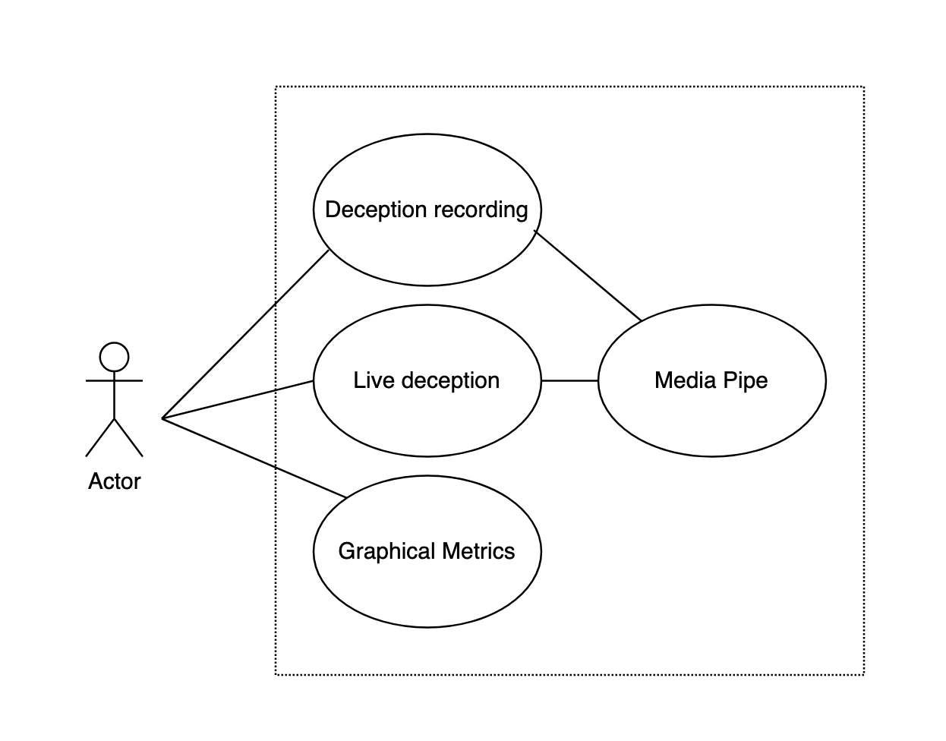
Figure 8.6.1: Illustrates various broad class interactions planned to be implemented within the web application.

DETECT - Web
User: Represents both participants and researchers interacting with the DETECT system. This class is responsible for managing authentication, user sessions, and access control, ensuring secure and seamless usage of the system's functionalities.
Deceptive Video Recording: Captures video footage of participants during scenarios where deceptive behavior may occur. These recordings form the core dataset used for behavioral analysis and pattern detection.
Graphical and Exportable Metrics: Generates visual representations such as charts and graphs based on the recorded data—highlighting patterns like gaze movement or facial cues. Researchers can export these insights for deeper analysis or formal reporting.
MediaPipe: Integrates Google’s MediaPipe framework to analyze video recordings in real time. It extracts key facial and behavioral features, laying the groundwork for future enhancement of deception detection capabilities.

8.6.2 Sequence Diagram
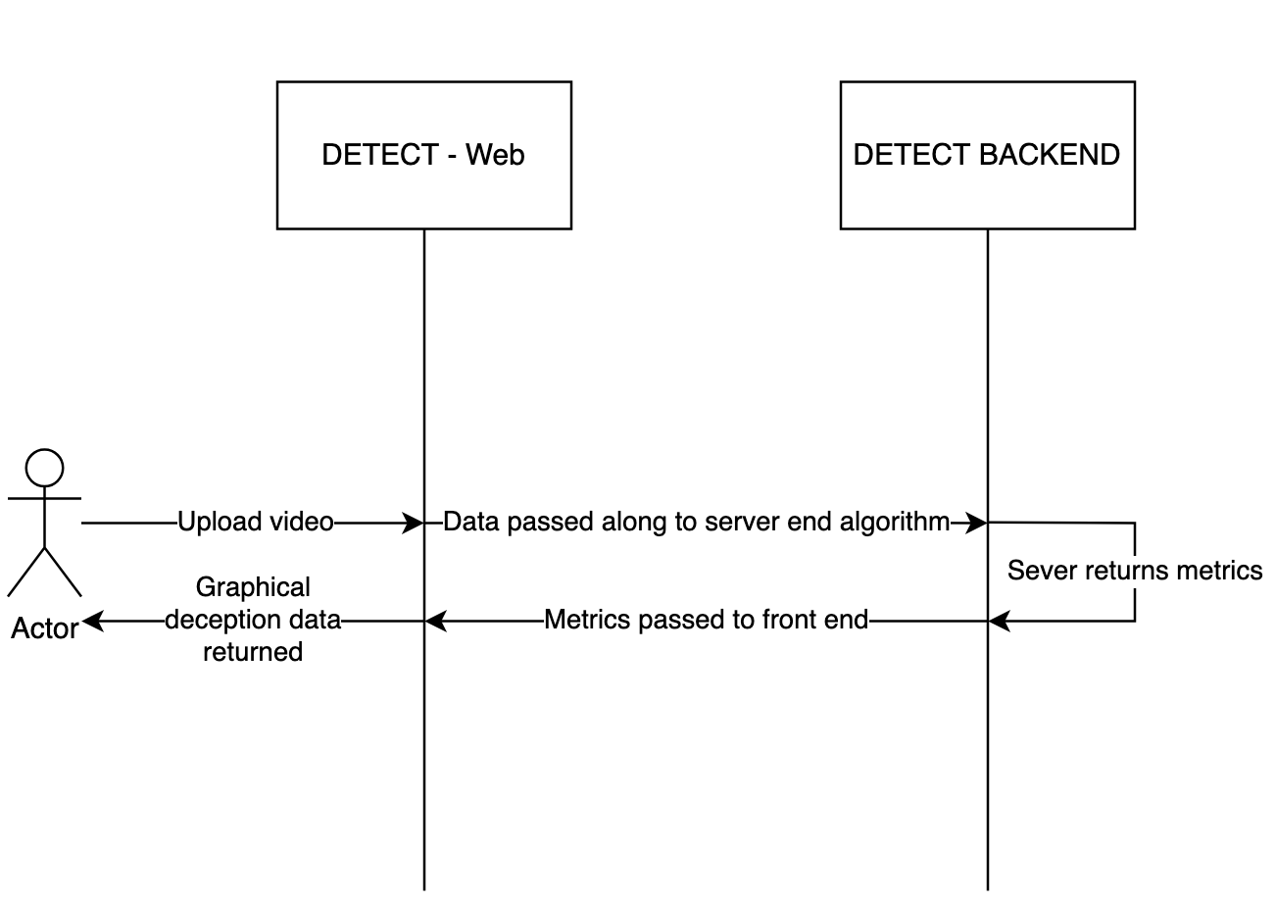
Figure 8.6.2: Illustrates a basic sequence of interactions between the front end of the web application and the backend that hosts the algorithm..
DETECT-WEB:
Serves as the front-end interface of the DETECT system, allowing users (researchers and participants) to upload video recordings and view deception analysis results. It manages user interaction, handles video submissions, and displays graphical deception metrics. DETECT-WEB forwards uploaded content to the backend for processing and presents the returned metrics in a visual format for interpretation.
DETECT-BACKEND:
Operates as the processing engine of the system. It receives video data from the front end, processes it using computer vision techniques via MediaPipe, and extracts relevant behavioral metrics. The backend generates deception-related insights, returns graphical data to the front end, and may also handle data storage and metric export functionality.

8.6.4 Block Diagram
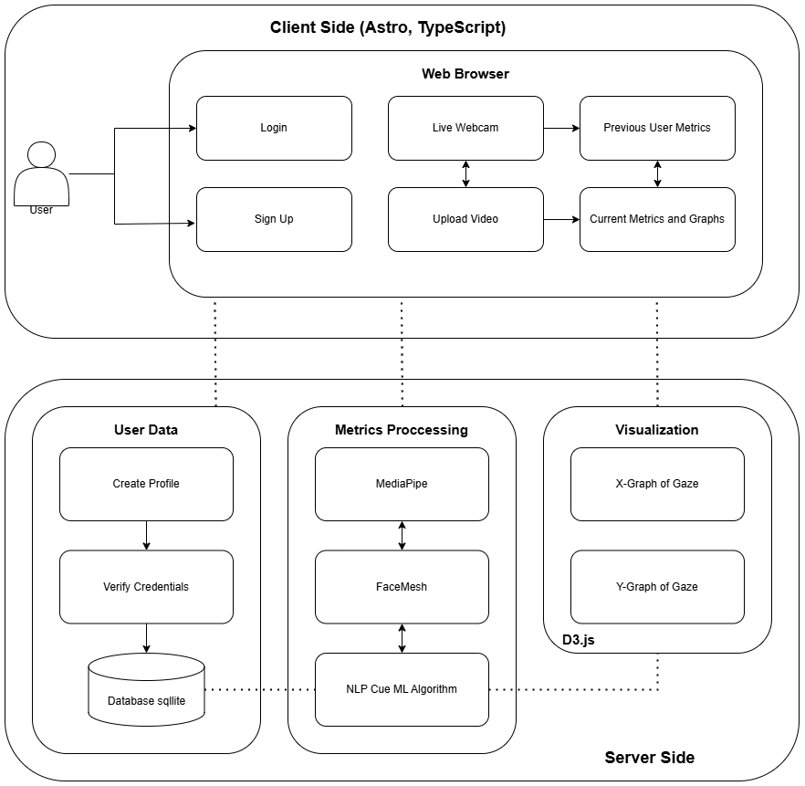
Figure 8.6.4: Block Diagram of DETECT-Web
NLP Cues

8.6.5 Peer Review of UML Diagrams
The peer review of UML diagrams has played a crucial role in maintaining the integrity and clarity of project designs. The team adopted a collaborative approach, conducting reviews during both in-person meetings and remotely via Discord, allowing for flexible and efficient feedback cycles.
The peer review sessions have several goals, including:
Ensuring Design Quality: By having multiple team members review each UML diagram, errors are caught early, inconsistencies are identified, and overall design clarity is improved.
Promoting Collaboration: Reviewing UML diagrams collectively allows the team to utilize each member’s expertise, leading to more robust and thoughtful designs. The diverse skill sets within the team ensure that different aspects of the diagram (from logic flow to system interactions) are scrutinized from various angles.
Maintaining Standards: All diagrams are reviewed to ensure conformity with project standards, maintaining consistency and alignment with the established system requirements.
In-Person Reviews: During the weekly in-person meetings, led by Adam Bawatneh, dedicated time is allocated specifically for reviewing UML diagrams as a team. These sessions facilitate real-time walkthroughs of the diagrams, allowing for immediate questions and feedback.
Remote Reviews via Discord: Between face-to-face meetings, Discord is utilized to continue discussions and reviews. This remote platform provides flexibility to share UML diagrams asynchronously, enabling participation regardless of individual schedules. Screenshots or links to the diagrams are posted, and team members leave comments or suggest changes.
By integrating in-person discussions with asynchronous feedback on Discord, the peer review process ensures that UML diagrams maintain a high standard of quality. This combined approach fosters a collaborative effort that enhances the consistency and reliability of the overall system design.

9. Research and Data Collection
The Research and Data Collection section forms the backbone of the DETECT project, outlining the foundational studies and methodologies that underpin the development of the AI-driven lie detection system. This section is bifurcated into two primary domains: Initial Research, which investigates existing lie detection techniques and explores eye-related cues in deception detection; and UML Documentation and Sequence Diagrams, encompassing the creation of class diagrams, sequence diagrams, and the peer review process for UML artifacts. Together, these components ensure a comprehensive approach to gathering and structuring the necessary data for effective system implementation.

9.1 Initial Research
The Initial Research subsection, focuses on surveying and analyzing current lie detection methodologies and identifying key eye-related indicators of deception. This research aims to evaluate the efficacy and reliability of various existing techniques, providing a critical foundation upon which the DETECT system is built. By synthesizing findings from previous studies and identifying gaps in current approaches, this initial phase ensures that the project leverages proven strategies while innovating in areas where improvement is needed.

9.1.1 Existing Lie Detection Techniques
Deception detection encompasses the investigative practices employed to assess an individual’s truthfulness and credibility. This assessment typically relies on a combination of behavioral and physiological cues, alongside contextual and situational information (Ekman, n.d.; Vrij et al., 2022). Historically, deception detection has evolved significantly, transitioning from non-scientific methods such as the Salem Witch Trials to more biologically-oriented approaches like phrenology and graphology. In contemporary settings, lie detection methodologies integrate behavioral psychology with advanced technological tools, including polygraphs and artificial intelligence systems (Brennen & Magnussen, 2022; Vrij et al., 2022).
One of the pioneering figures in the field, Dr. Paul Ekman, has extensively researched the nonverbal communication of emotions, particularly focusing on facial expressions and body language as indicators of deceit (Ekman, n.d.). Ekman’s work introduced the concept of micro-expressions—brief, involuntary facial expressions that can reveal genuine emotions despite attempts to conceal them. These micro-expressions are considered valuable in identifying deceptive behavior, although their interpretation requires careful analysis to avoid misjudgments (Ekman, n.d.; Vrij et al., 2022).
From the late 1970s onwards, research in verbal lie detection has focused on analyzing speech content to identify deception. Initial studies examined individual words and linguistic patterns associated with lying, such as increased use of exclusive words (e.g., "without," "except," "but") and generalizing terms (e.g., "always," "never") (Vrij et al., 2022). Meta-analyses have shown that lie tellers tend to use more exclusive words than truth tellers, although other verbal cues like self-references and negative emotions have not consistently distinguished liars from truth-tellers (Vrij et al., 2022).
A significant advancement in verbal lie detection came with the development of Criteria-Based Content Analysis (CBCA) in the late 1980s. CBCA involves evaluating statements based on a standardized list of verbal criteria that are more frequently present in truthful accounts than in deceptive ones (Vrij et al., 2022). Meta-analyses have demonstrated that CBCA can effectively discriminate between truth-tellers and lie-tellers, with effect sizes indicating moderate to large differences (Vrij et al., 2022). However, the practical application of CBCA is limited by factors such as high false alarm rates and the need for extensive training (Vrij et al., 2022).
Following CBCA, other veracity assessment tools like Reality Monitoring (RM) and Scientific Content Analysis (SCAN) were introduced. RM focuses on the distinction between memories of real experiences and imagined events, emphasizing the richness of sensory and contextual details in truthful statements (Vrij et al., 2022). SCAN, on the other hand, lacks standardization and has shown inconsistent results in empirical studies, making it a less reliable tool for deception detection (Vrij et al., 2022).
In the mid-2000s, interview protocols aimed at enhancing or eliciting verbal cues to deception emerged, including Strategic Use of Evidence (SUE), Verifiability Approach (VA), Cognitive Credibility Assessment (CCA), and Reality Interviewing (RI) (Vrij et al., 2022). These protocols leverage cognitive differences between truth-tellers and liars, such as the increased cognitive load experienced by liars during interviews. SUE, for instance, involves the strategic introduction of evidence to identify inconsistencies in a suspect’s account, thereby enhancing deception detection accuracy (Vrij et al., 2022).
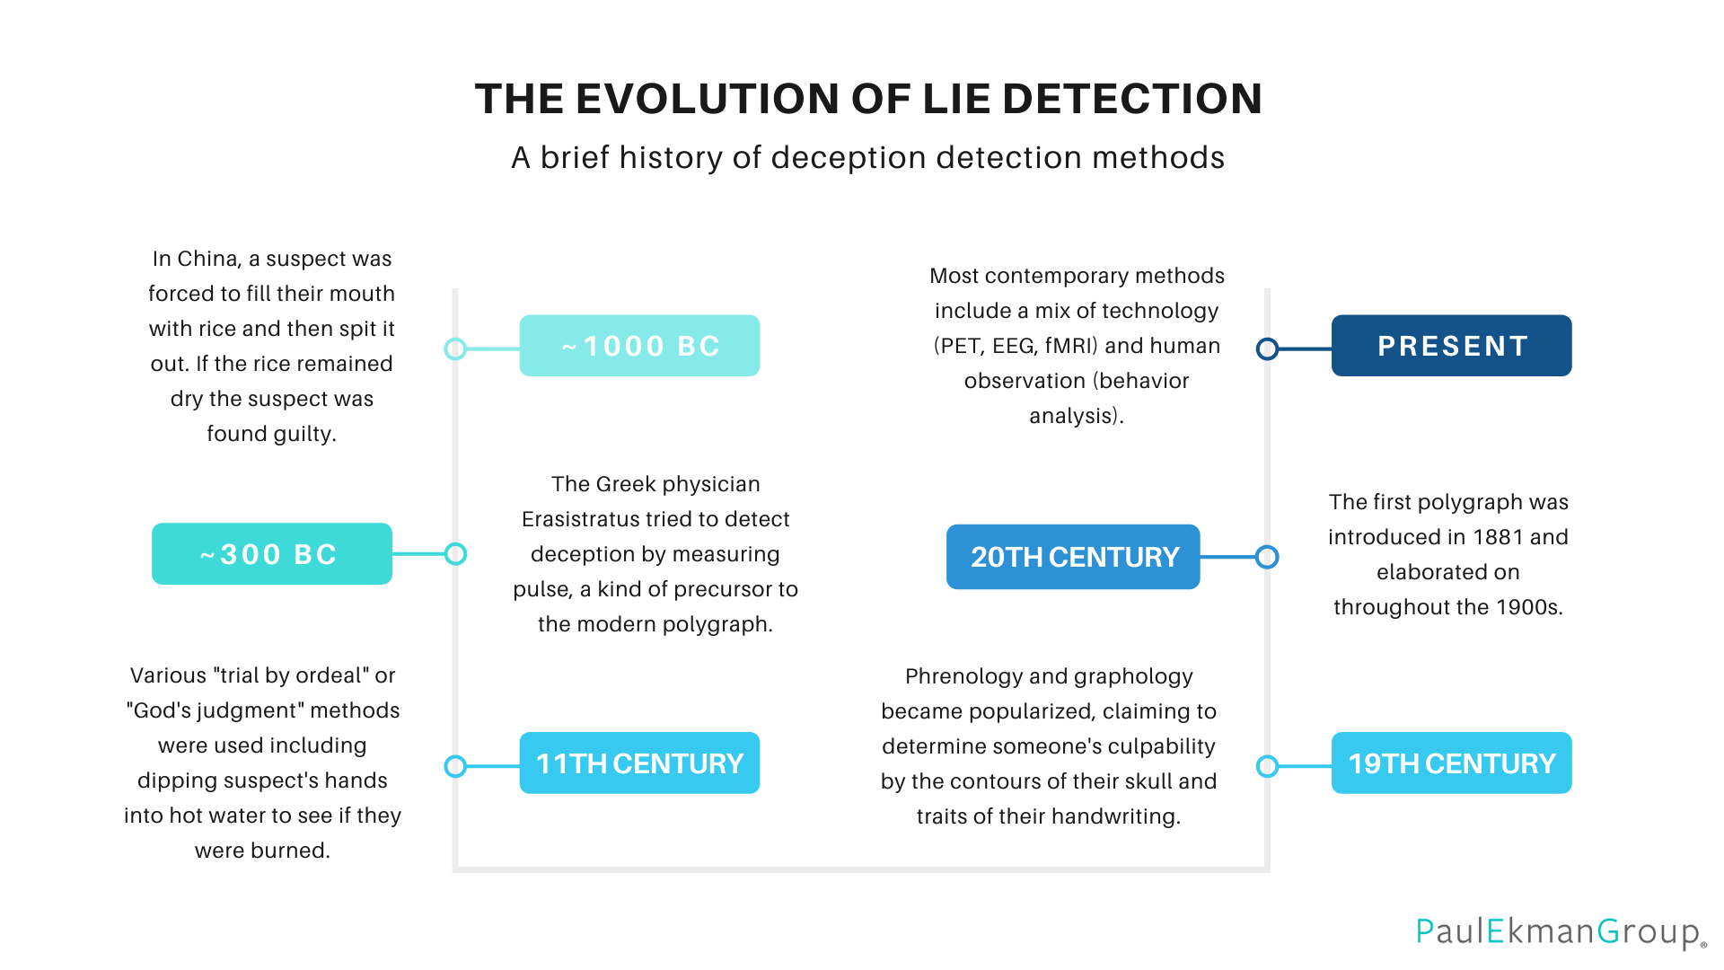
Figure 9.1.1 illustrates the historical progression of lie detection methods, highlighting key developments from early non-scientific practices to modern technological approaches.
Despite these advancements, deception detection remains fraught with challenges. There is no single, definitive sign of deceit; no muscle twitch, facial expression, or gesture can conclusively prove that someone is lying (Brennen & Magnussen, 2022). Modern methods, therefore, rely on a combination of cues to enhance accuracy. Polygraph tests measure physiological responses such as heart rate, blood pressure, and skin conductivity, operating on the premise that lying induces stress, which manifests in these physiological changes (Iacono & Ben-Shakhar, 2019). However, polygraphs are controversial due to their susceptibility to false positives and the influence of countermeasures employed by individuals attempting to deceive the test (Brennen & Magnussen, 2022).
In addition to polygraphs, recent research has explored the application of machine learning and artificial intelligence in deception detection. Automated systems analyze verbal and nonverbal cues with the potential to surpass human accuracy levels. For example, studies have demonstrated that machine-learning algorithms can classify truthful and deceptive statements with higher accuracy compared to human judges, though challenges such as overfitting and the need for large, diverse datasets remain (Brennen & Magnussen, 2022; Krishnamurthy et al., 2023).
Building upon the foundation of existing methodologies, the DEtECt project endeavors to take the next step in the evolution of lie detection, offering a more robust and versatile tool that builds on the strengths of both behavioral analysis and technological advancement by focusing on the integration of eye-tracking technologies with advanced machine learning algorithms, DEtECt seeks to enhance the objectivity and reliability of deception detection. This approach intends to mitigate issues such as high false positive rates and the need for extensive training associated with methods like CBCA and polygraphs. Additionally, DEtECt aspires to provide a scalable solution that can be effectively deployed in various settings, from security screenings to forensic interviews, thereby advancing the field towards more accurate and practical applications.

9.1.2 Eye-Related Cues in Deception Detection
Eye-related cues have garnered significant attention in the realm of deception detection due to their nonverbal nature and the rich information they convey about an individual's cognitive and emotional states. Unlike verbal cues, which can be consciously manipulated, eye-related indicators often reflect involuntary responses, making them valuable for identifying deceit. This section delves into the primary eye-related cues—blink rate, pupil dilation, and saccadic eye movements—and explores their theoretical underpinnings and empirical findings in the context of deception detection.

Blink Rate
Blink rate and blink duration are among the most extensively studied eye-related cues in deception research. Elevated cognitive load, which is frequently experienced during deceptive responses, has been linked to alterations in blinking behavior. Marchak (2013) demonstrated that individuals with false intent exhibit a reduced blink count difference, fewer blinks overall, and shorter maximum blink durations compared to those with truthful intent. These findings suggest that deceptive individuals may suppress blinking as a subconscious effort to manage increased cognitive demands associated with lying.
Furthermore, excessive blinking has been associated with heightened anxiety levels, a common emotional state experienced during deception. Rumble (2023) highlighted that while normal blinking serves as a physiological necessity, excessive blinking can indicate stress or discomfort, which may be elicited by the act of lying. However, it is crucial to contextualize blink-related cues, as factors such as fatigue or environmental conditions can also influence blinking behavior (Rumble, 2023).

Pupil Dilation
Pupil dilation serves as a robust indicator of cognitive and emotional arousal, both of which are integral to the deception process. Vrij et al. (2022) emphasized that pupil diameter increases in response to the sympathetic nervous system activation, which occurs during the cognitive effort required to fabricate lies. This physiological response is consistent with findings from Ganis et al. (2003), who reported that lying is associated with more extensive long-term memory (LTM) search compared to truth-telling. The increased LTM retrieval demands during deception lead to greater cognitive load, resulting in observable changes in pupil size.
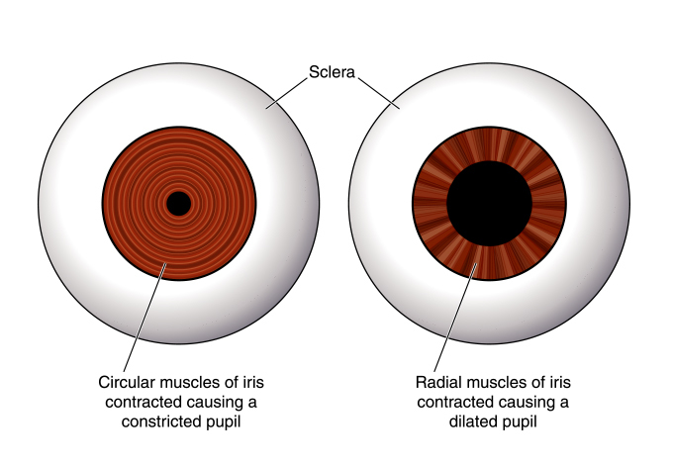
Figure 9.1.2: Illustration comparing a normal pupil with a dilated pupil.
Moreover, pupil dilation can be a subtle yet reliable marker of deceit, as it often occurs rapidly and may go unnoticed without specialized equipment. However, the interpretation of pupil dilation must account for individual differences and external factors such as lighting conditions, which can independently affect pupil size (Marchak, 2013).

Saccadic Eye Movement
Saccadic eye movements, characterized by rapid, involuntary shifts in gaze direction, have emerged as a novel and promising cue in deception detection research. Vrij and colleagues (2012) introduced the concept of non-visual saccadic eye movement rate (EMR) as a potential indicator of deceit. Their research posits that saccadic movements are closely tied to information retrieval processes in LTM. Specifically, tasks that require intensive memory search generate increased saccadic activity (Ehrlichman & Micic, 2012).
In their experiment, Vrij et al. (2012) found that participants exhibited a higher rate of non-visual saccadic eye movements when lying spontaneously compared to when they were truthful. This finding aligns with the hypothesis that lying necessitates more extensive cognitive processing and memory retrieval, thereby increasing saccadic activity. Schuetzler (2012) further explored the robustness of saccadic eye movements as deception cues, noting that even when participants employ countermeasures, certain patterns of saccadic activity remain indicative of deceit.

Countermeasures and Robustness of Eye-Tracking Methods
The effectiveness of eye-related deception cues can be undermined by countermeasures—deliberate attempts by individuals to manipulate their physiological and behavioral responses to appear truthful. Schuetzler (2012) investigated the impact of countermeasures on eye-tracking-based deception detection and found that participants trained in specific techniques, such as biting their tongues or counting backward, could significantly reduce the distinctiveness of their eye movement patterns. This susceptibility highlights the necessity for deception detection systems to incorporate multiple nonverbal and physiological indicators to mitigate the effectiveness of such countermeasures.
Moreover, integrating machine learning algorithms with eye-tracking data can enhance the resilience of deception detection methods against countermeasure strategies. By analyzing complex patterns and combinations of eye-related cues, systems like DEtECt aim to identify deceit with greater accuracy, even in the presence of intentional behavioral manipulations (Schuetzler, 2012).
The DEtECt project is at the forefront of leveraging eye-related cues for advanced deception detection. While the primary focus of DEtECt is on analyzing gaze patterns, the project also recognizes the potential of incorporating additional eye-related metrics such as blink rate and pupil dilation as stretch goals. These metrics, supported by substantial research, offer complementary insights into the cognitive and emotional states associated with deceit. By integrating blink rate and pupil dilation analyses, DEtECt aims to enhance its deception detection capabilities, creating a more comprehensive and robust system. However, the current emphasis remains on developing sophisticated algorithms to interpret gaze patterns, which serve as the foundational elements of the project's detection framework.

9.2 Tech Stack
Developing a lie detection tool using real-time eye tracking demands a high-performance technology stack capable of processing live data with minimal latency. Each component must efficiently manage resources, seamlessly integrate libraries, and ensure a responsive user experience. The following subsections outline the selected technologies, including their strengths, limitations, and suitability for the DETECT project.

9.2.1 Database
The DETECT project requires a database system that prioritizes lightweight, efficient storage with real-time data logging and retrieval capabilities. This subsection evaluates database options, focusing on structured data needs, data integrity, and system requirements.

SQL vs. NoSQL
Given the structured and relational nature of DETECT’s data—such as gaze metrics, timestamps, and session information—SQL databases present distinct advantages. SQL-based systems offer schema-based organization and ACID compliance, ensuring data consistency and reliability. This is essential for maintaining accurate metrics in deception detection. While NoSQL solutions like MongoDB handle unstructured data well, they introduce complexity when managing relational data, making SQL databases a more suitable choice for DETECT.

Potential Database Solutions
- SQLite: A serverless relational database that provides a lightweight design and portability. Its embedded architecture minimizes resource use, making it suitable for single-user applications and environments with low concurrency needs, aligning well with DETECT’s current scope.
- PostgreSQL: An open-source relational database known for handling complex queries and large datasets. Its server-based setup and robust concurrency support offer advanced data integrity features. However, PostgreSQL’s setup requirements and resource demand may exceed DETECT’s current needs.
- MySQL: Widely used for medium-scale applications, MySQL provides stability and supports multi-user environments. While suitable for projects with transactional processing needs, its server-based architecture introduces complexity beyond DETECT’s initial requirements.
- Cloud-Based SQL Solutions: Managed SQL services, such as AWS RDS and Google Cloud SQL, offer automated scalability and maintenance, benefiting projects with evolving data demands. However, their reliance on network connectivity and cost structure make them less practical for DETECT’s initial single-user setup.

Comparative Analysis and Selection
Based on resource efficiency, ease of deployment, and suitability for real-time single-user data handling, SQLite is identified as the optimal choice for DETECT’s database. Its embedded structure supports efficient data storage and retrieval, minimizing overhead. While PostgreSQL, MySQL, and cloud solutions provide scalability and multi-user support, they introduce unnecessary complexity at this stage.

Future Considerations
As DETECT’s data requirements expand, upgrading to a more scalable database like PostgreSQL or a managed cloud solution may be beneficial. This shift would enhance multi-user support and allow for increased data handling capabilities. SQLite’s compatibility with SQL-based migration tools ensures DETECT can transition to a scalable architecture seamlessly if necessary.

9.2.2 Backend
The DETECT project’s backend requires a high-performance language capable of handling real-time data processing with minimal latency. Go, a statically typed, compiled language developed by Google, was selected for its efficiency in managing concurrent operations and low-latency data processing. Go's performance advantages make it particularly suited for applications that require continuous data flow from backend to frontend.

Go’s Suitability for Real-Time Eye Tracking
Go is ideal for the eye-tracking deception detection project due to its speed, efficiency, and concurrency model. Unlike languages prioritizing flexibility, such as Python, Go’s performance ensures it can process eye-tracking data while maintaining smooth data flow to the front end. This low-latency environment is essential for real-time applications that depend on high responsiveness.

Comparison with Other Languages
- Flask (Python): While Flask offers a vast library ecosystem and flexibility for smaller applications, it lacks Go's native concurrency support. Flask would require additional asynchronous libraries, such as Celery, for concurrent tasks, which could add complexity and slow response times in real-time applications.
- Express (JavaScript): Known for its simplicity and non-blocking I/O model, Express is widely used in JavaScript-based tech stacks. However, Express relies on a single-threaded, asynchronous model, which may not handle large volumes of data processing as efficiently as Go's multithreaded design. Go’s goroutines allow for more efficient data processing and parallel operations in applications with high-frequency data requirements, such as real-time eye tracking.

Application of Go in DETECT
Go’s concurrency, low-latency processing, and efficient data handling capabilities align well with DETECT’s demands. For tasks like continuous webcam frame capture, gaze tracking analysis, and real-time UI updates, Go’s goroutines enable parallel processing with minimal resource use, ensuring data flows smoothly from the backend.

Supporting Real-Time Data Flow
Go’s standard library includes strong support for APIs and WebSocket connections, facilitating real-time data streaming. By leveraging WebSockets, DETECT can push real-time eye-tracking data to the front end, allowing users to see analysis results with minimal delay. This instant feedback is vital for an interactive lie detection application, where user experience relies on immediate responses.

Deployment and Scalability
Go’s cloud-friendly design simplifies deployment and allows for seamless scalability. As DETECT’s needs grow, Go can easily handle an increase in client connections and data processing demands. This scalability is essential for applications that may expand to include more complex analyses or multi-user support.

Utilizing the Gochi Package
The Gochi package enhances Go’s web capabilities by providing a structured framework for routing, middleware, and context handling, similar to how frameworks like Flask and Express organize HTTP requests. Gochi’s features enable DETECT to manage participant sessions, control video data flow, and implement secure protocols necessary for IRB compliance. With middleware support, Gochi monitors requests, ensuring that each application component operates within specified guidelines.
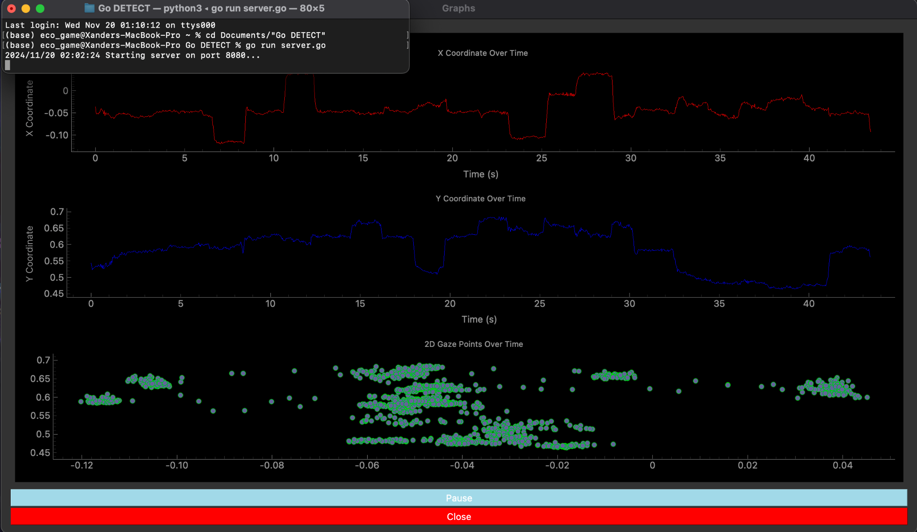
Figure 9.2.2: Display of Go server running with an API call to run the Python eye-tracking model

Summary
Go’s performance, concurrency model, and scalability make it an optimal backend choice for DETECT, capable of supporting real-time data flow and user interactions. Gochi adds essential routing and security features, ensuring reliable, responsive backend infrastructure.

9.2.3 Frontend
Astro is a modern web framework designed to build fast, high-performance websites by minimizing JavaScript load and employing a unique island architecture. Unlike traditional frameworks, which often load entire JavaScript bundles for each page, Astro adopts a "zero-JS" approach on the server side, ensuring that only essential JavaScript is loaded for interactive components. This selective and lean rendering approach positions Astro as an ideal solution for applications with demanding resource requirements, such as real-time eye-tracking systems.
Astro’s attributes make it particularly suitable for applications that prioritize performance, technology compatibility, and ease of use—key considerations for a tool like a lie detection app. Below, the key features and advantages of Astro are analyzed in relation to its applicability for such projects, alongside comparisons with other frameworks.

High Performance with Minimal JavaScript Overhead
Astro’s design philosophy prioritizes performance, making it highly effective for applications that depend on live data and video processing. By leveraging its island architecture, developers can isolate interactive elements and load JavaScript only where necessary, reducing overall resource consumption. This approach minimizes load times and optimizes the application's speed, ensuring smooth operation even during real-time eye-tracking tasks.
Comparison with Other Frameworks: Traditional frameworks such as React and Vue require full JavaScript bundles, even for static content, which can lead to significant performance bottlenecks. While frameworks like Next.js and SvelteKit incorporate optimizations, Astro’s granular control over JavaScript loading surpasses these solutions, making it superior for resource-intensive applications.

Efficient Resource Allocation through Island Architecture
Astro’s island architecture further enhances resource efficiency by allowing selective JavaScript execution. For a project like a lie detection app, which involves processing real-time webcam feeds and eye-tracking modules, this capability ensures that resource-heavy components operate independently without compromising the performance of other elements on the page.
Comparison with Other Frameworks: Frameworks such as Angular and Vue often distribute JavaScript broadly across the entire page, which can overwhelm client devices in high-interactivity scenarios. Astro’s targeted loading approach addresses this limitation, enabling consistent and reliable performance for applications with real-time processing demands.

Seamless Integration with Other Technologies
Astro supports straightforward integration with external tools and libraries, which is particularly advantageous for complex applications that rely on diverse functionalities. Whether incorporating eye-tracking libraries, webcam modules, or other third-party tools, Astro’s compatibility across multiple front-end frameworks simplifies the development process.
Comparison with Other Frameworks: While Next.js and other frameworks provide robust integration options, Astro’s streamlined implementation and cross-framework compatibility reduce configuration challenges, allowing developers to focus on building features without being hindered by technical overhead.

Accessible and Intuitive Syntax
Astro’s syntax is designed for simplicity and accessibility, resembling HTML closely. This makes it a practical choice for teams with varying levels of experience in modern JavaScript frameworks. Its user-friendly syntax facilitates rapid setup, prototyping, and iteration, enabling developers to allocate more time to refining the app’s complex eye-tracking algorithms.
Comparison with Other Frameworks: React and Angular, for instance, rely on advanced concepts like JSX and TypeScript, which can present a steep learning curve for newcomers. Astro’s familiar, HTML-like syntax eliminates this barrier, accelerating the development process and making it easier to produce high-quality, efficient applications.

Summary
Astro’s performance-centric approach, efficient resource management through island architecture, and flexibility in integrating third-party tools make it an excellent framework for resource-intensive, real-time applications like a lie detection app. Its accessible syntax further enhances its appeal, enabling rapid development while maintaining a focus on performance and usability. By leveraging Astro, developers can strike an optimal balance between speed, interactivity, and resource efficiency, creating a robust foundation for complex front-end projects.

9.2.4 Runtime Environments and Frameworks
Effective frontend frameworks for the project must support real-time interactivity, high performance, and efficient resource management to ensure seamless functionality for eye-tracking tasks. WebAssembly is assessed for its capability to execute computationally intensive operations at near-native speeds, while PyScript is considered for its potential to leverage Python’s rich library ecosystem within the browser environment. This evaluation focuses on the technical strengths, limitations, and applicability of each solution in addressing the project’s requirements for real-time processing and responsive interfaces.

9.2.4.1 Webassembly
WebAssembly (Wasm) introduces a groundbreaking capability in web development by enabling high-performance applications to run natively in web browsers. Defined as a low-level, binary instruction format, WebAssembly is optimized for near-native execution speeds, bridging the gap between the performance of traditional web technologies and native applications. It supports a range of languages, such as C, C++, and Rust, allowing developers to compile system-level code into browser-executable binaries. This efficiency makes WebAssembly especially suitable for tasks involving intensive computations like gaming, data processing, and machine learning.
WebAssembly represents a pivotal development in web standards, addressing one of the web's most significant challenges: achieving native-like performance within a browser environment. Its focus on speed, portability, and scalability positions it as a critical tool for modern, resource-intensive applications.

Origins and Development
The foundation of WebAssembly lies in its aim to create a portable, high-performance binary standard for the web. It evolved from earlier efforts like asm.js, a JavaScript subset optimized for better browser performance, yet limited by JavaScript's constraints. By offering a binary format independent of JavaScript, WebAssembly opens the web to computationally demanding applications.
WebAssembly’s development involved collaboration among major tech companies, including Mozilla, Google, Apple, and Microsoft. This collaborative effort ensured compatibility across all major browsers, cementing its role as a universal web standard. Officially becoming a W3C standard in 2019, WebAssembly continues to expand its capabilities, adapting to new demands such as improved threading, SIMD (Single Instruction, Multiple Data), and system-level integration.

WebAssembly: A Transformative Web Technology
WebAssembly (Wasm) introduces a groundbreaking capability in web development by enabling high-performance applications to run natively in web browsers. Defined as a low-level, binary instruction format, WebAssembly is optimized for near-native execution speeds, bridging the gap between the performance of traditional web technologies and native applications. It supports a range of languages, such as C, C++, and Rust, allowing developers to compile system-level code into browser-executable binaries. This efficiency makes WebAssembly especially suitable for tasks involving intensive computations like gaming, data processing, and machine learning.
WebAssembly represents a pivotal development in web standards, addressing one of the web's most significant challenges: achieving native-like performance within a browser environment. Its focus on speed, portability, and scalability positions it as a critical tool for modern, resource-intensive applications.

Origins and Development
The foundation of WebAssembly lies in its aim to create a portable, high-performance binary standard for the web. It evolved from earlier efforts like asm.js, a JavaScript subset optimized for better browser performance, yet limited by JavaScript's constraints. By offering a binary format independent of JavaScript, WebAssembly opens the web to computationally demanding applications.
WebAssembly’s development involved collaboration among major tech companies, including Mozilla, Google, Apple, and Microsoft. This collaborative effort ensured compatibility across all major browsers, cementing its role as a universal web standard. Officially becoming a W3C standard in 2019, WebAssembly continues to expand its capabilities, adapting to new demands such as improved threading, SIMD (Single Instruction, Multiple Data), and system-level integration.

Core Functionality and Interoperability
WebAssembly operates as a compiled language, translating code into a compact binary format that browsers can execute with near-native efficiency. Its architecture emphasizes portability, allowing execution on any device with a Wasm-compatible runtime, regardless of the underlying hardware.
WebAssembly's seamless integration with JavaScript is one of its standout features. Wasm modules can be imported directly into JavaScript applications, combining the performance benefits of WebAssembly with JavaScript’s ubiquity for tasks like user interaction and front-end logic. This hybrid model ensures that developers can optimize performance-heavy components without needing to rewrite entire applications.

Advantages of WebAssembly
Performance: WebAssembly’s binary format provides unparalleled execution speeds compared to JavaScript, making it indispensable for computationally intensive applications such as 3D rendering, Video editing, Scientific simulations, High-performance gaming,
Language Flexibility: Unlike JavaScript, WebAssembly supports compiling code from multiple languages, including C, C++, and Rust. This allows developers to leverage the strengths of system-level languages, such as low-level memory access, while deploying applications on the web.
Cross-Platform Accessibility: WebAssembly’s platform independence ensures that applications can run on any device with browser support, from desktops to mobile devices, without requiring additional software installations. This flexibility enhances both reach and usability, enabling developers to cater to diverse audiences seamlessly.

Applications of WebAssembly
Gaming: WebAssembly is transforming web-based gaming by delivering immersive, high-performance games directly in the browser. Its ability to handle complex physics engines and real-time rendering eliminates the need for traditional downloads.
Multimedia Processing: Applications like video editing and image filtering benefit from WebAssembly’s computational efficiency, allowing real-time effects and processing directly in the browser.
Data-Intensive Applications: WebAssembly supports scientific research and machine learning by enabling on-device computation. Researchers and students can simulate models and visualize data in real time, enhancing interactivity and accessibility without requiring specialized hardware.

Emerging Areas
WebAssembly’s secure and efficient design also suits blockchain, cryptography, and artificial intelligence (AI). For instance:
- Blockchain: Secure, high-performance ledger computations.
- AI: Real-time, browser-based model inference and analytics.

Future Developments
Advanced Features: Ongoing enhancements such as SIMD and threading support aim to improve WebAssembly’s efficiency further, particularly for parallel processing and real-time 3D rendering.
Expansion Beyond Browsers: The WebAssembly System Interface (WASI) extends Wasm’s capabilities into serverless computing and IoT environments. WASI allows WebAssembly to handle file I/O, network access, and process management, making it viable for cloud functions and embedded systems.
Integration with Web Standards: WebAssembly’s compatibility with tools like WebGPU enhances its potential for building visually complex, graphics-heavy applications. Similarly, its ability to execute machine learning models in-browser strengthens its relevance for real-time AI applications.

Conclusion
WebAssembly is a transformative technology reshaping how developers approach performance-critical web applications. Its capability to achieve native-like speeds in a browser unlocks possibilities for previously unattainable applications, from high-performance gaming to scientific simulations. By combining portability, language flexibility, and seamless JavaScript interoperability, WebAssembly blurs the line between web-based and native development.
As WebAssembly continues to evolve, its applications will expand across industries, ensuring its role as a cornerstone in the next generation of web and software development. Its integration into emerging technologies like serverless computing, AI, and IoT further underscores its potential to redefine digital experiences for both developers and users.

9.2.4.2 PyScript
Building on the foundational performance and portability of WebAssembly, PyScript emerges as an innovative tool for bringing Python applications directly into the browser. Developed by Anaconda, PyScript leverages WebAssembly and Pyodide to allow Python code to execute at near-native speeds, effectively transforming Python into a viable client-side language. This integration of Python with web development eliminates the traditional reliance on JavaScript for interactivity and empowers Python developers to extend their expertise into the web domain.

Purpose and Evolution of PyScript
PyScript addresses the growing demand for bridging Python’s computational strengths—widely recognized in data science, machine learning, and analytics—with the ubiquity of web applications. Historically, web development has revolved around JavaScript, limiting the scope of other programming languages. PyScript breaks this boundary by utilizing WebAssembly’s flexibility, enabling Python to function natively in browsers.
By abstracting the complexities of WebAssembly and offering a Python-centric interface for embedding code directly into HTML, PyScript creates an accessible platform for developers who are proficient in Python but lack experience with JavaScript. This democratization of web development supports a new class of applications where Python’s backend capabilities seamlessly integrate with the real-time interactivity of the web.

PyScript: Extending WebAssembly for Python Applications
Building on the foundational performance and portability of WebAssembly, PyScript emerges as an innovative tool for bringing Python applications directly into the browser. Developed by Anaconda, PyScript leverages WebAssembly and Pyodide to allow Python code to execute at near-native speeds, effectively transforming Python into a viable client-side language. This integration of Python with web development eliminates the traditional reliance on JavaScript for interactivity and empowers Python developers to extend their expertise into the web domain.

Purpose and Evolution of PyScript
PyScript addresses the growing demand for bridging Python’s computational strengths—widely recognized in data science, machine learning, and analytics—with the ubiquity of web applications. Historically, web development has revolved around JavaScript, limiting the scope of other programming languages. PyScript breaks this boundary by utilizing WebAssembly’s flexibility, enabling Python to function natively in browsers.
By abstracting the complexities of WebAssembly and offering a Python-centric interface for embedding code directly into HTML, PyScript creates an accessible platform for developers who are proficient in Python but lack experience with JavaScript. This democratization of web development supports a new class of applications where Python’s backend capabilities seamlessly integrate with the real-time interactivity of the web.

Key Features of PyScript
Python in HTML: PyScript simplifies the inclusion of Python code in web pages by introducing custom HTML tags like <py-script>. This intuitive interface mirrors the way JavaScript is integrated, allowing developers to write Python code alongside HTML content. This approach lowers the learning curve for web development, making it accessible to a broader audience of Python developers.
Extensive Library Support: Through Pyodide, PyScript provides access to a wide array of Python libraries, including NumPy, Pandas, and Matplotlib. These libraries enable complex computations, data transformations, and visualizations directly within the browser, removing the need for server-side infrastructure. This capability transforms the browser into a self-contained environment for scientific and analytical applications.
JavaScript Interoperability: PyScript enables seamless interaction between Python and JavaScript, facilitating tasks like DOM manipulation, event handling, and API integration. This interoperability allows developers to leverage the strengths of both languages, creating applications that are both powerful and responsive.
Real-Time Interactivity: By supporting event-driven programming, PyScript allows developers to build applications that respond dynamically to user input, such as clicks, keystrokes, and mouse movements. This feature is crucial for creating data visualizations, educational tools, and simulations, where immediate feedback enhances the user experience.
Built-In Package Management: PyScript includes a virtual environment manager that simplifies dependency management. Developers can specify Python packages within HTML, and PyScript ensures that all dependencies are loaded and available in the browser. This feature eliminates the need for additional installations, making applications portable and easy to distribute.

Architecture of PyScript
At its core, PyScript relies on Pyodide, a WebAssembly-based distribution of Python. By compiling Python to WebAssembly, Pyodide delivers efficient execution speeds while maintaining compatibility with Python’s extensive ecosystem. PyScript extends this foundation with a user-friendly HTML interface, enabling developers to embed Python code and manage dependencies effortlessly.
The architecture also includes a JavaScript-Python bridge, facilitating bi-directional communication between the two languages. This interoperability underpins many of PyScript’s advanced features, such as DOM manipulation and event handling, ensuring that developers can create rich, interactive applications without compromising on performance or flexibility.

Applications of PyScript
Data Visualization: PyScript excels in creating interactive data dashboards by leveraging Python’s visualization libraries. These dashboards enable users to explore and analyze data dynamically within a web-based interface, making insights more accessible and engaging.
Educational Tools: Python’s popularity in teaching programming and data science makes PyScript an ideal platform for interactive educational resources. Educators can create browser-based lessons, exercises, and simulations, eliminating the need for students to install Python locally.
Rapid Prototyping: For developers and researchers, PyScript simplifies the prototyping process by enabling the execution of Python code directly in the browser. This capability supports quick iteration and testing of ideas without the overhead of setting up a backend.
Computational Notebooks: Inspired by Jupyter notebooks, PyScript allows developers to build interactive browser-based notebooks that integrate code, visualizations, and widgets. These notebooks are ideal for sharing research findings or demonstrating machine learning models.
Lightweight Analytics: Small businesses and individual users can use PyScript to create custom analytics tools that run entirely in the browser. These tools support real-time data analysis and visualization without requiring server infrastructure, providing a cost-effective solution for data-driven decision-making.

Advantages of PyScript
Privacy and Local Execution: By running all computations in the client’s browser, PyScript minimizes the need for server-side processing. This local execution model enhances data privacy and reduces latency, making PyScript particularly valuable for sensitive applications.
Accessibility: PyScript’s ease of deployment—requiring only a web browser—broadens its accessibility to users who may lack the technical expertise to install software or manage dependencies.
Integration with Python’s Ecosystem: PyScript brings the power of Python’s libraries into the browser, enabling developers to leverage familiar tools for tasks ranging from numerical analysis to machine learning.
Real-Time Interactivity: By supporting event handling and DOM manipulation, PyScript enables the creation of highly interactive applications that provide immediate feedback to users.

Challenges and Limitations
Despite its potential, PyScript faces several challenges:
- Performance Overheads: Running Python in a browser, even with WebAssembly, introduces additional layers of complexity, making it less efficient than JavaScript for certain tasks.
- Library Compatibility: PyScript relies on Pyodide, which supports a subset of Python libraries. Packages with system-level dependencies may not function correctly in a browser environment.
- Memory Usage: Loading Python and its libraries into the browser can result in high memory consumption, particularly on low-resource devices.
- Debugging Complexity: Tools for debugging WebAssembly-based Python applications are not as mature as those for JavaScript, increasing development complexity.

Conclusion
PyScript represents a significant step forward in making Python a first-class language for web development. By combining the computational power of Python with the accessibility and interactivity of the web, PyScript opens new possibilities for creating rich, data-driven applications. While challenges remain, particularly around performance and library compatibility, the advantages of PyScript—its ease of use, privacy-focused execution, and integration with Python’s ecosystem—make it a compelling choice for a wide range of use cases.
As the PyScript ecosystem evolves, it is poised to become an integral tool for developers seeking to build accessible, interactive, and computationally robust web applications. Its reliance on WebAssembly highlights its position as a natural extension of the technology, bringing Python’s versatility into the web development space with unprecedented ease and efficiency.

9.2.4.3 PyScript vs. WebAssembly
The DETECT project’s real-time video processing and eye-tracking requirements necessitated an in-depth exploration of potential browser-based technologies. PyScript and WebAssembly (Wasm) were identified as two promising tools, each offering distinct strengths and limitations when integrating Python functionality into a web environment. This comparative analysis ultimately reveals that transitioning to a JavaScript-based solution is the optimal direction for the project to address performance challenges while retaining flexibility for future development.

Performance Testing: Evaluating Real-Time Viability

Frame Rate (FPS): A Clear Indicator of Real-Time Usability
Maintaining high frame rates is crucial for real-time video processing:
- PyScript struggled with an average of 4–5 FPS, which caused noticeable stuttering and rendered it impractical for eye tracking.
- WebAssembly achieved a smooth 50–60 FPS, demonstrating its ability to handle continuous frame processing with minimal lag.
The results highlight a significant performance gap between Python-based solutions and JavaScript-based frameworks that leverage WebAssembly's efficiency.

Memory Usage: Efficiency for Browser Applications
Efficient memory use is critical for applications running across devices:
- PyScript consumed 18–20 MB, largely due to the overhead of Pyodide’s emulated Python runtime.
- WebAssembly demonstrated a compact 1.5–2 MB memory footprint, showcasing its suitability for resource-constrained environments.

CPU Utilization: Reducing Device Strain
Real-time applications must balance CPU usage to maintain responsiveness:
- PyScript exhibited high CPU usage at 70–80%, resulting from the interpreted nature of Python.
- WebAssembly efficiently reduced CPU demands to 20–25%, leveraging precompiled binaries for faster execution.

Latency: Ensuring Immediate Feedback
Low latency is essential for real-time accuracy:
- PyScript exhibited a 200–300 ms delay, significantly impairing real-time tracking.
- WebAssembly achieved a responsive 30–50 ms, providing immediate feedback.
These findings collectively demonstrate the challenges posed by Python’s inherent overhead, especially in resource-intensive scenarios like real-time video analysis.

Developer Accessibility vs. Performance Priorities
PyScript offers a straightforward solution for running Python in the browser, with seamless access to Python libraries and simple integration into HTML. However, the performance trade-offs—high memory and CPU usage, low FPS, and significant latency—disqualify it as a viable choice for DETECT’s high-demand use case. While ideal for prototyping or academic tools, PyScript cannot meet the responsiveness requirements of real-time eye tracking.
WebAssembly provides unmatched performance by precompiling code into binary format for near-native execution. Its complexity, requiring development in low-level languages like C++ or Rust, poses a steep learning curve. While WebAssembly could be leveraged within a broader JavaScript ecosystem to optimize critical tasks, it does not inherently dictate the entire solution. Instead, it reinforces the need for JavaScript as a foundation, offering both versatility and compatibility.

Implications for the DETECT Project
The comparison underscores a pivotal realization for the DETECT project: Python’s overhead limits its feasibility for real-time applications. Transitioning to a JavaScript-based architecture minimizes these limitations and opens the door to scalable, high-performance solutions. While WebAssembly remains an attractive option for specific tasks requiring optimized execution, the project’s direction is not fixed on adopting WebAssembly exclusively. Rather, this shift represents a commitment to leveraging JavaScript’s flexibility to address performance bottlenecks.
Key takeaways guiding this transition:
- JavaScript minimizes overhead and ensures compatibility with modern browser environments.
- Flexibility in tooling allows the project to explore frameworks such as React, Vue, or Astro, alongside technologies like WebAssembly for performance-critical components.
- Future scalability is enhanced through JavaScript’s extensive ecosystem, which includes robust libraries for video processing and real-time interactivity.

Conclusion: A Strategic Shift Toward JavaScript
The DETECT project’s evaluation of PyScript and WebAssembly highlights a decisive need to move away from Python’s limitations and adopt a JavaScript-based solution for real-time processing. While WebAssembly demonstrated significant advantages over PyScript, the broader takeaway is that a JavaScript architecture aligns better with DETECT’s objectives, balancing developer accessibility, performance, and scalability.
This transition sets the stage for DETECT to explore a modular JavaScript implementation that integrates the most effective tools for its requirements. By prioritizing a foundation that minimizes overhead and maximizes responsiveness, DETECT ensures a robust framework for delivering real-time eye-tracking capabilities within a browser environment.

9.2.4.4 Bun
The DETECT project’s shift to a JavaScript-based architecture demands a runtime that ensures speed, efficiency, and ease of development for real-time video processing. After evaluating available JavaScript runtimes, Bun was selected over more traditional options like npm and Deno. Bun’s performance-focused design and built-in features align with DETECT’s requirements for a responsive and streamlined development process, making it an ideal choice for managing and executing the project’s computationally intensive tasks.

Evaluating JavaScript Runtimes for DETECT
JavaScript runtimes like Bun, npm, and Deno each serve the core purpose of enabling JavaScript code execution while offering different strengths. Bun, as a modern and performance-driven runtime, distinguishes itself by integrating essential development tools directly into its architecture. This minimizes delays and simplifies workflows, making it particularly suitable for real-time applications like DETECT’s eye-tracking system.
npm, the default package manager for Node.js, is widely used and reliable but often suffers from slower execution due to its reliance on additional tools like Webpack for tasks such as bundling and building. While npm is robust for general-purpose development, it introduces latency that can hinder the responsiveness required for DETECT.
Deno, a newer runtime created to address some of Node.js’s limitations, improves security and simplifies the use of modern JavaScript. However, Deno’s performance and tooling still fall short of Bun’s capabilities, making it less practical for the high-speed requirements of DETECT’s real-time video processing.

Why Bun Fits DETECT’s Requirements
Bun’s design prioritizes speed and simplicity, addressing key performance bottlenecks that other runtimes face. Its capabilities enable the efficient processing of video data, making it well-suited for DETECT’s real-time needs.

Performance at Its Core
Bun delivers significantly faster execution compared to npm and Deno, largely due to its low-level implementation in Zig, a language designed for performance and resource control. This speed ensures smoother processing of video frames and reduces delays during real-time eye-tracking analysis. For DETECT, this translates to a more seamless user experience, with lower latency and consistent responsiveness.
In contrast, npm’s reliance on external tools for tasks like bundling increases latency, while Deno, though faster than npm in some scenarios, lacks Bun’s raw efficiency. Bun’s ability to handle high computational loads efficiently sets it apart, making it the optimal runtime for DETECT’s video-based application.

Integrated Tools for Development
Bun streamlines development by incorporating tools for managing dependencies, bundling code, and running scripts directly into its runtime. This eliminates the need for external frameworks, reducing setup complexity and allowing developers to focus on enhancing application functionality.
npm requires third-party tools like Webpack for tasks that Bun handles natively, which increases the complexity of managing and deploying the application. Deno offers some built-in features but does not provide the same level of integration or performance as Bun. For DETECT, Bun’s all-in-one approach simplifies the development workflow, ensuring a faster path from prototyping to deployment.

Efficient Package Management
Bun’s package manager is optimized for speed, enabling quick installation and seamless integration of libraries. For a project like DETECT, which relies on modular components, this efficiency ensures that dependencies are managed without adding overhead or delays.
npm’s package management, while robust, operates on an older system that can slow down installations, particularly in projects with numerous dependencies. Deno, while adopting a more modern approach, lacks the simplicity and speed of Bun’s package management system. Bun’s focus on efficiency aligns with DETECT’s need for rapid iterations and high-performance integration.
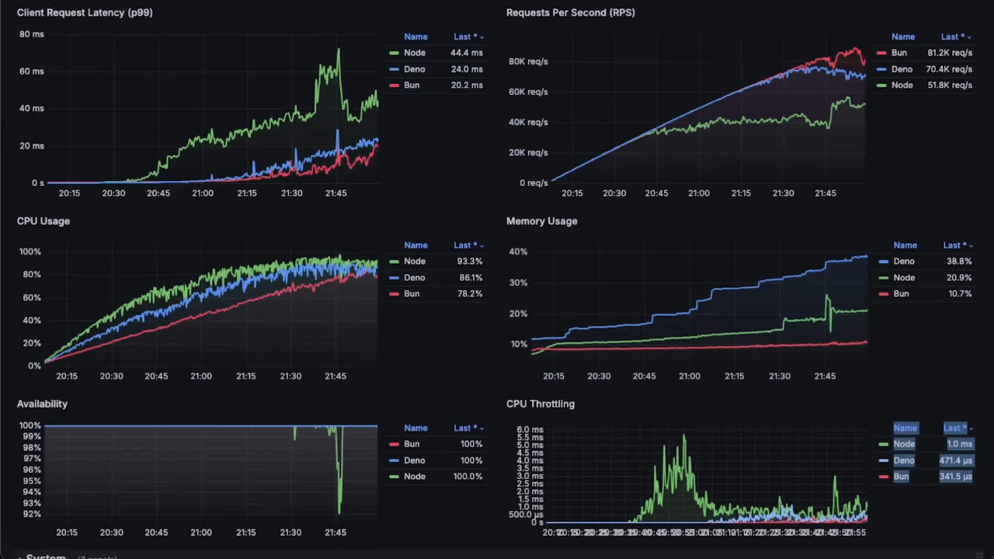
Figure 9.2.4: Bun vs Dino vs npm

The Role of Bun in DETECT’s JavaScript-Based Solution
Bun provides a strong foundation for DETECT’s real-time application by combining speed, integrated tooling, and efficient package management. Its ability to handle demanding tasks without introducing additional complexity ensures that the development team can maintain a smooth workflow while meeting the project’s performance goals. By leveraging Bun, DETECT can process video frames efficiently, enabling accurate and timely eye-tracking analysis in a browser environment.

Conclusion: A Strategic Choice for DETECT
As DETECT transitions to a JavaScript-based architecture, Bun emerges as the most suitable runtime for achieving the project’s objectives. Its performance-driven design and integrated development tools make it uniquely capable of addressing the demands of real-time video processing. Compared to npm and Deno, Bun offers a streamlined, high-performance solution that minimizes overhead while maximizing efficiency.
By adopting Bun, DETECT positions itself to deliver a responsive, cutting-edge application that aligns with the project’s focus on precision and speed. This decision reflects the team’s commitment to leveraging the best tools available to ensure success in a highly dynamic and interactive environment.

9.2.5 Hosting
The DETECT project requires a hosting solution that ensures scalability, reliability, and optimal performance to meet the demands of a real-time, browser-based application. Hosting must support the project’s JavaScript-based architecture while providing low-latency performance for video processing and efficient storage for analytics data. Additionally, the chosen service should offer flexibility to integrate with third-party tools and support features like load balancing and security.
With these requirements in mind, several popular hosting providers were evaluated, including AWS, Google Cloud Platform (GCP), Microsoft Azure, and DigitalOcean. Each of these platforms offers unique advantages tailored to different aspects of application hosting, from compute power to ease of use.

Popular Hosting Solutions

Amazon Web Services (AWS)
AWS stands out as a comprehensive and flexible hosting solution with a vast array of services tailored for high-performance applications. Its offerings, such as Amazon EC2 for scalable compute power and S3 for object storage, make it a go-to platform for hosting web applications. AWS’s Elastic Load Balancer ensures reliable distribution of traffic, which is crucial for DETECT’s real-time video processing. Additionally, AWS provides strong security measures, including IAM for user access control and CloudWatch for monitoring performance metrics.
While AWS offers unparalleled scalability and robustness, its complexity and cost structure can pose challenges for smaller teams. However, its extensive documentation and resources mitigate the steep learning curve, making it a viable choice for projects that require advanced capabilities.

Google Cloud Platform (GCP)
GCP offers high-performance hosting with seamless integration into machine learning and data analysis workflows, leveraging Google’s expertise in AI and cloud services. Services like Google Kubernetes Engine (GKE) and Cloud Run provide flexible options for containerized application hosting, making GCP suitable for microservice architectures. Its BigQuery service also enables efficient data analytics, which could benefit DETECT’s need for performance metrics tracking.
However, GCP’s pricing model can be less straightforward than AWS, and its market share is smaller, resulting in a smaller pool of community support. While GCP excels in data-heavy applications, it may not be as comprehensive as AWS for hosting general-purpose web applications like DETECT.

Microsoft Azure
Azure provides a strong offering for enterprise-grade applications, with a focus on hybrid cloud solutions and seamless integration with Microsoft tools. Services like Azure App Service and Azure Functions allow developers to deploy applications with minimal setup. Azure’s Content Delivery Network (CDN) optimizes global content delivery, which is essential for minimizing latency in real-time applications.
Despite its advantages, Azure’s focus on enterprise environments can make it less appealing for smaller, agile teams. Azure’s documentation and community support are extensive, but its interface is less user-friendly compared to competitors like AWS, which could slow initial setup for DETECT.

DigitalOcean
DigitalOcean is known for its simplicity and developer-centric approach, making it an attractive choice for smaller teams or straightforward applications. Its Droplets provide flexible compute power, and App Platform offers an easy-to-use solution for deploying web applications. DigitalOcean’s pricing model is straightforward, which appeals to teams looking to control costs.
However, DigitalOcean’s limited advanced features, such as load balancing and serverless architecture, may not fully meet the scalability and performance needs of DETECT’s real-time processing requirements. While it offers an excellent starting point, it lacks the depth of services provided by AWS or GCP for handling high-demand applications.

Conclusion
After evaluating these hosting platforms, AWS emerges as the most suitable choice for DETECT’s hosting needs. Its scalability, robust performance, and comprehensive suite of services align perfectly with the project’s requirements for real-time video processing and seamless application performance. AWS’s ability to handle dynamic workloads through services like Elastic Beanstalk and CloudFront ensures that DETECT can maintain low latency and high availability even under peak usage.
Additionally, AWS’s strong developer support, extensive documentation, and global infrastructure provide the DETECT team with the tools and flexibility needed to scale the application as it evolves. While AWS’s complexity may present a learning curve, its unparalleled capabilities make it the optimal choice for a project that demands both performance and reliability.

10. Eye Tracking Implementation
The successful detection of deception through eye-related cues necessitates a robust and precise eye tracking system capable of capturing and analyzing subtle ocular behaviors in real-time. This section delineates the comprehensive implementation of the eye tracking component within the DETECT project, utilizing MediaPipe's Face Mesh framework as the foundational technology for gaze detection. By leveraging MediaPipe's advanced capabilities, the system accurately identifies and tracks eye landmarks and iris centers, facilitating the calculation of gaze direction with high fidelity. Additionally, this section addresses the integration of smoothing functions to enhance data stability and the iterative improvements made to optimize system performance. Emphasizing the critical role of real-time processing, the implementation strategies outlined herein ensure that the eye tracking system operates seamlessly, thereby providing reliable data for subsequent deception detection analyses. Through meticulous setup and continuous refinement, the DEtECT project's eye tracking implementation lays the groundwork for effectively interpreting gaze patterns as key indicators of deceptive behavior.

10.1 Gaze Detection Using MediaPipe
This section focuses on the implementation of gaze detection using MediaPipe, a versatile framework for real-time perception. The setup process for the MediaPipe Face Mesh is described, including the extraction of key eye landmarks and the methodology used to calculate gaze direction.

10.1.1 Setting up MediaPipe Face Mesh
The MediaPipe Face Mesh solution offers a state-of-the-art approach to tracking facial landmarks in real-time. With its ability to identify 468 unique points on the face, it is particularly useful for eye-tracking and gaze detection. In this section, the steps required to set up MediaPipe Face Mesh are outlined, focusing on the necessary components, processes, and configurations. This setup will serve as the foundation for extracting key eye-related landmarks, enabling further work on gaze tracking and deception analysis.

Installing the Required Tools
To set up MediaPipe Face Mesh, you need to ensure that your development environment has Python and necessary libraries installed. The two essential libraries are:
MediaPipe – A machine learning library for building multimodal applications.
OpenCV – Used to capture video from a webcam or other sources and display the output.
These libraries are readily available and can be installed using standard package management tools. Conda (Anaconda or Miniconda) was utilized for packaging the required libraries since it helps with environment isolation and removing the “it works on my local machine” issue. To install the necessary dependencies, you can use the following command:
conda install -c conda-forge mediapipe opencv
The repository contains a requirements.txt file as of now and a .yml configuration file later that will contain the packages required in the correct version and format to reduce configuration issues. To install using the requirements.txt file, you can use the following command:

Configuring the Face Mesh Solution
Once the necessary tools are installed, the next step involves configuring the MediaPipe Face Mesh solution to detect and process facial landmarks, with a focus on the regions surrounding the eyes. MediaPipe offers pre-trained models designed for efficient detection, facilitating the tracking of facial expressions, iris position, and gaze direction.
The configuration requires setting specific parameters to optimize performance. For real-time applications, the system is typically limited to detecting a single face to ensure efficiency. Enabling refined landmarks enhances the level of detail in tracking iris points, which is critical for accurate gaze detection. Additionally, the confidence threshold must be adjusted to determine the minimum detection confidence, balancing the trade-off between accuracy and performance.
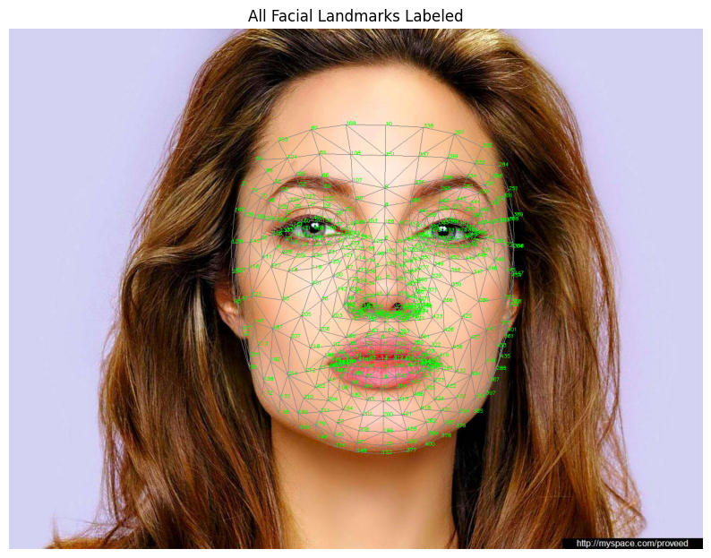
Figure 10.1.1.i: Official MediaPipe Face Mesh Landmark Diagram

Capturing Video and Processing Frames
The system captures video input through a webcam, continuously feeding frames into the MediaPipe Face Mesh solution. Each frame is processed to detect facial landmarks. For optimal performance, the video feed is mirrored (flipped horizontally) to make it intuitive for the user. Every frame must also be converted from BGR (used by most cameras) to RGB, as required by the MediaPipe model.

Identifying and Visualizing Eye Landmarks
MediaPipe detects detailed facial points, including the iris and surrounding regions. Specific landmarks around the eyes are critical for gaze tracking, including Upper and Lower Eyelids, Iris Center, Lateral and Medial Canthus (outer and inner corners of the eye). These landmarks are identified and extracted to enable further processing, such as calculating the gaze direction and analyzing pupil movements.
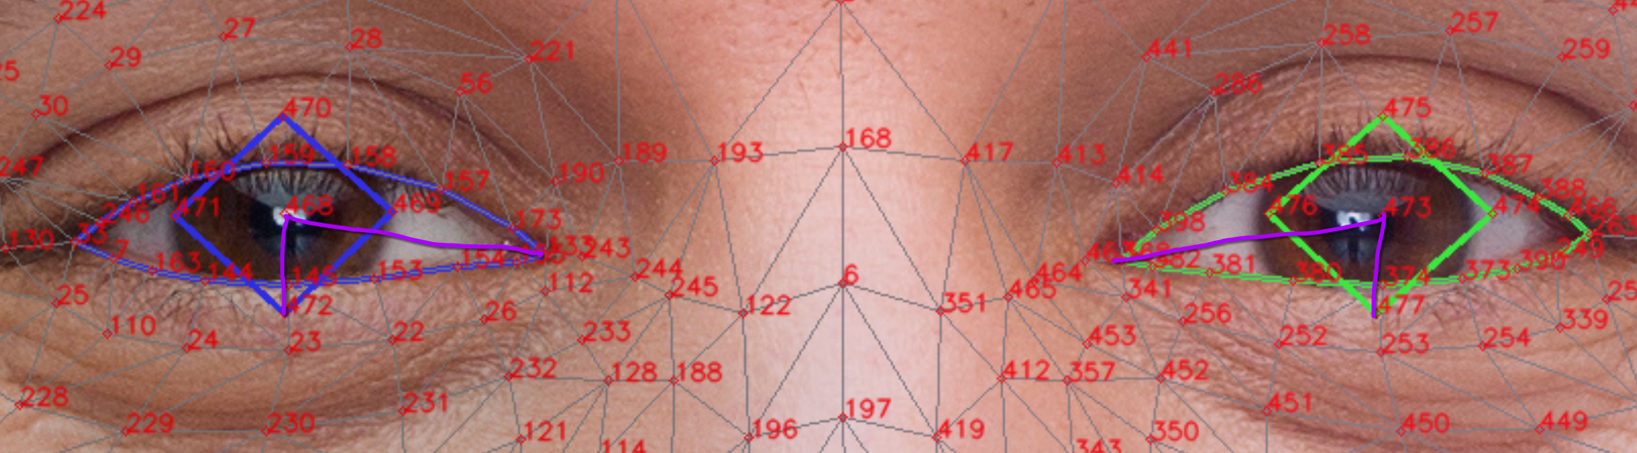
Figure 10.1.1.ii: depicts the Current System of Eye Coordinate Tracking using Eye Chart and Eyelid boundaries

Flow of the Detection Pipeline:
The detection pipeline involves several stages:
- Video Input: The webcam captures frames.
- Preprocessing: The frames are flipped and converted to RGB.
- Landmark Detection: MediaPipe identifies facial landmarks.
- Eye Landmark Extraction: Key eye-related points are extracted for further analysis.
- Eye Landmark Transformation: The identified points are transformed into a numeric format usable for the machine learning and pattern analysis
- Machine Learning and Pattern Analysis: Analyze the coordinate data obtained using machine learning and pattern analysis to determine a confidence level of deception detected.
- Video Output: Display the video output with the confidence level and tracked eye landmarks
The results are displayed on the video feed, showing real-time tracking of facial landmarks. This provides instant visual feedback on the detection performance, ensuring that the system correctly identifies eye movements and pupil positions.

Challenges and Optimizations in Real-Time Eye Tracking
Real-time eye tracking presents several technical challenges that require careful consideration. One key challenge involves variations in the subject’s distance from the camera, which can affect the precision of detected landmarks. Additionally, the angle at which the camera captures the subject’s face plays a critical role in system accuracy. Optimal performance is achieved when the subject faces the camera directly, but any deviation, such as head tilting or rotation, may introduce tracking errors.
Another challenge lies in the dynamic changes in the perceived size of the eye. Vertical eye movements, such as looking up or down, can alter the visible area of the eye, impacting the accuracy of landmark measurements. Addressing these issues requires thorough calibration of the tracking environment and precise adjustments to detection thresholds. Furthermore, the application of normalization techniques is essential to standardize landmark coordinates, thereby mitigating the effects of varying distances, angles, and other external factors.

10.1.2 Estimating Gaze from Tracked Coordinates
Estimating gaze direction is a critical component of this eye-tracking system, enabling the detection of subtle eye movements and patterns that could indicate deception. The accuracy of gaze tracking relies heavily on the precision of the coordinate system used to extract key features like pupil positions and eye movement. Initially, the team experimented with the default coordinate system provided by the MediaPipe Face Mesh, which tracks eye landmarks relative to the entire face. However, inconsistencies arose due to variations in eye shape and blinking, prompting an adjustment of the reference frame to the nose landmark for a more stable calculation.
This section explains the reasoning behind switching the reference frame to the nose, details the mathematical transformations currently involved, and describes how gaze direction is estimated from the tracked coordinates.

Coordinate System Adjustments: Using the Nose as a Reference
The original MediaPipe Face Mesh tracks landmarks in a normalized coordinate space, with points expressed as relative proportions of the image width and height. However, this system presented challenges for gaze tracking. Specifically, using eye landmarks alone resulted in inconsistent y-coordinates due to dynamic changes in eyelid positions when the subject looks up or down.
To mitigate these issues, there was a shift in the coordinate system to use the nose landmark as the primary reference point. The nose remains relatively stable during head movements and provides a more consistent anchor for eye-related calculations.

Rationale for Using the Nose Landmark
The nose landmark provides a stable reference point that enhances the precision of eye tracking by addressing several challenges. Unlike the eyes, which are subject to movement and fluctuations due to blinking and changes in eyelid size, the position of the nose remains constant, ensuring reliable tracking across these interruptions.
Moreover, the nose serves as a consistent reference during head movements. As a centrally located feature, it moves less than peripheral facial landmarks, offering greater stability in tracking. Subtracting the nose coordinates from eye landmark coordinates allows for the normalization of eye movements, mitigating distortions caused by shifts in head position, variations in camera distance, or changes in the angle of capture. This approach ensures more accurate and consistent gaze tracking.
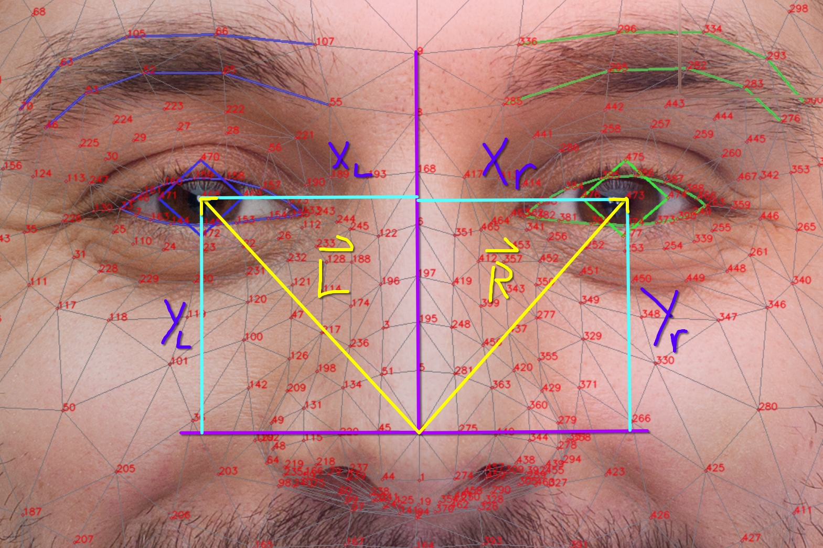
Figure 10.1.2.i: Illustrates Eyelid-Carthal Coordinate System (top) vs Nose Vector Coordinate System (Bottom)

Mathematical Transformation for Gaze Estimation
Once the nose is designated as the new reference point, the relative positions of the iris and surrounding eye landmarks are calculated. This provides two vectors pointing from the peak of the nose to the iris. The following formulas describe how to derive the adjusted coordinates for gaze estimation:

Left Eye Coordinates:
$x'_{left}=x_{left_iris}-x_{nose} , y'_{left}=y_{nose}-y_{left_iris}$

Right Eye Coordinates:
$x'_{right}=x_{right_iris}-x_{nose} , y'_{right}=y_{nose}-y_{right_iris}$
These calculations subtract the x and y components of the nose from the corresponding components of the iris landmarks. The use of the nose y-coordinate to normalize vertical movements accounts for the variability introduced by the eyelids.

Impact of Adjusted Coordinates on Gaze Tracking
Transforming to a nose-centered coordinate system enhances the accuracy of gaze estimation by minimizing the impact of external variables. Using the nose as the anchor point ensures that gaze calculations are more robust against camera angle variations. Even with slight head tilts or camera misalignments, the x-coordinates remain stable, reducing disruptions caused by head movements.
The transformation also stabilizes coordinates when the subject moves closer or farther from the camera. With the nose serving as a central reference for scaling, the system maintains consistent data, evident in the stability of coordinate graphs over time, even when the head position shifts. Additionally, by referencing the y-coordinate to the nose rather than the eyelids, the system avoids inaccuracies that occur when the subject blinks or looks vertically, further improving precision.
This adjustment increases the robustness of real-time gaze tracking, allowing for more reliable detection of eye movement patterns. It enhances the identification of fixation points (where the subject focuses on a target) and saccades (rapid transitions between two points).
However, despite these improvements, the numeric scale of the coordinates can vary significantly across different scenarios due to two main limitations. First, the lack of normalization and standardization in the coordinate vectors introduces variability. Second, the MediaPipe coordinate calculation process remains largely a black box, limiting the ability to fully understand or adjust its internal mechanics.

Estimating Gaze Direction
After calculating the adjusted coordinates, the next step is to estimate the subject’s gaze direction by analyzing the relative displacement of the iris landmarks over time. Key metrics in this process include horizontal and vertical gaze, as well as gaze symmetry.
Horizontal gaze is determined by tracking displacement along the x-axis. A positive or negative shift in the coordinates of the left and right eyes indicates whether the subject is looking to the left or right. Vertical gaze is measured using changes in the y-axis coordinates, revealing whether the subject's gaze is directed upward or downward.
Gaze symmetry is assessed by comparing the movements of the left and right irises. Detecting asymmetries between them may reveal subtle micro-expressions or signs of cognitive stress. This symmetry analysis adds a layer of depth to the gaze tracking system, enabling the identification of behavioral cues.
By continuously monitoring these metrics, the system can generate heatmaps or vector-based visualizations that illustrate areas of focus and movement patterns. Such visualizations are valuable for analyzing gaze behavior, particularly when detecting patterns associated with deception or attention shifts.
It is important to note that the system operates on the assumption that the average coordinates of both eyes, relative to the overall facial position, provide a reliable estimate of the subject’s gaze direction. This assumption underpins the accuracy of the gaze estimation process.

Iris Tracking Using Image Based Contours
Image-based contour recognition is a pivotal technique in the realm of computer vision and image processing, fundamentally aimed at identifying and delineating the boundaries of objects within digital images. In the context of iris detection, contour recognition is essential for accurately locating and tracking the iris within the eye region. This capability is instrumental in various applications, including gaze tracking, biometric authentication, and human-computer interaction interfaces.
At its core, a contour in image processing refers to a curve that connects all continuous points along a boundary that share the same color or intensity. Contour recognition involves detecting these curves to outline the shapes of objects within an image. This process is crucial for distinguishing different parts of an image, enabling further analysis and interpretation of visual data. In iris detection, accurately identifying the contour of the iris allows for precise extraction of its position and movement, which is vital for determining gaze direction or verifying identity based on unique iris patterns.
The process of contour recognition typically involves several stages, each designed to enhance the accuracy and reliability of boundary detection.

Preprocessing Steps
Before contour recognition can be effectively performed, the image undergoes a series of preprocessing steps to enhance its quality and facilitate accurate detection. Initially, the image is converted to grayscale to simplify the data by reducing it to intensity variations, thereby focusing on the structural aspects of the image rather than color information. This is followed by noise reduction techniques such as Gaussian blur or median filtering, which eliminate unwanted variations that could interfere with edge detection. Enhancing the contrast of the image through histogram equalization further improves the visibility of features, making it easier to detect significant boundaries.

Edge Detection
Edge detection is the cornerstone of contour recognition, as it identifies significant intensity gradients that signify object boundaries. The Canny Edge Detector is a widely used algorithm renowned for its accuracy in detecting true edges while minimizing noise and false positives. This multi-stage algorithm involves applying a Gaussian blur to reduce noise, calculating intensity gradients using Sobel operators, thinning the edges through non-maximum suppression, and finally, identifying strong and weak edges through double thresholding and edge tracking by hysteresis.

Thresholding and Binarization
After edge detection, the image is often converted to a binary format through thresholding, which simplifies the image by isolating object regions from the background. Global thresholding applies a single intensity threshold to segment the entire image, whereas adaptive thresholding determines thresholds locally, accommodating varying lighting conditions across different regions of the image. This binarization is crucial for accurately extracting contours by clearly distinguishing the object of interest from its surroundings.

Morphological Operations
Morphological operations refine the binary image by altering its structure, enhancing the contours' clarity and continuity. Techniques such as dilation and erosion expand or shrink object boundaries, respectively, helping to fill small holes or remove minor noise artifacts. Operations like opening (erosion followed by dilation) and closing (dilation followed by erosion) further clean up the image by removing small objects or filling gaps, ensuring that the contours are smooth and well-defined.

Contour Extraction
Once the image is preprocessed and binarized, contours can be extracted using algorithms like cv2.findContours() in OpenCV. This function retrieves contour points and organizes them hierarchically, allowing for the identification of outer and inner contours. Filtering contours based on criteria such as area, perimeter, and shape ensures that only the relevant contours, such as those resembling the circular shape of the iris, are retained for further analysis.

Circle Detection Algorithms
Given that the iris typically appears circular, specialized algorithms like the Hough Circle Transform are employed to enhance the accuracy of contour recognition. This algorithm maps edge points to a parameter space defined by circle equations, accumulating votes to identify probable circle centers and radii. While highly effective, the Hough Circle Transform is sensitive to parameter settings and can be computationally intensive, necessitating careful calibration and optimization for real-time applications.
In practical applications, image-based contour recognition for iris detection follows a structured pipeline. Initially, a clear image of the eye region is captured and preprocessed to enhance quality and reduce noise. Edge detection algorithms like Canny are then applied to identify significant intensity gradients, followed by thresholding to binarize the image. Morphological operations refine the binary image, preparing it for contour extraction. Contours are then identified and filtered based on predefined criteria to isolate the iris. Finally, algorithms like the Hough Circle Transform confirm and refine the iris boundaries, enabling accurate detection and tracking of the iris across video frames.
However, several challenges persist in this approach. Variability in eye appearance due to lighting conditions, eye movements, and occlusions can hinder accurate contour recognition. Noise and artifacts in low-quality images further complicate detection, while maintaining computational efficiency is crucial for real-time applications. To address these challenges, researchers have explored adaptive thresholding, region of interest (ROI) selection, refined morphological operations, and hybrid approaches combining traditional image processing with machine learning techniques.

10.1.3 Implementation of Smoothing Algorithms
Given that gaze tracking relies heavily on precise landmark detection, noise and jitter are inevitable due to small inaccuracies in MediaPipe’s facial landmark predictions. These inaccuracies can result from minor variations in lighting, subtle head movements, or temporary misalignment in the camera's angle. Without smoothing, these fluctuations can introduce erratic changes in the detected iris position, leading to unreliable gaze estimates. To address this issue, a smoothing algorithm was implemented to reduce noise and provide more stable gaze tracking over time.
The biggest issue in this section is deciding which smoothing algorithm works best for the case of gaze detection and iris movement tracking as a whole. There are a number of factors that affect that decision, including the following:

Type of Data and Noise Characteristics
The nature of the data—whether it's time-series, spatial data, or high-dimensional data—strongly influences the choice of a smoothing algorithm. Additionally, understanding the type of noise (random fluctuations, outliers, or systematic errors) is essential, as different algorithms handle noise differently. For example, simple moving averages are effective for random noise but struggle with outliers, while more advanced techniques like the Savitzky-Golay filter can smooth noisy data without distorting trends. The algorithm should balance removing noise without sacrificing the underlying signal.

Smoothness vs. Fidelity Trade-Off (Feature Retention)
Smoothing algorithms inherently introduce a trade-off between eliminating noise (smoothness) and retaining the original signal (fidelity). Over-smoothing can erase critical features, while under-smoothing may leave too much noise. Techniques like low-pass filters or spline smoothing need to be carefully tuned to avoid excessive smoothing, which could distort meaningful trends. The goal is to maintain a balance where the key patterns are preserved without being overshadowed by noise or excessive smoothing artifacts.
In the case for gaze tracking and pattern analysis, the significant features being preserved is of the utmost importance as that serves as the basis for the pattern analysis itself. Thus, an algorithm that would preserve the significant features and remove the majority of the noise with minimal fine tuning is ideal.

Computational Efficiency
The complexity of the algorithm becomes important, especially for large datasets or real-time applications. Some algorithms, such as moving averages, are computationally inexpensive, while others, like Gaussian smoothing or Kalman filters, can be more resource-intensive. The chosen algorithm must align with the system’s performance constraints, ensuring the trade-off between smoothness and speed meets the use case requirements. Real-time applications, for example, may require faster, less complex methods.

Handling of Outliers
Outliers can skew the results of certain smoothing algorithms. While algorithms like median filtering are robust against outliers by focusing on the median value rather than the mean, others like exponential smoothing may require additional handling mechanisms to avoid large deviations. It is important to select an algorithm that either inherently mitigates the impact of outliers or incorporates outlier detection and correction techniques, depending on the nature of the data.

Window Size or Smoothing Parameter Selection
Many smoothing algorithms rely on parameters, such as the size of a moving window or the bandwidth of a kernel, which control the extent of smoothing. Choosing the right parameter is crucial because small windows may leave noise unaddressed, while large ones can oversimplify the data. Adaptive algorithms that dynamically adjust the smoothing parameter based on data behavior can provide a more optimal solution, especially for non-stationary data where trends and variances change over time.
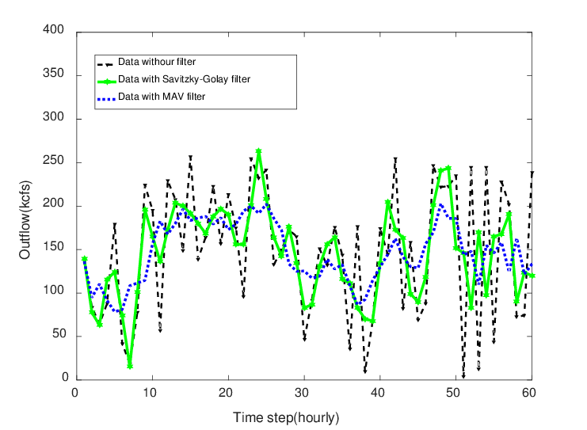
Figure 10.1.3.i: Comparison of the Savitzky-Golay Filter (SGF) and the Moving Average (MAV)
From the figure above (Fig. 9.1.3), it can be noticed that while the Moving Average Filter smooths out a lot of the data and preserves the shape of the data pretty well, the Savitzky-Golay Filter keeps the features of the data (the highs and the lows) intact while also keeping the rough shape of the initial data but a bit more smoothed.

Moving Average Filter
The Moving Average Filter works by maintaining a fixed-size queue of the most recent $n$ coordinate values for both $x$ and $y$ components of the iris. As each new frame is processed, the filter adds the latest coordinate values to the end of the queue and removes the oldest ones from the front. The smoothed output for each frame is then computed as the arithmetic mean of all the values currently stored in the queue. This ensures that the output reflects the average of recent coordinates, smoothing out any abrupt changes caused by outliers or temporary misdetections.
Mathematically, the smoothed coordinate at time $t$ is calculated as:
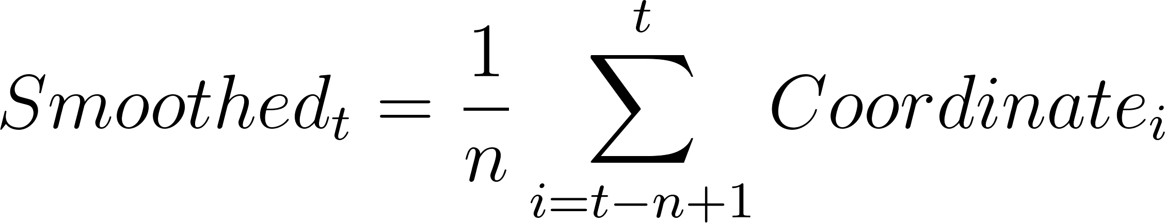
where $n$ is the size of the queue, and $Coordinatee_{i}$ represents the individual coordinate values within the queue. As new values enter the queue and older values are removed, the moving average continuously updates, producing a stable yet responsive output.
This queue-based Moving Average Filter balances smoothness with real-time responsiveness. For example, if the queue size is set to 10 frames, the filter computes the average of the latest 10 coordinate values for each frame update. This smooths out small jitters caused by tracking inaccuracies but still allows the system to adapt to genuine gaze shifts. A smaller queue size makes the filter more responsive to rapid changes in gaze, while a larger queue size provides greater stability but with a slight delay in responding to new movements.
The Moving Average Filter is particularly effective for real-time gaze tracking because it minimizes the impact of random noise without introducing significant computational overhead. As the system only needs to maintain and update a fixed-size queue, the filter can run efficiently in environments with limited computational resources. Additionally, the filter ensures that the gaze path remains smooth during common disruptions, such as blinks or slight head movements, which can temporarily skew individual coordinate readings.
Another benefit of using a Moving Average Filter is its adaptability to different applications. For highly interactive use cases, such as gaze-based control interfaces, a smaller queue size ensures that the system remains responsive to rapid eye movements. In contrast, for use cases like behavioral research or gaze heatmap generation, a larger queue size helps produce more stable data by smoothing out subtle fluctuations over a longer period. This flexibility allows the system to be tailored to meet the specific needs of different applications.
By employing a Moving Average Filter, the gaze tracking system achieves a stable and reliable output that minimizes noise while preserving real-time responsiveness. The filter ensures that jitter and sudden fluctuations are smoothed out effectively, providing more accurate gaze estimations across various scenarios. This makes it a critical component of the gaze tracking pipeline, supporting downstream tasks such as visualization, pattern recognition, and behavioral analysis with high precision and stability.
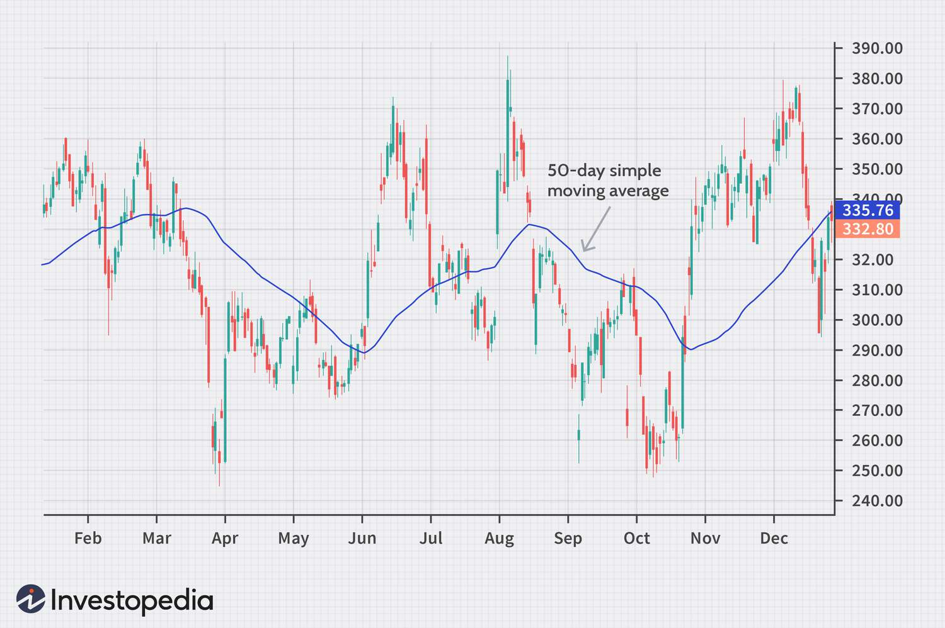
Figure 10.1.3.ii: depicts a practical usage of Moving Average Filter

Limitations of Moving Average Filter
The Moving Average Filter was initially implemented to address noise and jitter caused by MediaPipe’s facial landmark detection errors. While it effectively reduced random fluctuations and provided smoother gaze tracking, the filter also had several limitations that became apparent during development. These challenges led to the decision to explore alternative filtering techniques that could better meet the needs of real-time gaze tracking. Here are the limitations of using Moving Average Filtering in the gaze tracking use-case:

Lag in Response to Rapid Gaze Changes
One of the primary drawbacks of the Moving Average Filter is the inherent lag introduced when using a larger queue size. While a larger queue provides greater stability by averaging out fluctuations, it also delays the system’s response to sudden, intentional gaze shifts. In scenarios requiring high responsiveness—such as interactive eye-tracking applications or user interfaces—the delay becomes noticeable, reducing the effectiveness of the system. This trade-off between smoothness and responsiveness proved problematic, as it hindered the real-time nature of the gaze tracking system. In other words, the filter was becoming computationally expensive while also not showing much improvements in the smoothing.

Sensitivity to Queue Size Configuration
The performance of the Moving Average Filter depends heavily on the choice of queue size. A small queue size offers better responsiveness but sacrifices smoothness, causing the system to remain sensitive to minor fluctuations or noise. Conversely, a larger queue stabilizes the output but may mask subtle gaze shifts. Tuning the queue size to achieve the right balance across different users and environments became challenging, especially in scenarios where the subject's movement patterns or environmental conditions varied frequently. This lack of adaptability limited the filter’s effectiveness across different use cases.

Equal Weight to All Values in the Queue
In a Moving Average Filter, every value within the queue is assigned equal weight, regardless of when it was recorded. This can be problematic, as older values may continue to influence the output even when they are no longer relevant to the subject’s current gaze direction. For example, during rapid eye movements or saccades, older coordinate values can create a lagging effect, preventing the system from accurately capturing the user’s current focus. This uniform weighting limited the filter’s ability to reflect rapid, dynamic changes in gaze direction.

Inability to Handle Non-Stationary Data
The Moving Average Filter assumes that the incoming data stream is relatively stationary, meaning that fluctuations are small and occur around a stable mean. However, in real-world gaze tracking, non-stationary behaviors—such as sudden head tilts, blinks, or fast gaze shifts—are common. The filter struggled to adapt to these changes, leading to either oversmoothing or delayed responses. This limitation was particularly problematic when analyzing behavioral patterns that required precise tracking of rapid gaze movements or micro-expressions.

Cumulative Error in Real-Time Tracking
As the filter processes data continuously, small inaccuracies can accumulate over time, causing subtle drifts in the smoothed coordinates. If the system encounters several frames with misaligned landmark positions, the resulting average may drift away from the true gaze path. This cumulative error becomes more apparent over long periods of continuous tracking, potentially degrading the quality of downstream visualizations, such as heatmaps or gaze vectors.

Savitzky-Golay Filter
While the Moving Average Filter (MAV) offered some degree of smoothing by averaging recent data points, its limitations—such as delayed responsiveness, cumulative error, and difficulty balancing smoothness with real-time adaptation—necessitated a shift to a more advanced smoothing technique. After evaluating alternatives, the Savitzky-Golay (SG) Filter was chosen as the optimal replacement.
The SG Filter applies a least-squares polynomial fit to a small, fixed-size window of recent data points. For each frame, the filter takes a subset of past and present coordinate values (both $x$ and $y$ components), fits a polynomial curve through them, and calculates the smoothed value at the center of the window. As new frames arrive, the window slides forward, updating the polynomial fit and recalculating the smoothed coordinates. This sliding-window approach ensures that the smoothing process adapts continuously to new data, providing a stable but responsive output.
Mathematically, for a given window of $n$ coordinate points, the polynomial fitting is represented as:
(to get the polynomial)
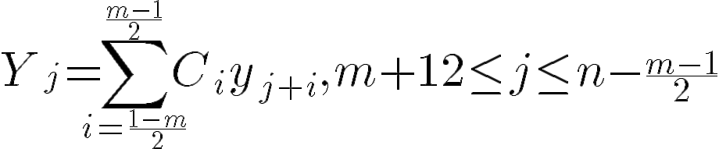 (to get the smoothed data point)
where $Y$ is the set of smoothed data points, $C$ is the set of convolution coefficients and $m$ is the cardinal number of the set of convolutional coefficients.
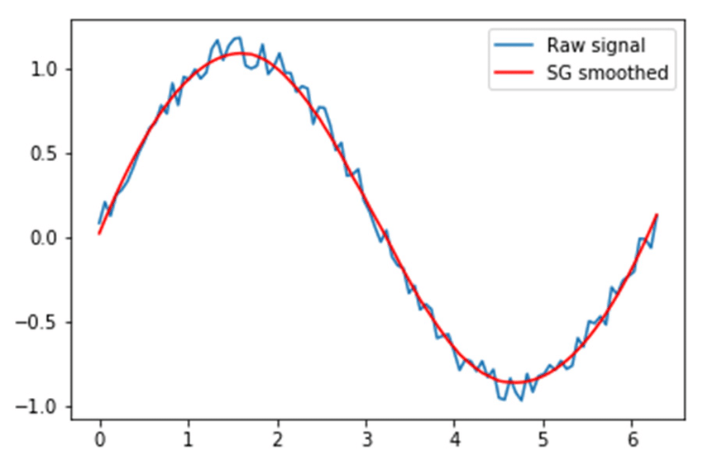
Figure 10.1.3.iii: illustrates how the Savitzky-Golay Filter is applied on a graph

Advantages of Savitzky-Golay Filter for Gaze Tracking
The Savitzky-Golay (SG) Filter was implemented to address the limitations encountered with the Moving Average Filter (MAV), offering a more advanced method for smoothing noisy data without sacrificing responsiveness. Originally designed for signal processing, the SG Filter fits a polynomial curve to a sliding window of data points, enabling it to reduce noise while preserving the underlying structure and sharp transitions in the data. This makes it particularly effective for real-time gaze tracking, where accurate tracking of rapid eye movements, such as saccades or smooth pursuits, is crucial.

Preservation of Rapid Gaze Shifts
One of the key strengths of the SG Filter is its ability to smooth noise without suppressing sharp changes. When subjects make rapid gaze shifts or saccades, the polynomial fit preserves these transitions, avoiding the lag that occurs with MAV. This ensures that the gaze tracking system can accurately capture fast movements without compromising real-time performance, making it suitable for applications requiring high responsiveness, such as interactive user interfaces or real-time behavioral analysis.

Reduction of Oversmoothing
Unlike MAV, which averages all values equally, the SG Filter retains important variations in the data by fitting a polynomial to each window. This reduces the risk of oversmoothing, where subtle but meaningful eye movements could be lost. The filter’s ability to maintain the original structure of gaze patterns ensures that even small shifts or micro-expressions are detected accurately, enhancing the precision of downstream visualizations like heatmaps or gaze trails.

Adaptive Polynomial and Window Size
The SG Filter provides greater flexibility in tuning the smoothing process. The degree of the polynomial and the size of the window can be adjusted to optimize the filter for different scenarios. A lower polynomial degree prioritizes noise reduction, while a higher degree captures more complex movements. Similarly, the window size determines how many data points are included in each fit. A smaller window allows for faster adaptation to sudden movements, while a larger window provides smoother output, ideal for long-term gaze pattern analysis.

Handling of Non-Stationary Data
The SG Filter excels in scenarios with non-stationary data, such as abrupt head movements or changes in facial orientation. Its polynomial fitting process ensures that the output remains stable even when the gaze data is not centered around a fixed mean. This adaptability makes it particularly effective in real-world settings, where users may shift their gaze direction unpredictably or adjust their position relative to the camera which might introduce noise that won’t be caught by the algorithm.

Real-Time Efficiency
Although the SG Filter involves fitting polynomials to sliding windows, it is computationally efficient. The least-squares fitting process is performed only for the small subset of points within the window, ensuring that the filter can run smoothly in real time. This efficiency allows the gaze tracking system to maintain high frame rates and accurate output, even when processing continuous streams of data in interactive applications or research settings.

Limitations of Savitzky-Golay Filter
While the SG Filter offers several advantages, it is not without limitations. One challenge is selecting the optimal polynomial degree and window size. A window that is too small may not provide adequate noise reduction, while a large window could introduce slight delays in capturing rapid gaze shifts. Additionally, if the polynomial degree is set too high, the filter may overfit the data, leading to unnecessary oscillations in the output. However, with proper tuning, these limitations can be mitigated to suit the specific needs of the application.

Conclusion
The Savitzky-Golay Filter proved to be a significant improvement over the Moving Average Filter for gaze tracking. By fitting polynomials to sliding windows of data, it offered a superior balance between smoothing and responsiveness, effectively capturing both rapid and subtle gaze movements. Its ability to adapt to non-stationary data and handle sudden shifts without introducing cumulative error made it an ideal choice for real-time applications. The flexibility of the SG Filter ensured that it could be fine-tuned for a variety of use cases, from interactive interfaces to behavioral research. With this algorithm in place, the gaze tracking system achieved the stability, precision, and responsiveness required for practical deployment in complex real-world environments.

10.1.4 Versions and their Improvements
This project is an innovative endeavor aimed at identifying deceptive behavior through the analysis of visual cues and subtle indicators. This project leverages advancements in computer vision and signal processing to interpret human behavior accurately. Over time, the project has seen significant enhancements, evolving from its initial iteration, Version 1 (V1), to a more sophisticated and feature-rich Version 2 (V2). This progression not only reflects technological improvements but also a deeper understanding of the nuances involved in gaze detection.

10.1.2.1 Version 1: The Foundation
Version 1 laid the groundwork for subsequent developments. In its initial phase, V1 employed a relatively straightforward approach to gaze detection by focusing on the detection of iris coordinates within the frame. The system calculated these coordinates based on the frame's width and height, providing a rudimentary means of tracking eye movements. This method, while basic, served as a critical starting point for understanding how eye movements could be indicative of deception. To process the raw data obtained from iris movements, V1 utilized Moving Average Filtering. This technique averaged data points over a specified window, effectively smoothing out fluctuations and reducing noise to produce a clearer signal for analysis. However, the Moving Average Filter, though simple and easy to implement, had limitations in handling more complex noise patterns, potentially affecting the accuracy of the detected gaze pattern.
Configuration and user interaction in V1 were managed through Command-Line Interface (CLI) arguments, offering users the ability to specify essential parameters such as the source of input (whether it be a webcam, static image, or video file), the path to the input source if required, and the type of data displayed. The displayed data was organized into nine arbitrary directional regions categorized as Left-Center-Right and Up-Center-Down. This segmentation provided a basic framework for monitoring eye movements across different regions, but it lacked the granularity needed for more detailed analysis. Additionally, the reliance on frame dimensions for coordinate calculation made the system less adaptable to varying lighting conditions and dynamic environments, potentially limiting its effectiveness in real-world scenarios, especially factors such as camera angle and distance from the camera.

10.1.2.2 Version 2: Enhanced Precision and Flexibility
Building upon the foundation established by V1, Version 2 introduced a series of significant improvements aimed at enhancing both the accuracy of gaze tracking and the overall user/testing experience. One of the most notable advancements in V2 was the shift from frame-based coordinate calculation to the utilization of the eye-nose vector. By establishing a reference line between the eyes and the nose, V2 achieved a more precise and reliable method for determining iris coordinates. This approach accounts for variations in head position and facial orientation, thereby providing a more consistent measurement of eye movements. This enhanced precision is crucial for accurately detecting deceptive behavior, as subtle changes in eye movement patterns can be more reliably interpreted.
In terms of signal processing, V2 replaced the Moving Average Filter with the Savitzky-Golay (Savgol) Filter. The Savgol Filter performs a polynomial regression on data within a moving window, effectively smoothing the signal while preserving important features such as peaks and trends. This superior filtering technique reduces noise more effectively without compromising the integrity of the underlying data, resulting in a smoother and more accurate representation of eye movements. This improvement is vital for enhancing the fidelity of the analyzed signals, thereby increasing the reliability of deception detection.
Configuration management saw a significant overhaul in V2, transitioning from CLI arguments to a JSON-based configuration file. This change provided a more organized and scalable approach to managing settings, allowing for easier adjustments and better readability. The JSON configuration not only encompassed all the options available in V1—such as source selection, file paths, and displayed data regions—but also introduced new capabilities. Users could now enable live graphing for real-time data visualization, overlay graphical representations directly onto the webcam feed for intuitive monitoring, and export data in various formats including final graphs, CSV files, or simulated animations. These additional features greatly expanded the flexibility and functionality of the system, making it more versatile and user-friendly.

10.1.2.3 Version 3: Contours, Maps and Linear Transformations
Image-based contour recognition is a fundamental technique in computer vision and image processing, aimed at identifying and delineating the boundaries of objects within digital images. In the context of iris detection, contour recognition plays a pivotal role in accurately locating and tracking the iris within the eye region, facilitating applications such as gaze tracking, biometric authentication, and human-computer interaction.
A contour in image processing refers to a curve joining all continuous points along a boundary that have the same color or intensity. Contour recognition involves detecting these curves to outline the shapes of objects within an image. Accurate contour recognition of the iris is essential for:
- Gaze Tracking: Determining the direction of a user's gaze.
- Biometric Authentication: Verifying identity based on unique iris patterns.
- Human-Computer Interaction: Enabling gaze-based control interfaces.
Accurate contours ensure reliable extraction of iris features, crucial for downstream applications. Before contour recognition, several preprocessing steps are typically performed to enhance image quality and facilitate accurate detection.

Comparative Analysis and Improvements
When comparing V2 and V3, the advancements in V3 are clear and substantial. The transition from frame-based coordinate calculation to the eye-nose vector method in V3 provides a marked improvement in precision and reliability, addressing one of the key limitations of V2. The implementation of the Savgol Filter over the Moving Average Filter enhances signal processing by effectively reducing noise while maintaining critical data features, thereby improving the overall accuracy of the gaze patterns.
The shift from CLI arguments to a JSON-based configuration system in V3 not only simplifies the setup process but also allows for more complex and comprehensive configurations. This flexibility is further enhanced by the inclusion of features such as live graphing, webcam drawing, and data exporting options, which were absent in V2. These additions not only improve the user experience by providing more intuitive and interactive tools for data analysis but also facilitate the integration of the system with other platforms and applications through export capabilities.
Furthermore, V3's enhanced data visualization options, including real-time graphing and graphical overlays on the webcam feed, offer users a more dynamic and informative way to interpret the detected data. This contrasts sharply with V2's basic nine-region directional display, which provided limited insight into eye movement patterns. The ability to export data in various formats also opens up new avenues for further analysis and sharing, making V3 a more robust and versatile tool for deception detection.

Conclusion
Version 3 represents a significant leap forward from its predecessor, V2. By incorporating more precise coordinate calculation methods, advanced signal processing techniques, and a flexible configuration system, V3 enhances both the accuracy and usability of the deception detection system. The added capabilities for real-time visualization and data exporting further enrich the user experience, providing multiple avenues for data interpretation and utilization. These improvements not only address the limitations of V2 but also lay a strong foundation for future developments, positioning the project for continued growth and application in various domains where accurate deception detection is paramount. Overall, the evolution from V2 to V3 exemplifies a thoughtful and effective enhancement of the project's capabilities, underscoring its potential as a reliable tool for analyzing deceptive behavior.

10.2 Optimizations for Real-Time Performance
To ensure accurate and responsive gaze tracking, several optimizations are required to enhance real-time performance. These optimizations focus on minimizing latency, improving detection accuracy, and maintaining system stability even under varying conditions.

10.2.1 Model Optimization and Lightweight Inference
Using pre-trained models such as MediaPipe’s Face Mesh offers a significant advantage by providing efficient inference with minimal computational cost. However, to further improve real-time performance, it is necessary to reduce the resolution of the input frames. Lowering the resolution minimizes the amount of data processed per frame, decreasing computational overhead while maintaining sufficient accuracy for tracking gaze direction. Additionally, the detection scope is often limited to a single face to reduce processing time, making the system more responsive for real-time applications. Another key strategy involves implementing on-demand detection, where the system detects the face only intermittently. Once detected, the model switches to continuous landmark tracking instead of performing repeated detections, thereby improving efficiency and avoiding redundant computations.

Adaptive Frame Rate Handling
Dynamic frame rate adjustment ensures that the system remains stable under varying conditions. When computational demand increases, the frame rate is temporarily reduced, maintaining consistent system performance without dropping frames or causing noticeable lag. This adaptive frame handling also accounts for differences in hardware configurations, ensuring that the gaze tracking system performs reliably across various devices. In low-complexity scenarios, such as when the subject remains still, the system can increase the frame rate to enhance precision. Conversely, during periods of higher computational load, such as sudden movements or and live graphing, temporarily lowering the frame rate prevents the system from being overwhelmed. This approach ensures a balance between performance and accuracy, enabling real-time operation across a wide range of conditions.

Efficient Data Streaming and Visualization
Minimizing latency in data streaming and visualization is essential to maintain the system’s responsiveness. Lightweight visualization techniques are employed to generate heatmaps and vector-based gaze visualizations in near real-time. These visual tools provide immediate feedback on gaze patterns, making it easier to detect areas of focus or shifts in attention. Efficient streaming and visualization not only enhance the user experience but also improve the system’s ability to detect complex gaze behaviors, such as fixation points and rapid eye movements, without introducing significant lag.

Offloading Frame Calculations to the Client Side
A key optimization strategy involves offloading frame calculations to the client side, reducing the processing burden on the server and enhancing overall system responsiveness. By performing key computations, such as facial landmark detection and coordinate extraction, directly on the user’s device, the need for continuous data transmission between the client and server is minimized. This decentralized approach improves real-time performance, especially in applications with limited network bandwidth or high latency. Modern browsers and devices, including smartphones and desktops, can leverage WebAssembly or WebGL to run machine learning models locally, ensuring that gaze tracking remains fluid and uninterrupted. This method also offers privacy advantages, as raw video feeds do not need to be transmitted to remote servers, reducing the risk of data leakage. However, balancing performance across diverse devices remains a challenge, since older or low-powered hardware may struggle with computational demands. To address this, adaptive algorithms can be employed to adjust the complexity of the calculations based on the user’s device capabilities. By offloading frame calculations to the client side, the system achieves faster response times, lowers server costs, and enhances the user experience, making it more scalable and efficient in real-world applications.
By applying these optimizations, the gaze tracking system rides a delicate balance between high performance and low latency, delivering robust performance even under fluctuating environmental conditions. The combination of efficient model inference, adaptive frame rate handling, and streamlined visualization ensures that the system remains responsive, reliable, and suitable for real-time applications. These strategies allow for seamless analysis of gaze patterns, enabling practical use in fields such as behavioral research, human-computer interaction, and deception detection.

10.2.2 PyQtGraph Integration for Enhanced Real-Time Performance
As the gaze tracking system evolved, it became evident that real-time responsiveness and efficient visualization were critical areas needing improvement. The initial optimizations involving model adjustments, adaptive frame rate control, and lightweight visualization techniques laid a strong foundation, but the limitations of using traditional tools like matplotlib and OpenCV for real-time data visualization persisted. To address these issues and bring the system to the next level, PyQtGraph was integrated as a modern solution designed explicitly for fast, high-performance graphics. This integration significantly improved the efficiency of both real-time plotting and video rendering, allowing the system to achieve smoother, more responsive behavior. The following sections explore the motivation, implementation, and the resulting benefits of incorporating PyQtGraph, as well as the performance gains observed compared to previous methods.

10.2.2.1 Overview and Motivation for PyQtGraph Integration
In the pursuit of achieving real-time responsiveness in gaze tracking, visualization has remained a significant challenge. The initial versions of the gaze tracking system utilized tools like matplotlib for data plotting and OpenCV for displaying video frames. While these methods provided basic functionality, they quickly revealed their limitations in the context of high-frequency, real-time gaze tracking. Specifically, issues related to high latency, inefficient data handling, and performance bottlenecks became apparent as the system's complexity grew and the need for seamless, instantaneous feedback became more pronounced.
To address these challenges, PyQtGraph was identified as an ideal solution due to its focus on high-performance graphics in Python. PyQtGraph is a graphics and user interface library built on PyQt (or PySide), leveraging the Qt framework for GUI design. Unlike general-purpose libraries such as matplotlib, PyQtGraph was designed explicitly for real-time applications where frequent updates are necessary. It makes extensive use of NumPy arrays for efficient data management, enabling it to plot and visualize large data sets at high speeds with minimal computational overhead. Furthermore, PyQtGraph's integration with OpenGL allows it to take advantage of GPU acceleration, ensuring that visualization remains smooth and responsive even under conditions of high computational demand.
PyQtGraph has found success in domains where fast, dynamic visualization is critical, such as scientific research, medical imaging, and real-time signal processing. Its ability to provide interactive plots, high frame rate visualization, and asynchronous data handling has made it a preferred choice in applications requiring both speed and flexibility. These strengths are precisely what makes PyQtGraph suitable for enhancing the real-time capabilities of the gaze tracking system. The transition to PyQtGraph was driven by a need to overcome the limitations of the previous approach and ensure that the system could handle the complexities of real-time gaze tracking without compromising on performance.
The primary motivation behind integrating PyQtGraph was to tackle three major performance issues observed in earlier iterations of the system. First, latency in real-time visualization became a significant bottleneck. While matplotlib is widely used for static plots and slower updates, it struggled with the demands of real-time gaze tracking, resulting in delayed plot updates and reduced responsiveness. In contrast, PyQtGraph's asynchronous plotting and optimized buffering mechanisms allowed for nearly instantaneous updates, ensuring that gaze coordinates and other critical data were rendered without visible lag.
Second, there was the issue of efficient use of system resources. Real-time video rendering with OpenCV's imshow() function, though convenient, was limited by its inability to efficiently leverage hardware acceleration, leading to high CPU usage and slower performance. PyQtGraph, through its support for the Qt framework and OpenGL, makes effective use of GPU acceleration to handle rendering tasks. By offloading these processes to the GPU, the system was able to reduce the burden on the CPU, allowing it to focus on other intensive tasks such as facial landmark detection and tracking. This shift not only improved frame rates but also contributed to a more balanced distribution of computational load across the system's hardware.
The third motivating factor was the need for scalability and flexibility in handling real-time interactions. The gaze tracking system needed to evolve in a way that could accommodate future requirements, such as more complex visualizations and richer user interactions. PyQtGraph’s modular architecture makes it particularly flexible for building new types of visual components—such as detailed gaze heatmaps, interactive plots, and multi-dimensional visualizations—without major rework. This capability is vital for ongoing system improvements, especially as new visualization needs arise to support evolving research in behavioral analysis, deception detection, and human-computer interaction.
In addition to addressing these core technical issues, PyQtGraph also offers practical advantages from a development and user experience standpoint. It integrates seamlessly with the PyQt or PySide libraries, allowing developers to create cohesive user interfaces where interactive plots, video streams, and control elements coexist within the same application window. This streamlined integration is particularly useful in gaze tracking applications, where users need clear, instantaneous feedback about their gaze direction or calibration status, and where ensuring an intuitive interface is critical to the system's overall usability.
Overall, PyQtGraph represents an important step forward in the optimization of the gaze tracking system, addressing the need for high-speed visualization, reduced computational load, and enhanced flexibility. By incorporating PyQtGraph, the system can now achieve a level of smoothness and interactivity that was previously unattainable with the earlier visualization tools. This positions the gaze tracking system to better serve real-time applications in various fields, offering a reliable platform for capturing and analyzing gaze data with minimal latency and maximum responsiveness. The following sections will explore the practical aspects of integrating PyQtGraph into the system and provide a comparative analysis of its performance benefits.

10.2.2.2 Replacing Matplotlib for Real-Time Visualization
In the development of the gaze tracking system, enhancements were made to improve the real-time visualization capabilities of the application. Initially, Matplotlib was used for plotting gaze data, but limitations were encountered regarding performance and interactivity, particularly during continuous data updates. To address these issues, a transition was made from Matplotlib to PyQtGraph, a library specifically designed for fast plotting and interactive visualization within PyQt applications.

Benefits of Using PyQtGraph
Performance: PyQtGraph is optimized for real-time data visualization, allowing for efficient rendering of large datasets without noticeable delays. This capability is crucial for applications like gaze tracking, where data points are generated rapidly.
Interactivity: Unlike Matplotlib, which focuses on static plots, PyQtGraph provides built-in interactivity features. Users can zoom, pan, and dynamically update plots, facilitating a more engaging and exploratory experience when analyzing gaze data.
Seamless Integration: Since the application is built on the PyQt framework, integrating PyQtGraph simplifies the development process. The library's components can be easily embedded into the existing GUI, ensuring a cohesive user interface.

Implementation Overview
Initialization: A PyQt application was set up, and a main plotting window was created using PyQtGraph's capabilities, establishing a framework for displaying visualizations.
Creating Plots: Instead of static figures, multiple plots were established for displaying gaze data, such as line plots for X and Y coordinates and scatter plots for real-time gaze points.
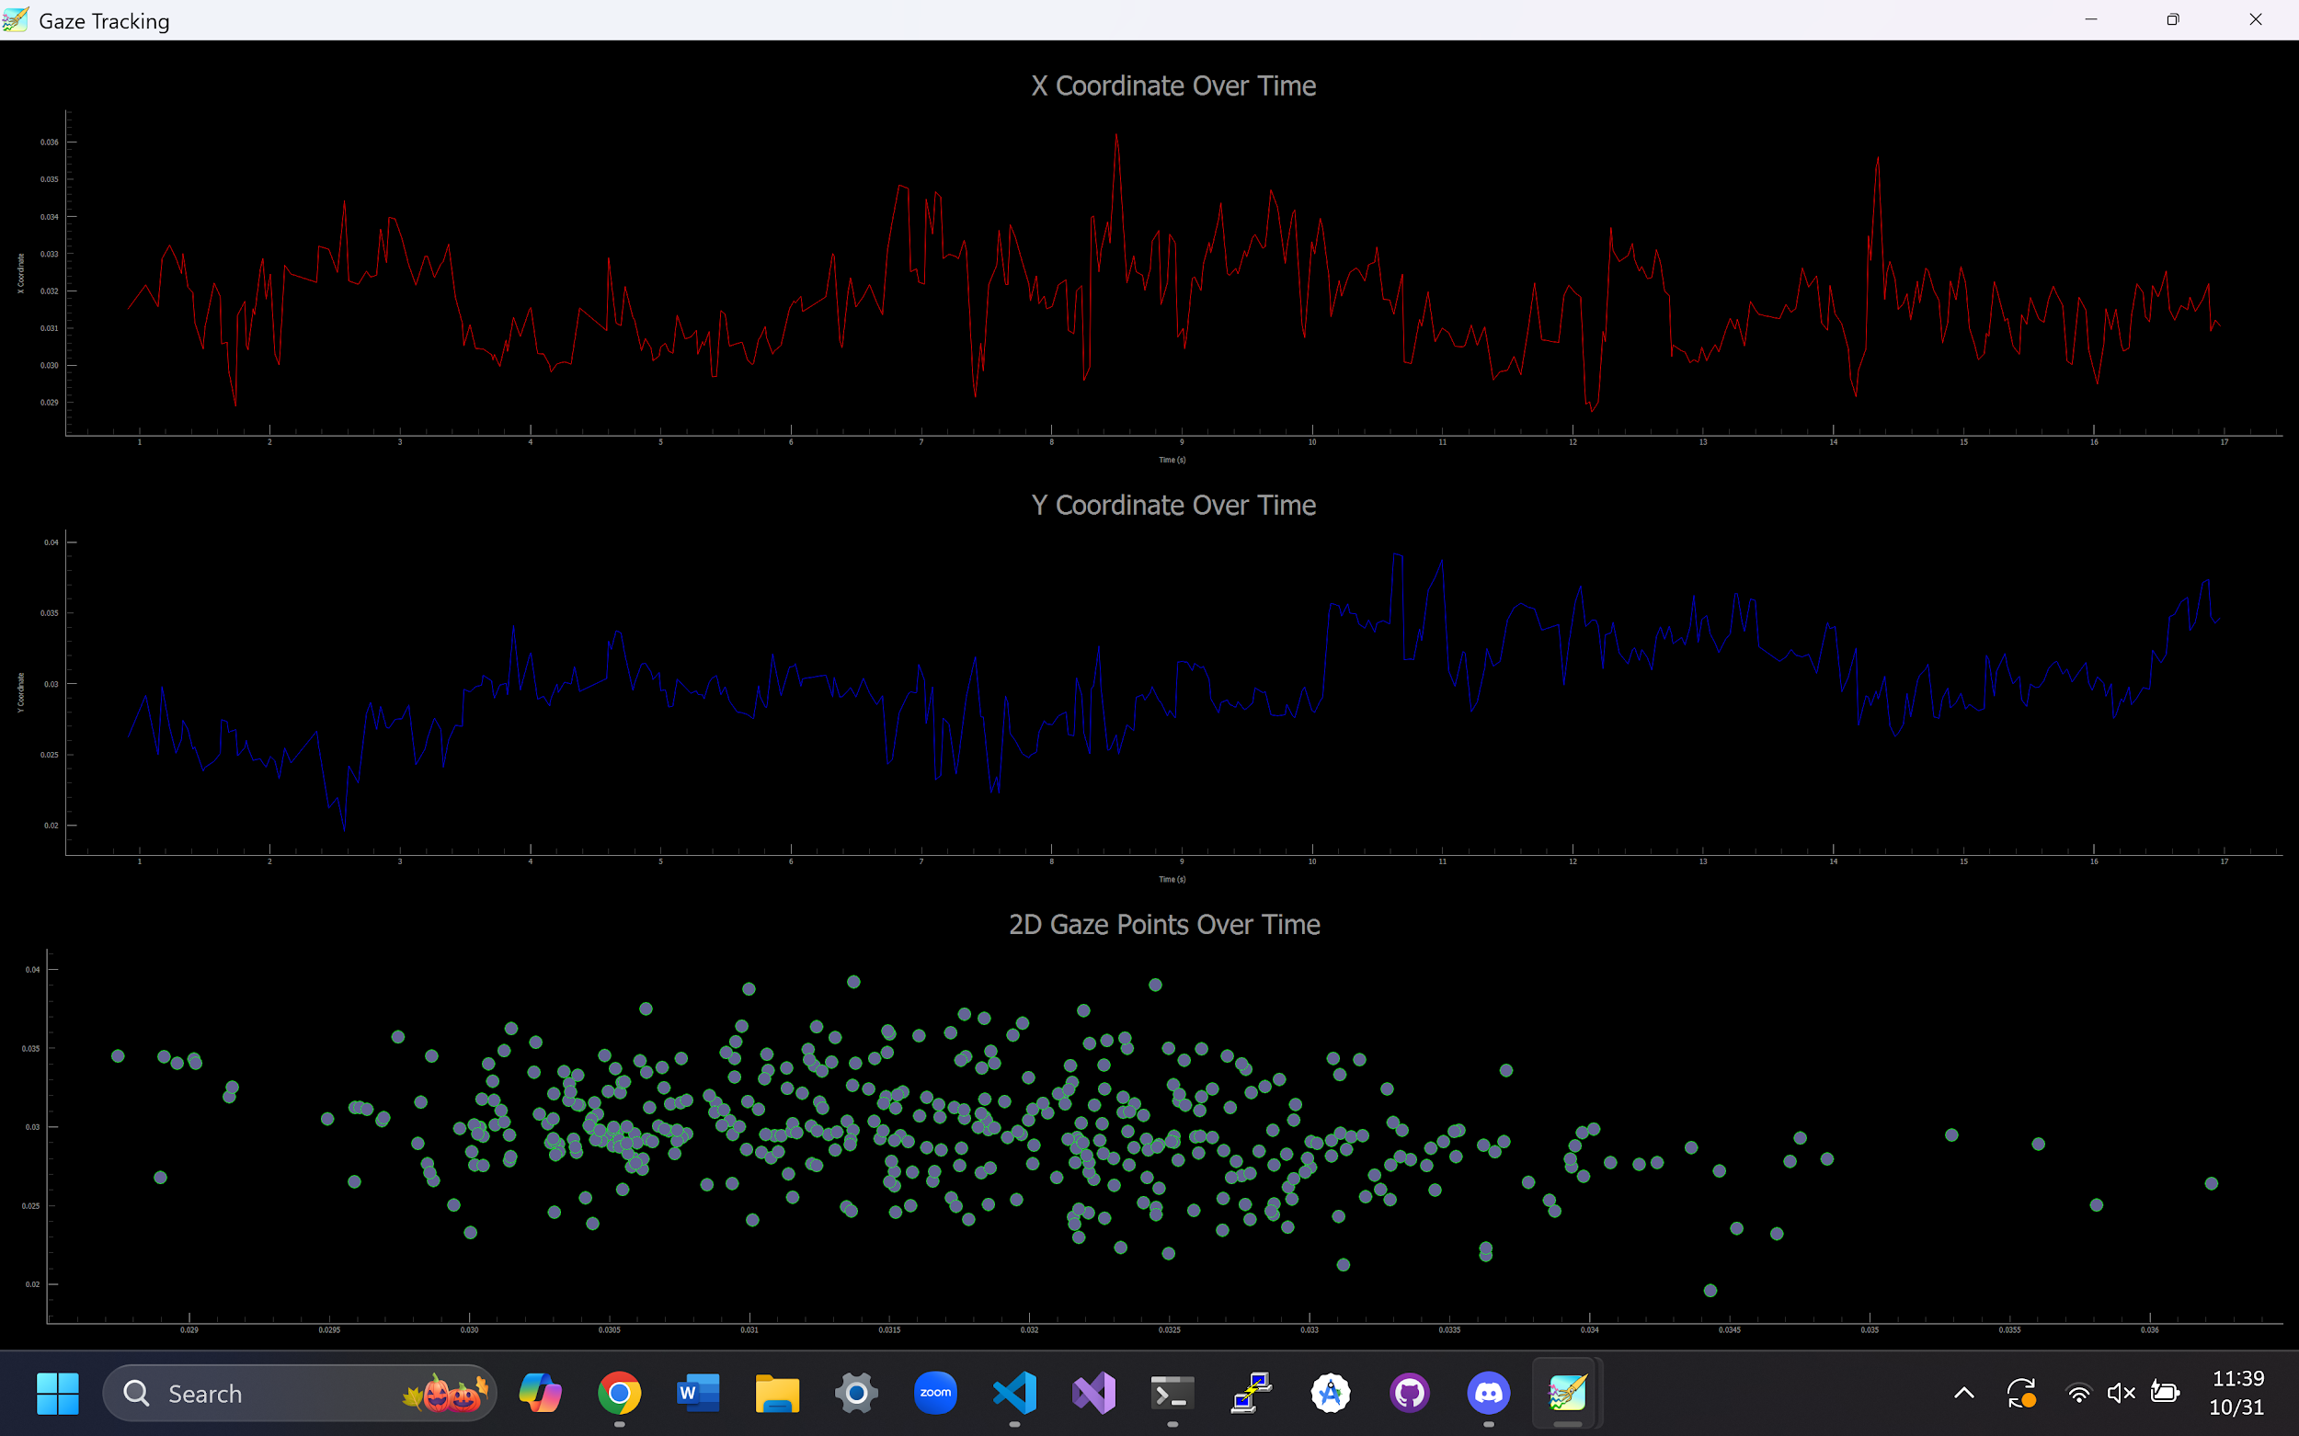
Figure 10.2.2.2: Visual representation of 2D graphs using pyqt graphing.
Real-Time Updates: Data handling was modified to allow for real-time updates of the visualizations. As new gaze data was generated, the relevant plots were refreshed quickly without redrawing the entire figure, thereby enhancing performance.
By replacing Matplotlib with PyQtGraph, significant improvements were achieved in the performance and usability of the gaze tracking application. The new library enabled real-time data updates, enhanced interactivity, and better integration within the PyQt framework. This change not only optimized the user experience but also laid the groundwork for future enhancements, such as more advanced visual representations and interactive features for analyzing gaze data.

10.2.2.3 Performance Metrics and Comparison
To objectively evaluate the performance improvements resulting from the integration of PyQtGraph, a series of metrics were defined and measured across both versions of the gaze tracking system. The testing process aimed to quantify enhancements in real-time responsiveness, computational efficiency, and overall system stability. This section outlines the metrics used, the methodologies applied to gather them, and a comparative analysis of the results obtained.

Metrics Used for Performance Evaluation
The following metrics were used to assess the performance of the gaze tracking system using both Matplotlib and PyQtGraph:
The Average Frames Per Second (FPS) metric was used to gauge the smoothness of frame rendering per second, which is a critical indicator of responsiveness in real-time applications. A higher FPS signifies better visualization quality and user experience. To calculate the average FPS, the formula applied was:
$FPS=\frac{Total Frames Processed}{Total Processing Time}$
Average Frame Processing Time measures the time required to process each frame before visualization, providing insight into the computational burden involved. The calculation was performed as follows:
$Average Frame Processing Time (s)=\frac{Total Time for Frame Processing}{Total Frames Processed}$
The Average Plot Update Time was a key area of difference between Matplotlib and PyQtGraph. This metric assessed the time taken to update visual plots after processing each frame. For real-time responsiveness, minimizing this time is crucial. The formula used was:
$Average Plot Update Time (s)=\frac{Total Time Spent Updating Plots}{Total Number of Plot Updates}$
Additionally, Average CPU Usage provided an understanding of the computational load placed on the CPU by each implementation. Lower CPU usage implies a more efficient system, freeing up processing power for other critical tasks. Similarly, Average Memory Usage was used to evaluate how efficiently each library managed memory resources. High memory usage can indicate inefficiencies or increased resource demands, affecting overall system performance.
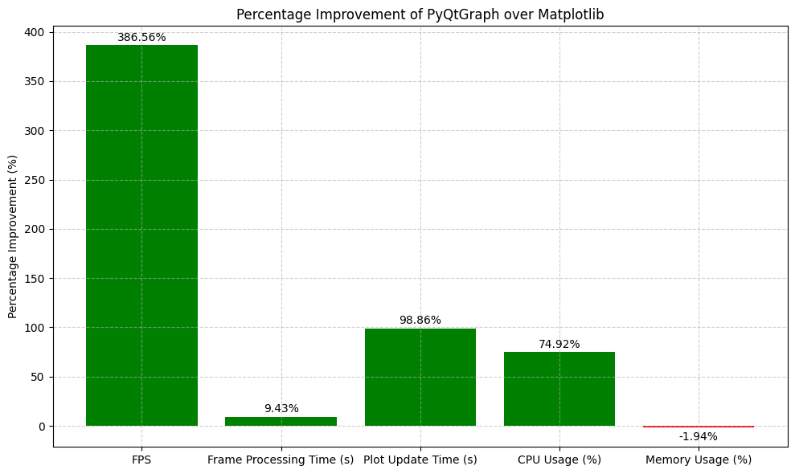
Figure 10.2.2.3: Percentage Improvement of PyQtGraph Over Matplotlib

Results and Analysis
The results of the performance evaluation demonstrated clear differences between Matplotlib and PyQtGraph across all measured metrics:
For Average FPS, Matplotlib achieved 1.86 FPS, whereas PyQtGraph reached 9.05 FPS, representing an improvement of 386%. This substantial gain can be attributed to PyQtGraph’s efficient use of GPU acceleration and optimized rendering, which allows it to handle the rapid visualization requirements without introducing delays.
Regarding Average Frame Processing Time, Matplotlib took 0.0265 seconds per frame, while PyQtGraph reduced this to 0.0240 seconds. Although this reduction was modest, it nonetheless indicates better optimization of frame handling in PyQtGraph. The improved efficiency contributes to more seamless data processing and overall smoother real-time interaction.
A stark difference was observed in Average Plot Update Time, where Matplotlib required 0.5158 seconds to update plots, while PyQtGraph took only 0.0059 seconds. This 98% reduction is largely due to PyQtGraph's asynchronous updating capabilities and its use of GPU buffering. These enhancements made it possible to achieve near-instantaneous updates, a critical requirement for real-time gaze tracking.
Average CPU Usage showed a significant reduction when using PyQtGraph, dropping from 6.62% with Matplotlib to 1.66%. This decrease highlights PyQtGraph's efficiency in offloading visualization tasks to the GPU, significantly reducing the computational strain on the CPU. As a result, the CPU could be reallocated to other intensive operations, such as facial landmark detection and processing complex algorithms.
Conversely, Average Memory Usage was slightly higher with PyQtGraph, measuring 84.13% compared to Matplotlib's 82.53%. This increase in memory demand is expected, given PyQtGraph’s use of GPU buffering and its handling of multiple real-time visualizations. Although the memory usage rose by approximately 2%, the considerable gains in FPS, CPU efficiency, and reduced latency clearly outweigh this minor drawback.

Conclusion
The analysis of performance metrics unequivocally shows that PyQtGraph is a superior solution for real-time gaze tracking visualization when compared to Matplotlib. The enhancements in FPS (a 386% increase), plot update times (98% reduction), and CPU usage (significantly decreased) make PyQtGraph an ideal choice for handling high-frequency, real-time data visualization. While memory usage slightly increased, the overall gains in responsiveness, smoothness, and computational efficiency far outweigh this limitation. Thus, PyQtGraph emerges as the optimal choice, ensuring that the gaze tracking system delivers maximum performance and an improved user experience.

10.3. Fixes and Features
Throughout the development process, several bugs were identified and addressed, along with key improvements that enhanced the system’s efficiency, modularity, and usability. These changes not only improved the accuracy of the gaze tracking system but also made the codebase more maintainable and user-friendly.

10.3.1 Time Synchronization Issues
During development, the gaze tracking system encountered challenges related to time synchronization between different data streams. Since the system continuously captured video frames, extracted facial landmarks, and processed gaze coordinates in real time, even minor delays in any part of the pipeline could lead to misaligned data. This desynchronization often manifested as inconsistencies in gaze estimates, where the tracked coordinates would not correspond precisely to the moment they were captured. As a result, visualizations such as gaze trails or heatmaps displayed incorrect paths, reducing the accuracy of behavioral analysis and real-time feedback mechanisms.
Initially, the gaze tracking application encountered a significant challenge related to timestamp accuracy. The time_data array, responsible for recording the timestamp of each processed frame, was being populated based on the actual time taken to process each frame. This approach introduced inconsistencies because the processing time for each frame could vary due to factors such as system load, the complexity of image transformations, and hardware performance. As a result, the timestamps became unreliable, leading to misalignment between the gaze data and the video timeline. This misalignment compromised the ability to accurately analyze gaze patterns and synchronize gaze points with specific moments in the video.
To resolve this, the system implemented timestamp-based synchronization across all components. Each frame and its associated data were tagged with precise timestamps to ensure alignment throughout the processing pipeline. The solution involved calculating the Frames Per Second (FPS) during the initialization phase of the video processing. For video files, the FPS was retrieved directly using OpenCV's cap.get(cv2.CAP_PROP_FPS) method. In cases where the FPS could not be determined, such as with certain webcam inputs, a standard FPS value of 30 was assumed to maintain consistency. Additionally, a frame counter was introduced to keep track of the number of frames processed. For each frame, the script incremented the frame counter and calculated the timestamp by dividing the frame count by the FPS (frame_count / FPS). This method ensured that the timestamps were based on a consistent frame rate rather than variable processing times, thereby eliminating the inaccuracies previously encountered.
By shifting from a processing time-based timestamping system to an FPS-based frame count methodology, the application achieved precise and consistent synchronization between gaze data and the video timeline. This enhancement not only improved the reliability of temporal analyses, such as measuring gaze fixation durations and transitions but also simplified the timestamp management process. The introduction of a frame counter and the reliance on a stable FPS value ensured that each gaze data point accurately corresponded to its respective video frame, thereby enhancing the overall integrity and dependability of the gaze tracking application.

10.3.2 Landmark Position Adjustments
During testing, it became evident that landmark detection inconsistencies were negatively impacting the precision of gaze tracking. These inconsistencies manifested when facial features were not consistently mapped, especially during subtle head movements, changes in facial expression, or when the subject was partially obscured. For example, shifts in the detected location of the eyes, nose, or mouth could lead to inaccuracies in gaze estimation, even if the subject’s gaze did not actually change. This issue was particularly evident when tracking landmarks during blinks or slight rotations of the head, where the instability of these points caused noticeable jitter in gaze tracking output.
To address this, smoothing algorithms were implemented to stabilize landmark positions across consecutive frames. One method involved applying a moving average filter to dampen the jitter caused by minor detection shifts. This ensured that small deviations in the detected positions would not result in significant changes in gaze direction. Additionally, adjustments were made to fine-tune the sensitivity of the landmark detection algorithm, ensuring that even under less-than-ideal lighting or head poses, the detected points would remain reliable. Further calibration was performed to align landmark positions consistently with the actual facial geometry, reducing errors caused by slight variations in camera angles or user posture. These adjustments collectively improved the system’s ability to track gaze movements accurately and maintain stability during real-world use cases.

10.3.3 X and Y Coordinate System Fixes
Another significant challenge was ensuring the accuracy and reliability of the x and y coordinate system used to measure gaze direction. While the x-axis tracking, which measured horizontal eye movements, yielded consistent results, the vertical axis (y-axis) proved to be more problematic. This discrepancy arose due to the variability in eyelid positioning when a person looked up or down, as well as differences in eyelid size among users. Because the detected y-coordinates fluctuate based on eyelid movements rather than the true gaze direction, vertical tracking was often unreliable, resulting in skewed gaze estimations.
To fix this, the y-coordinate system was restructured to rely on the nose landmark as a stable reference point instead of the more dynamic eyelid positions. By subtracting the y-coordinates of the eyes from the y-coordinate of the nose landmark, the system could filter out distortions caused by blinking or changes in eyelid size. This adjustment ensured that the measured vertical movement corresponded more closely to actual gaze shifts rather than eyelid motion. Similarly, the x-axis tracking, which already performed well, was further refined by calibrating the system to align the horizontal movement of both eyes with respect to the nose. This recalibration reduced inaccuracies introduced by minor head tilts, improving the precision of left and right gaze detection.
Additionally, normalization techniques were explored to further refine the coordinate system, making the system more resistant to variations in camera distance or angle. This ensured that even if a subject changed their distance from the camera or tilted their head slightly, the gaze tracking remained consistent. These improvements in the x and y coordinate system were crucial for achieving stable, reliable tracking across both axes, enabling the system to accurately capture gaze direction and enhance the quality of downstream visualizations, such as heatmaps or fixation point tracking.

10.3.4 Modular File Structure
To enhance maintainability and streamline development, the project adopted a modular file structure. This approach involved dividing the system into separate modules, each responsible for a specific functionality, such as individual frame processing, graphing, simulation creation, configuration argument management and a main program to act as the glue for all the other modules to work together harmoniously. By isolating these components, the codebase became easier to navigate and maintain, reducing the likelihood of conflicts during development. This structure also facilitated collaborative work, allowing multiple developers to work on different parts of the project simultaneously without interfering with each other’s progress.
The modular design improved scalability, enabling new features to be added with minimal disruption to the existing code. For example, the gaze tracking module could be independently updated or replaced with an alternative algorithm without needing to modify the visualization or detection modules. This flexibility allowed for smoother iteration and experimentation, ensuring the system could evolve over time. Furthermore, modularization enhanced testing by allowing each component to be independently validated, making it easier to identify and resolve issues. This structure not only improved the development workflow but also made the system more robust and adaptable to future changes.

10.3.5 Usage of JSON for Configuration
The shift from command-line arguments (CLI) to JSON-based configuration brought significant improvements in usability, flexibility, and maintainability. CLI arguments often required users to input multiple parameters manually, which increased the potential for errors and made it challenging to manage complex configurations. JSON, by contrast, provides a structured and human-readable way to store configuration parameters, making it easier to organize, modify, and reuse settings. With JSON configuration files, users could manage settings such as detection thresholds, input resolution, or tracking modes more efficiently. Instead of manually entering arguments each time the system was launched, users could load predefined configurations, saving time and reducing errors.
Using JSON also made it easier to maintain consistency across different deployments. Configuration files could be version-controlled, allowing teams to track changes over time and ensure all members used the same settings. This was particularly useful for testing, where specific configurations needed to be replicated accurately across different environments. Additionally, the JSON format enabled the system to be more adaptable by supporting multiple configuration profiles. Users could switch between profiles quickly to test different settings without altering the core code or re-entering parameters manually. The adoption of JSON not only improved the user experience but also enhanced the system’s flexibility, making it easier to scale and maintain across various use cases.

10.3.6 Vectorization of Iris Location
The vectorization of iris location was a pivotal improvement that significantly enhanced the efficiency, accuracy, and performance of the gaze tracking system. Traditional gaze tracking algorithms often relied on calculating gaze direction through discrete coordinate differences or complex geometric models, which introduced computational overhead and made real-time performance challenging. Vectorization, by contrast, streamlined these calculations using mathematical vectors to represent the position and movement of the irises. This approach allowed the system to efficiently compute the direction and magnitude of gaze shifts with minimal latency.
In this method, the position of each iris relative to a stable landmark, such as the nose, was expressed as a vector. Each vector represented the displacement of the iris from its neutral position, with both magnitude and direction encoded in the vector's components. For horizontal movement, the x-components of the vectors were analyzed, while vertical movements were captured through the y-components. This vectorized representation enables rapid calculations of gaze direction by performing linear algebra operations, such as dot products or vector norms, which are computationally efficient even when performed continuously across multiple frames (due to numpy and its blazingly fast computations).
Vectorization also improved the accuracy of gaze tracking. By treating each iris movement as a vector, the system could better capture subtle gaze shifts and patterns, such as saccades—rapid eye movements between two points—or smooth pursuits, where the eyes follow a moving target. Additionally, this approach allowed for the comparison of vectors between the left and right eyes, enabling the detection of asymmetries that could indicate cognitive stress or micro-expressions. The mathematical precision of vectorization reduced cumulative errors that often occur when relying on discrete coordinate differences, ensuring that the gaze tracking system maintained high fidelity over time.
Another advantage of vectorization was its ability to handle variability in head position or camera alignment. Because vectors are independent of absolute position and scale, the system remained robust even if the user changed their distance from the camera or tilted their head slightly. This independence from external factors made the vector-based gaze tracking system more resilient to environmental changes, ensuring consistent performance across different scenarios. Moreover, vectorization facilitated the generation of smooth and continuous gaze paths for visualization purposes, such as heatmaps or gaze trails, which provided intuitive insights into gaze behavior.
In addition to improving performance and accuracy, vectorization also contributed to the scalability of the system. The mathematical operations involved in vector manipulation are well-suited for parallelization, meaning they can be efficiently executed on modern hardware, such as GPUs. This scalability ensures that the gaze tracking system can handle higher frame rates and more complex use cases, such as multi-user tracking or real-time feedback applications, without compromising performance.
The adoption of vectorization ultimately transformed the way iris location and gaze direction were computed within the system. It not only reduced the computational complexity of the tracking algorithms but also enhanced the accuracy and robustness of the gaze estimation. This improvement laid the foundation for more advanced features, such as dynamic gaze-based interactions, behavioral analysis, and deception detection, making the system more versatile and powerful for real-world applications.

11. Deterministic Gaze-Based Analysis
The DETECT system uses a deterministic algorithm to analyze gaze behavior and identify deception-related patterns based on established NLP eye cue theories. This method replaces the previously proposed Hidden Markov Model (HMM), offering greater transparency, adaptability, and real-time performance. The analysis focuses on two core metrics—gaze dispersion and gaze acceleration—which are computed directly from the raw (x, y) eye coordinate stream extracted via MediaPipe.

11.1 Core Analysis Methodology
As users interact with DETECT, the system collects sequential gaze coordinates (x, y) alongside timestamp information. Each gaze point is then evaluated based on the following metrics:

- Variance (Dispersion): Measures how far gaze points deviate from a central region. High variance indicates erratic gaze behavior, often linked to cognitive stress or intentional redirection of attention—markers correlated with deception.
- Acceleration: Captures the rate of change in gaze direction, identifying sudden shifts in eye movement. Sharp accelerations may suggest abrupt mental transitions, uncertainty, or scripted responses.
To standardize interpretation, each metric is scaled using predefined Min-Max normalization:
$normalized_value=\frac{current-min}{max-min}$
This normalization ensures that all scores fall within a [0, 1] range, creating a uniform probabilistic space for evaluating abnormal behavior.

11.2 Backend Processing Pipeline
Once extracted from the frontend, gaze data is streamed to the backend using the Gorilla WebSocket library, allowing low-latency, bidirectional communication. The Go-based backend processes each gaze point as follows:
- Parse (x, y, t) inputs from the WebSocket buffer.
- Compute dispersion and acceleration incrementally.
- Apply session-level normalization using rolling min and max statistics.
- Generate a deception likelihood score in real time.
- Store raw metrics and results in the PostgreSQL session table for future analysis/export.
To ensure consistency and fairness, the backend recomputes the min/max ranges dynamically per session, initializing with system defaults but adjusting if a user’s behavior deviates significantly. This guards against outlier distortion and supports both short and extended testing sessions.

11.3 Sensitivity Settings
The DETECT algorithm introduces a user-configurable sensitivity multiplier that adjusts how strict or lenient the scoring thresholds are. This multiplier directly scales normalized scores before final classification:
- Sensitivity < 1.0: More lenient detection (e.g., 0.75)
- Sensitivity = 1.0: Standard, balanced detection
- Sensitivity > 1.0: Stricter detection (e.g., 1.25)
This setting is especially useful for adapting DETECT to different testing environments or behavioral baselines—such as distinguishing between informal interviews and high-stakes interrogations.
The current sensitivity multiplier is set at 1.00 by default, but can be configured per session by an administrator or study leader. All adjustments are logged and linked to session metadata in the database for traceability.

12. Data Modeling and Documentation
In the DETECT project, data modeling and documentation are critical for translating the raw output from the gaze-tracking system into meaningful insights. This section explores the various methods used for visualizing, calculating, and analyzing gaze data to evaluate model performance. Utilizing real-time graphs, graphical representations, and accuracy metrics, a comprehensive analysis of how the system tracks eye movements is presented. Detailed documentation of testing procedures and results ensures transparency and reproducibility of findings, providing a foundation for future improvements and applications in lie detection technologies.

12.1 Data Visualization
In the DETECT project, effective data visualization plays a critical role in conveying the underlying patterns captured through eye-tracking and gaze detection. Visualization allows for clear representation of eye movement data, helping users understand how eye behavior correlates with deception and other cognitive activities. This section outlines two major components of data visualization within the project: real-time graphs and graphical representations of gaze patterns and animations. Both components are designed to work in tandem to provide users with comprehensive insights into eye movement and its implications for detecting deception.

12.1.1 Real-Time Graphs
In the DETECT project, real-time data visualization plays a fundamental role in the dynamic analysis of gaze tracking information. By implementing real-time graphs, the system provides a visual representation of how the subject’s gaze moves over time, offering immediate insights into their eye movements, direction, and focus. This section outlines the system's design, functionality, and the various practical elements that support the real-time graphs, which include tracking and plotting horizontal and vertical eye coordinates relative to a fixed nose point.

Overview of the Real-Time Graphing System
The real-time graphing system in DETECT is built to capture and plot eye movement data as it happens. The system tracks the movement of the subject’s eyes by using MediaPipe’s face mesh model to identify facial landmarks, focusing on the iris and its position in relation to the nose. The nose, particularly the point at the facial landmark[4], is treated as a stationary reference point, and all movements of the iris are measured in relation to it. This approach allows for a stable frame of reference for graphing eye movements, assuming the subject’s head remains relatively stationary throughout the session.
The primary goal of the real-time graph is to plot the horizontal (x) and vertical (y) coordinates of the subject’s gaze over time. By using real-time data from the MediaPipe facial landmark model, the system tracks the relative positions of the iris in relation to the nose. These coordinates are then plotted on two separate graphs: one for horizontal movement (left-right) and another for vertical movement (up-down). These graphs update continuously as new data is captured, providing a real-time visual representation of where the subject is looking.

Data Capture and Processing Pipeline
The real-time graphing pipeline begins with video input, which can either come from a live webcam feed or from a pre-recorded video file. Each frame of the video is processed using MediaPipe’s face mesh model to detect the subject’s facial landmarks. The iris position is extracted based on specific landmarks around the eyes, while the nose’s position is extracted from landmark[4], which remains the point of reference throughout the session.
Once the position of the iris is detected, the x and y coordinates of the iris relative to the nose are computed for both eyes. The system averages the x and y coordinates from both eyes to create a single data point representing the overall gaze direction. This ensures that any minor differences between the left and right eyes, which may occur due to natural asymmetry or slight variations in detection accuracy, do not cause erratic graph behavior.
The resulting data points—representing the averaged horizontal and vertical gaze positions—are then plotted on the real-time graph. The x-axis of the graph represents time in seconds, while the y-axis represents either the horizontal or vertical coordinate value. The graphs are updated continuously as new data points are generated, giving the user a real-time view of the subject’s gaze movements.

Horizontal and Vertical Gaze Tracking
The horizontal gaze tracking graph plots the x-coordinate of the subject’s gaze over time. This graph reflects how much the subject’s gaze moves from left to right during the session. The x-coordinate is normalized so that a higher value indicates a gaze direction to the right, while a lower value indicates a gaze direction to the left. Since the nose is considered the reference point, any movement of the iris to the right of the nose results in an increase in the x-coordinate, while movements to the left result in a decrease.
The vertical gaze tracking graph, on the other hand, plots the y-coordinate of the subject’s gaze over time. This graph reflects how much the subject’s gaze moves up and down during the session. Similar to the x-coordinate, the y-coordinate is normalized so that a higher value indicates that the subject is looking upwards, while a lower value indicates a downward gaze. The nose again serves as the fixed reference point, so any upward movement of the iris in relation to the nose increases the y-coordinate, while downward movements decrease it.
These two graphs are displayed side-by-side in the DETECT system, allowing the user to see both the horizontal and vertical components of the subject’s gaze simultaneously. The graphs update continuously in real time, providing a dynamic visual representation of how the subject’s gaze is moving at any given moment.

Real-Time Graph Display and User Interface
The real-time graphs are implemented using Python’s Matplotlib library, which provides flexible and high-performance graphing capabilities. The graphs are designed to update at a fixed rate, ensuring that they stay in sync with the video feed or webcam input. The graphing process is implemented on a separate thread from the video processing pipeline, which ensures that the video and graphing systems do not interfere with each other, maintaining smooth performance even during high frame-rate video playback.
The user interface displays the real-time graphs in a clear and accessible format. Each graph is labeled with appropriate axes and legends, allowing users to easily interpret the data. The horizontal gaze graph is labeled as “X Coordinate (Left-Right)” and shows the subject’s gaze movements along the x-axis over time. The vertical gaze graph is labeled as “Y Coordinate (Up-Down)” and shows the subject’s gaze movements along the y-axis over time.
For added clarity, the graphs include gridlines, making it easier to track the exact time and coordinate values of any given point on the graph. This feature is particularly useful when users need to correlate specific moments in the video with changes in the subject’s gaze direction, such as when the subject is asked a specific question during an interrogation or interview.
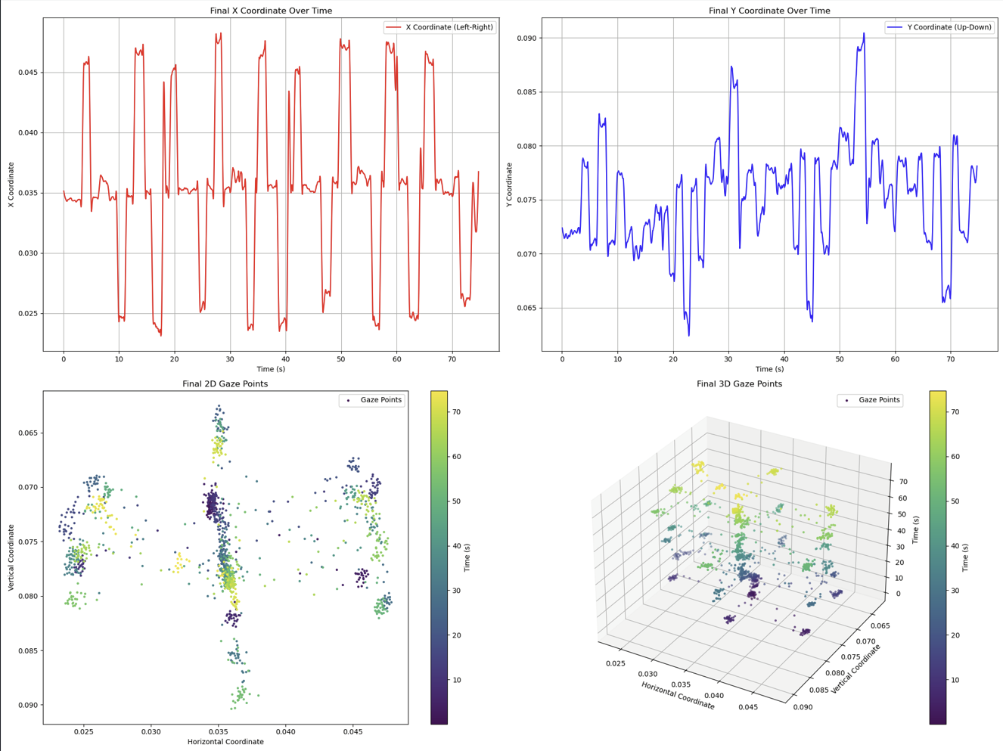
Figure 12.1.1.i: Gaze Tracking Data Visualization: X and Y Coordinate Plots, 2D and 3D Gaze Distribution

Thresholds and Region Categorization
One of the core features of the real-time graph system is its ability to categorize gaze movements into predefined regions. Based on the experience and experimental data collected during the development process, the team identified threshold values for the x and y coordinates that define nine distinct regions of gaze direction: top-left, top-center, top-right, middle-left, middle-center, middle-right, bottom-left, bottom-center, and bottom-right. These regions help categorize gaze patterns in a structured way.
The categorization process works by comparing the current x and y coordinates of the subject’s gaze to the threshold values. Depending on whether the x and y coordinates fall above or below these thresholds, the system assigns the subject’s gaze to one of the nine regions. This categorization is updated in real time, and the system can display the current gaze region as text on the video output (e.g., “Gaze Direction: Center-Center”), as seen in the video image output provided below.
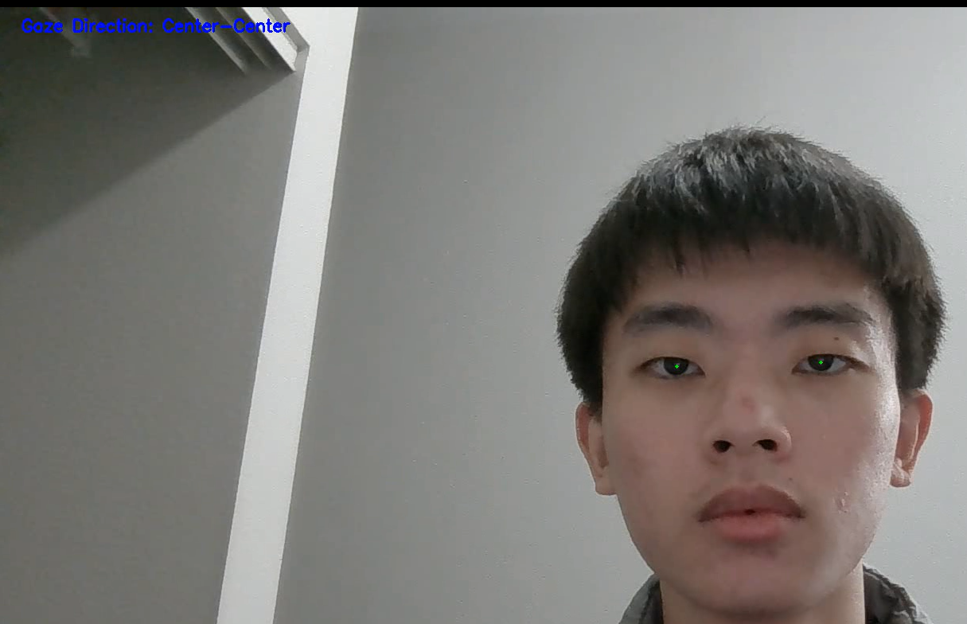
Figure 12.1.1.ii: Real-Time Gaze Tracking with Nose Vector Coordinate System
This region-based categorization is particularly useful for identifying patterns in the subject’s gaze behavior over time. For instance, if the subject consistently looks to the top-right during certain questions, this pattern might provide insights into their thought processes or emotional state. However, the current system focuses purely on the categorization and tracking of gaze patterns, leaving deeper behavioral analysis for future development.

Use Cases of Real-Time Graphs
The real-time graphing system in DETECT has a variety of potential applications across different fields. One of the most important use cases is in lie detection and behavioral analysis. By monitoring how the subject’s gaze moves in real time, users can identify patterns that may be associated with cognitive load, stress, or deception. For instance, erratic or inconsistent gaze patterns might indicate that the subject is struggling to recall information or is fabricating a response.
Another key use case is in research settings where eye-tracking data is used to study attention, engagement, and decision-making processes. In these contexts, the real-time graphs provide immediate feedback on how the subject is responding to different stimuli, such as images, videos, or questions. By tracking where the subject is looking and how their gaze shifts over time, researchers can gain valuable insights into their thought processes and reactions.
Real-time graphs also have practical applications in fields like education and user experience (UX) design. In educational settings, real-time gaze tracking can be used to monitor student engagement during lessons or presentations. By analyzing the graphs, educators can identify when students are paying attention and when they may be distracted. Similarly, in UX design, gaze tracking can be used to analyze how users interact with websites or software interfaces, providing insights into which elements capture their attention and which elements they may be ignoring.

Future Improvements for Real-Time Graphs
While the real-time graphing system in DETECT is already functional, there are several potential areas for future improvement. One major area is the inclusion of additional data visualizations that provide more granular insights into gaze behavior. For example, adding heatmaps that show the density of gaze points over time could help users identify areas where the subject’s gaze is concentrated, offering a more intuitive understanding of gaze patterns.
Another possible improvement is the integration of more advanced graphing techniques, such as three-dimensional plots that capture not only the horizontal and vertical gaze coordinates but also the depth or duration of gaze fixation. This would allow users to see not only where the subject is looking but also how long they are focusing on a particular area. By incorporating these additional dimensions into the real-time graph, the system could provide a richer and more detailed representation of the subject’s gaze behavior.
Furthermore, there is potential for the system to automatically detect and flag certain gaze patterns that might be of interest to the user. For example, the system could be trained to recognize patterns associated with cognitive load or stress and highlight these moments on the graph. This would allow users to quickly identify critical moments during a session without having to manually analyze the entire graph.
In conclusion, the real-time graphing system in DETECT provides a powerful tool for tracking and visualizing gaze movements

12.1.2 Graphical Representations of Gaze Patterns and Animation
In the DETECT system, graphical representations of gaze patterns and animations play an integral role in interpreting the collected data, especially regarding the user’s eye movements. These visual representations are central to understanding where the user is focusing during a session and how the gaze shifts over time. By providing clear, accessible visual data, the system allows researchers, developers, and users to comprehend how the subject’s eye movements behave in real time or over a recorded session. The primary graphical outputs currently supported by DETECT include both static graphs and a dynamic animation feature that visualizes the subject’s gaze over time.

Gaze Patterns Visualization
One of the key outputs of the DETECT system is a series of static plots illustrating gaze data in both two dimensions (2D) and three dimensions (3D). These graphs are generated using iris coordinate data, with the position of the irises tracked in relation to a stable facial feature—the nose, represented by MediaPipe's landmark [4]. The use of the nose as a reference point ensures consistent tracking, even during slight head movements. By fixing the nose as a reference, eye movements can be isolated from head movements, enabling a more accurate representation of gaze patterns.
In the 2D scatter plots, the x and y coordinates of the subject’s gaze are visualized as points that correspond to horizontal and vertical movements. A larger x-coordinate value indicates that the user is looking further to the right, while a larger y-coordinate indicates that the gaze is directed upward. Over the course of a session, this collection of data points begins to form clusters, offering a clear representation of the user’s gaze tendencies. These clusters help in identifying where the subject looked most frequently and how often their gaze returned to a particular area. For example, a concentration of points in the upper-left quadrant of the plot may indicate that the subject spent a significant portion of the session looking toward that direction. These 2D plots are straightforward, making it easy for users to interpret general gaze behavior at a glance.
The 3D scatter plot adds an additional layer of depth to this visualization by incorporating time as a third dimension. This allows for a more comprehensive analysis of how the gaze shifts over the duration of the session. In the 3D plot, the z-axis represents time, with each point's position on the axis corresponding to when the gaze was recorded. This temporal dimension reveals trends in gaze behavior that are not apparent in the 2D plot alone. For instance, if a subject repeatedly shifts their gaze from left to right over the course of the session, the 3D plot will display a wave-like pattern as the points alternate between the left and right sides of the x-axis, moving steadily along the z-axis over time. These 3D visualizations are particularly valuable in applications where time-based analysis is important, such as assessing a subject's attention span or tracking how their gaze behavior changes in response to stimuli.

Gaze Animations
Another significant aspect of the graphical outputs in the DETECT system is the gaze animation feature, which dynamically visualizes the subject’s gaze in real-time or over a pre-recorded session. In this animation, a moving dot represents the subject’s gaze as it shifts across the screen. The position of the dot corresponds to the average position of the irises relative to the nose, calculated using the same coordinate system applied in the scatter plots. As the user moves their eyes, the dot moves accordingly, tracing the trajectory of the gaze in a smooth, continuous motion. This real-time visualization is particularly useful for users who need to follow gaze behavior as it unfolds, allowing for an intuitive understanding of eye movement patterns.
The simplicity of the gaze animation—represented by a single moving dot—ensures that users can focus on the key elements of eye movement without being distracted by unnecessary visual clutter. Although the current version of the system uses this basic dot representation, it effectively conveys the subject's gaze direction and movement. The animation clearly shows when the subject shifts their gaze from one part of the screen to another, making it easy to identify moments of focused attention versus moments of rapid scanning or distraction. This feature is valuable for real-time applications such as behavioral analysis, where quick interpretation of gaze patterns is essential.
The DETECT system also integrates gaze categorization within its graphical outputs. By dividing the screen into nine distinct regions based on predefined thresholds for x and y coordinates, the system can categorize the user’s gaze into specific regions, such as “Top-Left,” “Center-Right,” or “Bottom-Center.” These categories provide an additional layer of insight, helping to identify not just whether the subject's gaze is moving but also where exactly they are focusing at any given moment. This categorization can be visualized both in the animation, where the moving dot shifts between regions, and in the accompanying textual output, where the system provides real-time updates on the current gaze direction. This feature is especially useful in contexts where knowing the precise direction of gaze is important, such as in attention-tracking studies or lie detection, where gaze aversion or fixation on certain areas might be indicative of deception.

Potential Future Improvements
While the current system performs well in terms of tracking and visualizing gaze, there are several areas for potential future enhancements. One such area is the addition of heatmaps to the graphical outputs. Heatmaps would provide a more intuitive and comprehensive summary of where the subject spent most of their time looking during the session. By aggregating gaze points into a 2D grid and color-coding areas based on the density of points, heatmaps would allow users to quickly identify focal points of attention. Areas where the subject concentrated their gaze for extended periods could be represented in warm colors (e.g., red or orange), while areas with less frequent gaze activity could be shown in cooler colors (e.g., blue or green). This feature would be particularly useful in long sessions, where a large number of gaze points could make scatter plots difficult to interpret at a glance.
Another potential improvement is the incorporation of color-coding into the gaze animation itself. In its current form, the animation uses a single, uniform color to represent the moving dot that tracks the user’s gaze. However, future iterations of the system could enhance this by using color to indicate additional metrics, such as the speed of gaze movement or the duration of gaze fixation. For example, rapid eye movements could be represented by a red dot, while slower or more focused movements could be shown in blue. This would provide users with an immediate visual cue about the nature of the subject’s gaze behavior, offering deeper insights into how the subject is interacting with their environment.
Moreover, future versions of the system could incorporate advanced metrics into the gaze animation. Currently, the animation focuses solely on tracking the position of the gaze, but future iterations could introduce additional data points, such as fixation duration (how long the subject remains focused on a particular point) or saccade velocity (the speed at which the gaze shifts from one point to another). These metrics could provide valuable insights into the subject’s cognitive and emotional state, offering a more nuanced understanding of their behavior. For example, longer fixations might indicate increased focus or concentration, while rapid saccades could suggest nervousness or distraction. By integrating these metrics into the animation, the system could offer a more comprehensive view of gaze behavior.
In conclusion, the DETECT system's graphical representations and animations provide valuable tools for visualizing and interpreting gaze data. The combination of 2D and 3D scatter plots, along with the gaze animation, offers users a clear and intuitive way to track and analyze eye movements over time. These visual outputs are essential for understanding gaze behavior in various contexts, from behavioral analysis to real-time applications. While the current system is highly effective in its core functionality, future enhancements—such as the addition of heatmaps, color-coded animations, and advanced gaze metrics—could further improve the system’s ability to deliver actionable insights. These improvements would not only make the visualizations more engaging but also provide users with a deeper, more comprehensive understanding of gaze behavior.

12.2 Metrics Calculation
In the DETECT project, the primary metric for evaluating the performance of the gaze-tracking models is accuracy. Accuracy refers to the proportion of correct predictions made by the model relative to the total number of predictions. It is critical for understanding how well the system detects and categorizes gaze directions based on eye-tracking data.

Accuracy Formula
Accuracy in this context is computed using the following formula:
$Accuracy = \frac{Number of Correct Predictions}{Total Number of Predictions} ×100$
The numerator in the accuracy calculation refers to the count of instances where the model accurately predicted the gaze direction (such as left, right, center, up, or down) at particular timestamps. The denominator indicates the total number of predictions made across the selected timestamps. This ratio is then multiplied by 100 to derive a percentage, providing an intuitive measure of the model's performance in gaze tracking.
Instead of calculating accuracy continuously, the DETECT system samples gaze data at random timestamps, typically between 25 and 35, over the course of each test. These random timestamps are used to reduce potential biases and provide a more representative view of the model's performance across different moments within the video or webcam feed.

Gaze Tracking Model (V1) Accuracy
The Gaze Tracking Model (V1) was the first iteration of the eye-tracking system, which attempted to predict gaze direction based on raw iris coordinates. The model struggled with noise and fluctuations in iris movement, which made predictions less reliable. Accuracy was calculated using the aforementioned formula, but only at 25-35 random timestamps throughout each test video.
For Jeff, Model V1 had an accuracy of 30.36%, indicating significant difficulty in predicting his gaze movements correctly. Mill achieved 44.00% accuracy, while John performed the best with 62.50% accuracy. These numbers reflect the limitations of V1 in handling noisy or fluctuating gaze data. The random timestamp approach highlighted inconsistencies, where V1 sometimes succeeded in making accurate predictions but often failed in others due to its inability to stabilize gaze tracking over time.
The overall accuracy for Model V1, based on these random timestamps, was 46.47%, which was significantly lower than desired. This performance indicated that improvements were needed, particularly in filtering out noise and stabilizing predictions over time.

Smoothing Model (V2) Accuracy
To overcome the limitations of Model V1, Model V2 incorporated a smoothing algorithm that averaged iris positions over several frames. This approach effectively reduced noise and enhanced the stability of the predictions. Similar to the evaluation of Model V1, the accuracy of Model V2 was assessed at 25-35 randomly selected timestamps per test to maintain consistency and fairness in the evaluation process.
Compared to Model V1, Model V2 demonstrated significant improvements across all testers. Jeff’s accuracy increased to 81.48%, Mill’s to 80.00%, and John’s to 78.13%. These results indicate that the smoothing algorithm effectively minimized the fluctuations observed in V1, resulting in more consistent predictions. The overall accuracy of Model V2 was calculated at 79.76%, using the same random timestamp approach to provide an unbiased assessment, avoiding skewed results from evaluating only continuous frames and offering a balanced view of the model's overall performance.
The smoothing process proved critical in achieving these improved results. By reducing noise and averaging iris data, V2 was able to avoid the erratic predictions that plagued V1. As a result, Model V2 demonstrated that stabilizing gaze predictions can lead to substantial gains in accuracy, especially when using the random timestamp approach to evaluate performance.

Gaze Direction Categorization and Thresholding
Both Model V1 and Model V2 predicted gaze direction by analyzing x and y coordinates relative to the nose landmark. The system utilized MediaPipe landmark[4] as the fixed point for the nose and calculated the x and y coordinates of the iris relative to this point. These coordinates were used to categorize the gaze direction into one of five regions: left, right, center, up, or down.
To establish the categorization, thresholds for x and y values were set based on empirical testing. Positive x values indicated a gaze to the right, while negative x values indicated a gaze to the left. Similarly, positive y values represented an upward gaze, and negative y values represented a downward gaze. These threshold values were consistent across both models.
During the random timestamp evaluation, the model's predicted gaze direction was compared to the ground truth for each selected timestamp. Correct predictions were counted, while incorrect ones were recorded separately. This approach enabled an accuracy calculation for each model using a representative subset of data points, minimizing potential biases or inconsistencies that could arise from evaluating every single frame.

Data Logging and Testing
Throughout testing, gaze data (x and y coordinates) and the predicted gaze direction were logged for further analysis. For each test video, 25-35 random timestamps were selected, and the model’s predictions were recorded at those points. This logging system enabled a retrospective analysis of the performance of both models and to understand the specific moments where the models succeeded or failed.
The accuracy calculation was then based on these specific timestamps, providing insight into the model's ability to generalize across various conditions. The logged data included the actual iris positions, predicted gaze directions, and whether the predictions were correct or incorrect. Additionally, the timestamps assisted in the understanding of how well the model performed at different moments, such as when the subject's gaze shifted quickly or remained steady.
This method of selecting random timestamps for evaluation ensures that the results are not overly influenced by transient errors or noise at particular moments. Instead, it provides a more robust evaluation of the model’s overall performance.

Future Metrics and Improvements
While accuracy remains the core metric for evaluating the performance of both Model V1 and V2, additional metrics such as precision, recall, and F1-score could be introduced in future iterations to provide a more comprehensive understanding of model performance. These metrics enabled an assessment not only of the proportion of correct predictions but also how well the model handles false positives and false negatives.
Furthermore, additional accuracy metrics could be introduced that take into account the different categories of gaze directions. For example, accuracy could be evaluated specifically for upward gazes versus downward gazes, allowing an assessment of whether the model performs better in certain directions. This breakdown would provide a more granular view of performance and could guide future improvements in the system.
In summary, accuracy served as the primary metric for evaluating the performance of gaze-tracking models in the DETECT project. Calculating accuracy at 25-35 random timestamps per test provided a representative evaluation of each model's performance. The implementation of a smoothing algorithm in Model V2 resulted in significant improvements in accuracy, as the model demonstrated enhanced stability in gaze predictions and noise reduction. Future work may consider incorporating additional metrics, such as precision and recall, for a more comprehensive evaluation of model performance.

12.3 Testing and Results
The Testing and Results section presents a comprehensive overview of the testing methodologies used and the subsequent analysis of the outcomes. It details the procedures implemented to evaluate the accuracy and reliability of the gaze detection system and provides insights into the findings that validate the system's performance and highlight areas for improvement.

12.3.1 Testing

Procedures
In this project, the focus was on testing two core models: the GazeTracking model and the Smoothing model. These models form the foundation of the system for detecting deception by analyzing eye movements. The primary objective of the testing phase was to evaluate the effectiveness, accuracy, and overall reliability of both models in tracking gaze patterns in real-time video. Pre-recorded video data was processed through the models, and their outputs were compared against manually annotated ground truth data. This process was crucial to validate the models' accuracy in predicting eye movements, particularly under conditions that simulate real-world scenarios where deception detection is critical.

Video Testing Process
Each pre-recorded video contained various types of gaze behavior under different conditions, such as changes in lighting, rapid eye movements, direct stares, and subtle shifts in gaze. These variations were included to simulate different real-life scenarios, which are important for evaluating the robustness of the models across diverse conditions. After processing the video data through the models, an output video was generated displaying the predicted gaze directions alongside timestamps. This allowed for visual verification of the model's predictions against the actual gaze behaviors observed in the video.
By creating custom videos and manually annotating the ground truth data, the test data was made as accurate and representative as possible. This approach also ensured full control over the testing environment, making sure that any discrepancies between the predicted gaze and the actual gaze could be attributed solely to the model’s performance rather than external factors. The ground truth data served as the baseline for assessing the accuracy of the models' gaze behavior predictions.

Ground Truth and Predictions
The ground truth data was collected manually by reviewing the video and annotating the correct gaze direction for each frame. This process requires careful attention to detail, as even slight changes in gaze needed to be recorded with timestamps. These annotations were categorized into different gaze directions: left, right, center, up, and down. Once the ground truth was established, the videos were processed through both the GazeTracking model and the Smoothing model to generate the predicted gaze directions. The models' outputs were then compared against the ground truth to determine their accuracy. This comparison was crucial for identifying areas where the models excelled and where they required further refinement.

Testing the GazeTracking Model
The GazeTracking model was designed to predict gaze direction in real-time by processing video input. It detected the subject's eye movements and assigned a gaze direction (left, right, up, down, or center) to each frame of the video. To evaluate the model's performance, multiple videos featuring various gaze behaviors were inputted, and the predicted gaze direction for each frame was collected.
After generating predictions, these were compared to the manually annotated ground truth data. This comparison involved matching the model’s predictions with the actual gaze direction recorded at each timestamp in the video. The closer the model's predictions were to the ground truth, the higher its accuracy.
Performance metrics used to evaluate the GazeTracking model included accuracy, defined as the percentage of frames in which the model’s prediction matched the actual gaze direction. To capture additional nuances in the model's performance, metrics such as Mean Absolute Error (MAE) were used to quantify the average error between predicted and true gaze directions. The collected data was logged into an Excel spreadsheet for comparison and analysis, containing columns for video ID, user ID, timestamps, ground truth data, model predictions, and overall accuracy. This level of detail allowed for the identification of specific patterns in the model's behavior, such as common errors and areas where the model had difficulty, such as rapid eye movements.
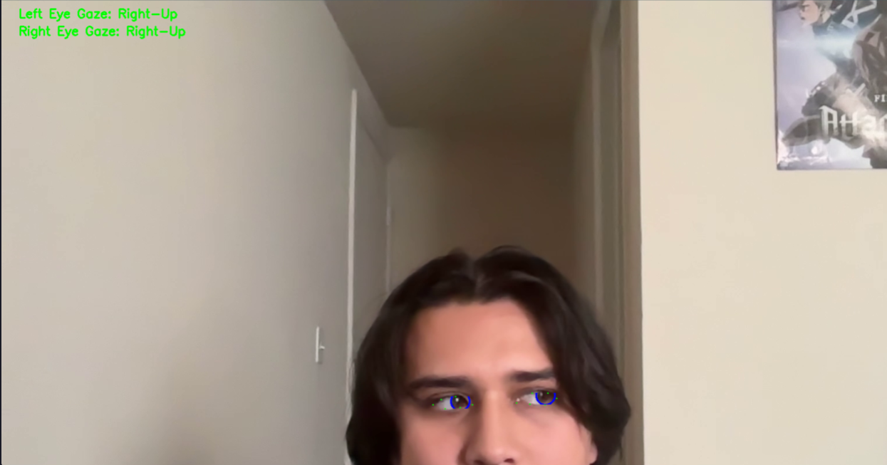
Figure 13.3.1.i: Gaze Tracking model frame

Testing the Smoothing Model
The Smoothing model was designed to refine the raw gaze data produced by the GazeTracking model. Its primary purpose is to reduce noise and smooth out abrupt changes in gaze direction that may be caused by inaccuracies in the gaze tracking algorithm or by natural jitter in the subject's eye movements. By smoothing the transitions between gaze points, the model is better suited for applications where continuous and stable gaze tracking is essential, such as detecting deception cues.
During testing, the Smoothing model was applied to the raw gaze data generated by the GazeTracking model. The idea was to compare the smoothed data with both the raw data and the ground truth to see if the smoothing process improved the model's accuracy in predicting gaze direction.
To achieve better results, modifications were made to the classification thresholds that determine whether a gaze was directed left, right, up, or down. Specifically, in the HorizontalRegion() function, the threshold for detecting "Right" was adjusted to values below 0.050, while "Left" was set to values above 0.055. Similarly, for vertical detection in the VerticalRegion() function, "Up" was defined for values greater than 0.055, and "Down" for values below 0.045. These threshold adjustments were implemented to better capture subtle eye movements that were missed by the initial settings. Fine-tuning these thresholds played a crucial role in improving the Smoothing model's ability to accurately capture gaze movements, particularly in dynamic scenarios involving rapid eye shifts, ultimately leading to significant gains in accuracy.

Figure 13.3.1.ii: Smoothing model frame output
Once testing was completed, the results were logged into an Excel spreadsheet, mirroring the approach used for the GazeTracking model. The spreadsheet was organized to capture both the ground truth and the predictions from the smoothed data. Each entry included details such as video ID, user ID, timestamps, as well as both the ground truth and smoothed predictions for each frame. This structured approach facilitated the calculation of overall accuracy metrics and allowed for clear visualization of the performance improvements achieved by the Smoothing model compared to the GazeTracking model.

12.3.2 Results and Analysis
Overview of Model Performance: The results of the testing showed a clear distinction between the performance of the GazeTracking model (V1) and the Smoothing model (V2). The following analysis highlights the key differences in performance across multiple testers and provides insight into the effectiveness of both models.
GazeTracking Model Performance (V1): The GazeTracking model (V1) had varied performance depending on the tester, as illustrated in the table below:
Jeff (V1): Total count = 56 (Accuracy = 30.36%)
Mill (V1): Total count = 50 (Accuracy = 44.00%)
John (V1): Total count = 64 (Accuracy = 62.50%)
As the data shows, the GazeTracking model struggled the most with Jeff, achieving an accuracy of only 30.36%. Mill’s results were slightly better, at 44%, while John had the highest accuracy at 62.50%. These discrepancies suggest that the model had difficulty adapting to the different gaze behaviors and eye shapes of individual testers. This variability indicates that V1 is likely too sensitive to subtle differences in eye movements, leading to frequent misclassifications
Smoothing Model Performance (V2): In contrast, the Smoothing model (V2) demonstrated more consistent and superior performance across all testers:
Jeff (V2): Total count = 54 (Accuracy = 81.48%)
Mill (V2): Total count = 50 (Accuracy = 80.00%)
John (V2): Total count = 64 (Accuracy = 78.13%)
The results show a significant improvement in accuracy for all testers, particularly for Jeff, whose accuracy jumped from 30.36% in V1 to 81.48% in V2. The smoothing algorithm effectively reduced noise and smoothed out transitions in eye movements, leading to more accurate predictions. Both Mill and John also saw substantial increases in accuracy, further demonstrating the model's robustness across different testers.
Aggregated Metrics: Aggregated results across all testers demonstrated the superiority of the Smoothing model. Model V2 achieved an overall accuracy of 79.76%, representing an increase of 33.29% compared to Model V1's accuracy of 46.47%. This substantial improvement underscores the effectiveness of incorporating smoothing techniques into the gaze-tracking process.
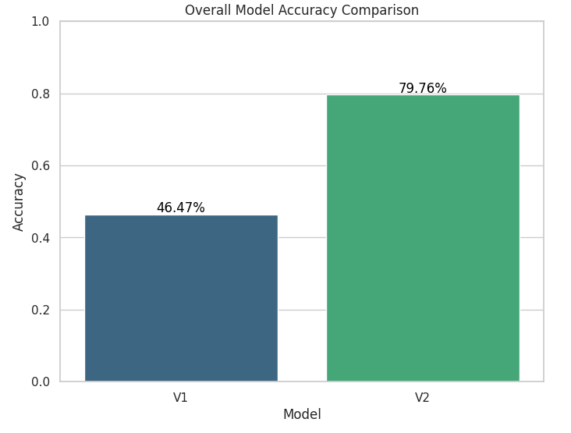
Figure 13.3.2.i: Overall Model accuracy Comparison

Observations
True Positives: Model V2 correctly identified 134 gaze patterns across all testers, significantly higher than Model V1's 79.
Model V1 produced more than twice as many false negatives (91) as Model V2 (34). This large discrepancy demonstrates that V1 was less capable of detecting gaze changes, leading to many missed detections.
Model V2 achieved an overall accuracy of 79.76%, which is 33.29% higher than Model V1's accuracy of 46.47%. This substantial improvement in accuracy underscores the effectiveness of the enhancements made in V2, particularly in smoothing and refining gaze predictions.
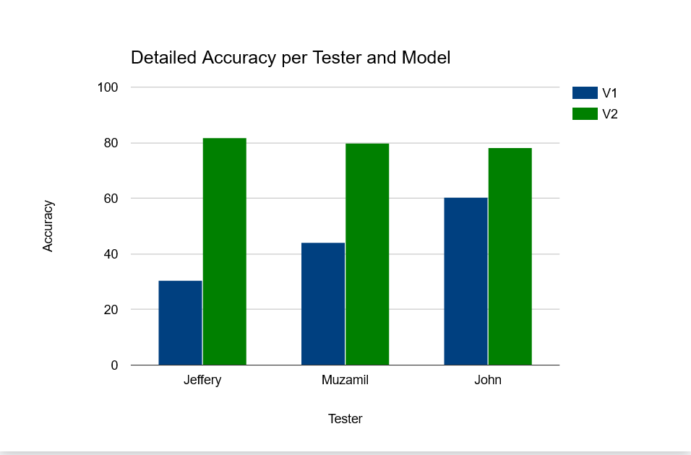
Figure 13.3.2.ii: Detailed Accuracy per Tester and Model

Insights and Key Takeaways
From the testing results, it is clear that Model V2 is vastly superior to Model V1 in terms of accuracy, consistency, and ability to predict gaze movements. Several key insights can be drawn from the results:
Smoothing Effects: The enhanced smoothing mechanisms in Model V2 played a crucial role in improving accuracy. By refining gaze movement transitions and reducing noise, V2 was able to achieve more reliable predictions.
Tester-Specific Performance: V1's accuracy varied greatly across testers, indicating that it may have struggled with certain types of eye shapes and gaze behavior. For example, it performed particularly poorly for Jeff, with only 30.36% accuracy, while performing better for John at 62.50%. V2, on the other hand, demonstrated consistent accuracy across all testers, suggesting it is more robust to individual differences in gaze patterns.
False Negatives: One of the major issues with V1 was its high number of false negatives. The model failed to detect a significant number of gaze directions, leading to incorrect predictions. In contrast, V2 reduced the false negatives substantially, indicating it is more reliable at detecting gaze movements.

13. Web Development and Porting
This section provides an in-depth look into the process of porting the deception detection system from a Python-based solution to a web-based environment. It covers the migration approach, the setup of the web application, integration of real-time webcam input, facial landmark detection, and the implementation of vectorized calculations for gaze tracking. Additionally, the section details how program capabilities were expanded to include custom video uploads, the porting of configuration options, performance optimization techniques, and ensuring cross-platform compatibility. The goal was to create a robust, real-time application that performs efficiently across various devices and environments while maintaining high standards of accuracy and usability.

13.1 Migration Approach
The process of porting the original Python-based eye-tracking program to a web-based application involved several stages that required careful consideration of efficiency, scalability, and user experience. Initially, it became evident that running the Python code directly within a web environment, either through WebAssembly (Wasm) or PyScript, would introduce a significant amount of computational overhead. This overhead would result in noticeable latency and hinder the real-time requirements of the application. Given the sensitivity of the application, where accurate and timely detection of gaze direction is crucial for determining deception, this approach proved impractical. As such, a decision was made to migrate the core functionality to the web front-end using modern JavaScript frameworks and libraries. This migration allowed the team to achieve a more responsive and performant solution, suitable for real-time analysis and adaptable for different user environments.

13.1.1 Initial Considerations
The migration process involved evaluating several technologies that could replace the Python-based components while ensuring a similar level of accuracy and reliability. The team had to ensure that the ported solution would meet the performance standards required for real-time analysis, as even minor delays could significantly impact the effectiveness of deception detection. Additionally, the transition to web technologies had to consider the accessibility and user experience aspects, making the application usable across a wide range of devices and platforms. Ultimately, the combination of JavaScript frameworks, including Astro.js and Mediapipe.js, was chosen to build a solution that maintained the accuracy of the original Python code while ensuring the application could be run efficiently in a browser environment.
One key decision during the migration process was not to port OpenCV, which was used in the original Python implementation to access the webcam and perform certain image processing transforms. Since much of OpenCV's advanced capabilities were not leveraged in the Python version, adding OpenCV.js would have introduced unnecessary complexity and computational overhead without providing significant benefits. Instead, the team opted to use native JavaScript APIs for webcam access and simpler image processing, which were sufficient to meet the project's requirements for real-time performance and efficiency.

Envisioning the Webapp
During the early stages of designing the web application, the team focused on outlining a structure that could efficiently handle the real-time requirements of gaze tracking while also being flexible enough to support future features. The frontend of the application was envisioned to be mostly server-side rendered, with the primary task of setting up the mechanisms for collecting and traversing eye tracking data. This involved ensuring that data collection was consistent and uniform, thus providing a reliable input for the machine learning models responsible for deception detection.
The design also considered how best to manage the collected data. Eye tracking generates a significant amount of time-sensitive coordinate data that needs to be processed in real-time or near real-time. To achieve this, the team decided to pool the collected data and transfer it to the backend at regular intervals. The backend, written in Go, would then process this data using machine learning models to determine the probability of deception, while also storing the data in a relational database (PostgreSQL) for future analysis. This approach allowed the system to efficiently handle the data pipeline, ensuring that eye tracking information could be consistently processed without overwhelming the system.
One of the critical challenges considered during the design phase was the issue of transferring large amounts of coordinate data in real time. Using a traditional REST API for this purpose could lead to significant delays and bottlenecks, given the volume and time-sensitive nature of the data. Instead, using WebSockets emerged as a potentially more effective solution, as it would allow for continuous data streaming between the client and server, thus minimizing latency. This consideration, however, will be explored in more detail in a dedicated section focused on data transfer optimization.

13.1.2 The Big Solution
WebSockets provide a powerful solution for addressing the challenges of transferring large volumes of time-sensitive coordinate data in real-time. Unlike the traditional REST API model, which is based on individual request and response cycles, WebSockets enable a continuous, bidirectional communication channel between the client and the server. This persistent connection allows data to be transferred seamlessly without the need to establish a new connection for every exchange, making it particularly effective for applications that require real-time data flow.

Websockets
WebSockets work by maintaining an open connection, which significantly reduces latency issues that are commonly associated with repeated HTTP requests. This is especially beneficial for applications like the deception detection system, where high-frequency data is continuously generated by the eye-tracking module. The ability to stream this data as it is produced means that the server can process it almost instantaneously, leading to timely feedback and more accurate deception analysis. This efficiency is crucial for maintaining the real-time integrity of the application, ensuring that users receive immediate insights based on their eye movements.
Moreover, WebSockets are designed to be lightweight, reducing the amount of overhead involved in data transmission. This is important for scalability, as it ensures that the application can handle multiple users without degrading performance. By using WebSockets, the application not only improves responsiveness but also provides a smoother user experience. The bidirectional nature of WebSockets also allows the server to send updates back to the client in real-time, which is useful for features like visual feedback or adjusting parameters dynamically based on ongoing analysis. This level of interaction would be cumbersome and inefficient using a REST API, highlighting the advantages of WebSockets in scenarios where speed and efficiency are paramount.
WebSockets are commonly used in applications like online gaming, live chat, and financial trading platforms, where low latency and rapid updates are crucial. In the context of the deception detection web application, WebSockets are used to facilitate the efficient transfer of gaze-tracking data from the client to the server. This ensures that the time-sensitive coordinate data, which includes the positions of key facial landmarks over time, can be processed quickly by the machine learning model. By reducing the need for repeated HTTP requests and responses, WebSockets help minimize latency, ensuring that the server can provide timely feedback on deception probability while storing the data in a relational database.

Implementation Strategy
The decision to implement WebSockets was guided by the need for an efficient solution that could handle the high-frequency data generated by the eye-tracking process. REST APIs, while suitable for many applications, introduce too much overhead when dealing with continuous streams of data. Each HTTP request and response involves additional headers and connection setups, which can create significant bottlenecks when handling data that requires constant, real-time updates. With WebSockets, the web application can maintain a persistent, full-duplex connection with the server, allowing data to be streamed continuously as it is generated without the repeated overhead associated with traditional HTTP methods.
WebSockets facilitate the transfer of eye-tracking coordinate data by creating a direct communication line between the client and the server. This means that data packets can be sent as soon as they are generated by the client, and the server can process them in near real-time. The low latency achieved through this persistent connection is crucial for the accuracy of deception detection, as it allows for immediate feedback and ensures that the machine learning models have access to the most current data without lag. Additionally, the WebSocket protocol includes features for managing data integrity and connection reliability, such as heartbeat messages that help keep the connection alive and detect disconnections quickly, thus ensuring that the data stream remains stable and robust throughout the session.
By implementing WebSockets, the deception detection application can handle rapid data transfers and deliver prompt analysis results to the user, significantly improving the overall performance and usability of the system. The efficiency of WebSockets also supports scalability, enabling multiple users to connect and stream data simultaneously without causing server overload. This scalability is achieved by managing concurrent connections more effectively, as WebSockets reduce the overhead of managing multiple HTTP connections. The bidirectional communication capability allows not only for sending eye-tracking data from the client to the server but also for the server to push updates, such as probability scores and user feedback, back to the client in real-time. This real-time interaction is essential for applications where immediate responses can impact user engagement and decision-making, making WebSockets a fitting solution for this high-demand use case.

13.1.3 Setting Up the Web Application
The development began by establishing the foundation of the web application using Astro.js, a framework that is well-suited for managing static and server-rendered components in a lightweight and efficient manner. Astro.js provided the flexibility needed to handle the web application's dynamic and static aspects, ensuring a smooth user experience. The initial setup involved using Bun as the package manager to streamline the environment configuration and dependency management. Bun was chosen due to its performance benefits and ability to manage dependencies with minimal overhead, thereby accelerating the initial development process.

Installation of Application Materials
To install the application materials on various systems, the process begins by cloning the project's repository from a version control system like Git. This can be done using a command like git clone https://github.com/bingKegeta/DETECT.js. Once cloned, users need to navigate into the project directory using cd DETECT.js. After navigating to the directory, dependencies must be installed using Bun or npm. On Unix-based systems like Linux and macOS, the command bun install or npm install will fetch all the necessary dependencies specified in the package.json file. For Windows users, the same commands apply, but it is crucial to run the command prompt or terminal with administrator privileges to avoid permission issues.
After installing the dependencies, the application can be started locally using npm run dev or bun astro run dev. This command sets up a local development server, allowing users to view the application in their browser. Cross-platform considerations, such as installing Bun or npm, might vary slightly, with Windows requiring additional steps like adding Bun to the system PATH. Astro.js's setup is streamlined, ensuring that the development server can be run on various operating systems with minimal configuration, providing flexibility for contributors and users across different environments.

Setting up an Astro.js Project
The setup process also involved configuring the development environment to support the integration of multiple libraries and frameworks seamlessly. Proper configuration of tools like Bun ensured that all necessary dependencies were handled efficiently, allowing the team to focus on building the application's core features without getting bogged down by setup issues. Setting up an Astro.js project begins with initializing the project directory using a terminal command such as bun create astro, which sets up the basic file structure and configurations required for an Astro.js application. Astro.js offers a straightforward structure that helps developers easily manage static and dynamic components, making it ideal for modular development.
Once the initial setup is complete, developers proceed by installing dependencies. Using Bun or npm, the necessary dependencies such as Mediapipe.js, and other third-party libraries are added. Configuration files such as astro.config.mjs are edited to include specific routes, integrations, and build options. This step ensures that all components are properly linked and ready to be deployed as part of the application. Setting up a local server with a command like bun astro run dev allows developers to view changes in real-time and iteratively adjust the project and inspect it with astro specific tooling. The decision to use Astro.js also helped in modularizing different components of the application, which allowed for easier updates and maintenance as new features were added or existing features were refined. Establishing this robust foundation was crucial for the success of the overall project, as it set the groundwork for the subsequent integration of real-time video processing and eye-tracking features.

13.1.4 The Big Port
The decision to port the Python-based eye-tracking program to a web-based solution was driven by several considerations and priorities. One of the primary motivations was the need for improved performance and scalability. The original Python implementation, while effective in controlled environments, was not suitable for real-time web deployment due to the limitations associated with running Python code in the browser. The overhead introduced by using technologies like WebAssembly (Wasm) or PyScript was significant and would have compromised the user experience by causing noticeable latency. Therefore, the goal was to create a more streamlined solution that leveraged modern web technologies to ensure responsiveness and efficiency.
Another key priority was to maintain the accuracy of the original algorithm while making the application more accessible and user-friendly. The team needed to carefully evaluate the components of the Python code that could be replaced or adapted without losing functionality. For instance, the use of OpenCV for webcam access and image processing in the Python version was reconsidered. Given that OpenCV's more advanced features were not being fully utilized, it was deemed unnecessary to incorporate OpenCV.js, which would have added complexity and increased computational requirements without significant benefits. Instead, native JavaScript APIs were used to handle webcam access and basic image processing tasks, providing a leaner and more efficient solution. The priority throughout the porting process was to make the system accessible on various platforms, ensuring that users could easily interact with the application regardless of their device or browser configuration.

13.1.4.1 Webcam Integration
A significant first step in this migration process was ensuring that the web application could capture a real-time video feed from the user's webcam, as this would serve as the primary source of visual input for eye tracking. Capturing the webcam feed required integrating media capture APIs and ensuring cross-browser compatibility, which was critical to ensuring that the application would function consistently across different platforms. The capability to capture a real-time video feed was crucial for facilitating the rest of the workflow, where webcam data could be processed for identifying eye-related landmarks.
Integrating the webcam functionality required dealing with various challenges, such as obtaining user permissions for camera access and ensuring that the application could handle different webcam resolutions and frame rates. Additionally, ensuring a consistent experience across different browsers, such as Chrome, Firefox, and Safari, required extensive testing and adjustments to the codebase. Cross-browser compatibility was vital because users might access the application from different devices, each with unique hardware and software configurations. By successfully capturing real-time video, the application could move forward with the implementation of advanced gaze-tracking features.
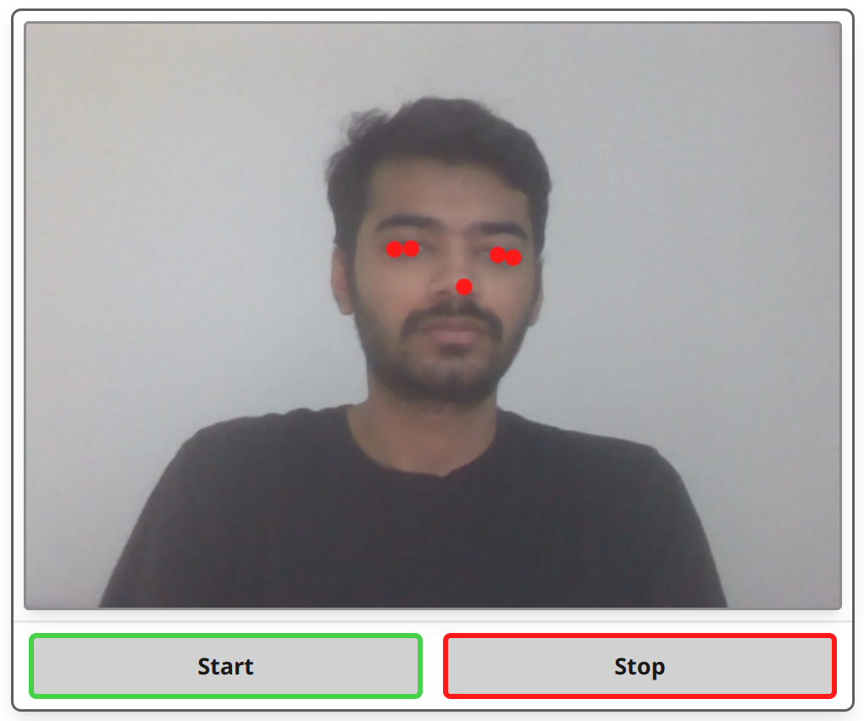
Figure 14.1.4: Image depicting landmark detection integration with webcam output

13.1.4.2 Facial Landmark Detection with Mediapipe.js
Once the webcam integration was functional, the next phase involved incorporating Mediapipe.js to detect relevant facial landmarks in real-time. MediaPipe, an efficient cross-platform library developed by Google, allowed for precise detection of facial features such as eye corners, eye centers, and the nose tip, all of which are critical for the gaze-tracking algorithm. Initially, MediaPipe detected a broad range of facial landmarks; however, for the purposes of this project, it was necessary to filter these down to only the relevant landmarks required for the eye-tracking process. By focusing on these specific landmarks, the team was able to streamline the data processing pipeline, thereby improving both performance and accuracy. The selective approach ensured that unnecessary computations were eliminated, reducing processing overhead and making it possible to run in real-time within a browser environment.
Implementing MediaPipe.js involved fine-tuning its landmark detection capabilities to cater specifically to the needs of deception detection. While MediaPipe can detect a wide range of facial features, not all of these were required for the project. Therefore, the team had to develop an optimized pipeline that filtered out extraneous information and focused solely on the relevant facial points that contributed to the gaze-tracking calculations. This not only reduced the computational load but also ensured that the eye-tracking component remained as accurate as possible, even when the user's facial orientation changed slightly. Ensuring precision in identifying these landmarks was essential, as inaccuracies could cascade into the subsequent calculations, leading to unreliable results.

Implementing Vectorized Calculations
With the necessary eye landmarks identified, the next step was implementing the vectorized calculations to obtain a normalized average coordinate for gaze direction. These calculations were directly adapted from the existing Python code, maintaining consistency with the initial mathematical approach used in prototyping. The mathematical calculations involved the use of vector operations to determine the relative positions of the eyes and nose, providing an estimated gaze direction. These calculations were essential for determining the focus of the user's gaze and ultimately identifying potential indicators of deception.
The implementation of vectorized calculations in JavaScript required the team to carefully translate the mathematical logic from Python into a format compatible with the web environment. The differences between Python and JavaScript, especially in handling numerical computations and data structures, posed some challenges. The team utilized JavaScript's built-in math functions to replicate the Python logic as closely as possible. Maintaining accuracy during this transition was crucial, as even minor discrepancies in calculations could lead to significant errors in gaze direction estimation. The team also worked on optimizing these calculations for performance, ensuring that they could be executed in real time without causing any noticeable lag for the user.

Challenges in Porting Vector Transformations
The main challenge here was replicating the exact vector transformations that were previously implemented in Python, but in a JavaScript environment. JavaScript, being quite different from Python in terms of syntax and available libraries, required careful adaptation of the mathematical operations to ensure accuracy. While most of the mathematical logic could be ported directly, there remained one significant exception: the affine transform. Affine transformations had been used in the original implementation to help normalize the data across varying positions and distances from the camera. This normalization is crucial for ensuring consistency, as different users may have different distances and angles relative to the camera. At the current stage of development, the team has not yet implemented this transform due to its complexity within a JavaScript framework, though it remains on the roadmap as a key enhancement to further improve the robustness of the gaze-tracking system.
The absence of a direct affine transform method has prompted the team to explore alternative methods for normalizing gaze data. In the interim, various scaling techniques have been tested to compensate for differences in user positioning. However, these methods have not yet reached the level of robustness provided by the affine transformation. Implementing this feature remains a high priority, as it will help standardize the output regardless of the user's distance from the camera or their facial orientation. Achieving this level of consistency is vital for ensuring that the deception detection algorithm can reliably identify subtle changes in gaze direction, which could be indicative of deceptive behavior.

13.1.4.3 Affine Transformation with Mediapipe.js
In the DETECT project, stabilizing key facial landmarks during real-time video processing posed a significant challenge, particularly as users moved their heads. While Mediapipe.js effectively detected critical facial features such as iris centers, eye corners, and the nose tip, these landmarks tended to shift with head movements, negatively impacting gaze-tracking accuracy and consistency. To address this issue, an affine transformation process was implemented to align and normalize the detected landmarks, reducing the influence of head movement and improving the reliability of the system.
Affine transformation is a geometric method that preserves spatial relationships between points in an image while allowing for scaling, translation, rotation, and shear. In the context of DETECT, this process aligned facial landmarks to a canonical pose by centering the nose tip and stabilizing the relative positions of other landmarks. This approach improved the consistency of detected features and provided a robust foundation for downstream tasks such as gaze tracking and real-time interaction.

Implementation Details
Identifying and Extracting Key Landmarks
The first step in the transformation process involved identifying key landmarks essential for stabilization: the left and right iris centers, the left and right eye corners, and the nose tip. Using Mediapipe.js, these landmarks were extracted based on predefined indices. However, detection inconsistencies—such as landmarks being undefined in certain frames—necessitated validation checks. Frames with incomplete data were skipped, and errors were logged to support debugging, ensuring only reliable data was processed.
Mathematical Foundation for Affine Transformation
The affine transformation process comprised scaling and translation operations. The nose tip served as the reference point for translation, centering the face within the coordinate space. Scaling was applied based on the inter-ocular distance (the distance between the left and right eye corners) to normalize landmark positions relative to head size and distance from the camera. Transformation matrices for these operations were generated and merged into a single matrix to facilitate real-time execution.
Application of the Transformation
Landmarks, represented as normalized points within the canvas dimensions, were adjusted using the combined transformation matrix. This realignment ensured that all landmarks adhered to a consistent coordinate space. During testing, transformed landmarks were visualized on the canvas as red dots to provide immediate feedback, and debugging logs were employed to validate calculations. The transformed nose tip was consistently centered at (0, 0), while other landmarks were accurately positioned relative to it.
Optimizing for Real-Time Performance
Real-time video processing required the transformation to be applied to multiple landmarks in every frame without introducing noticeable lag. To achieve this, vectorized calculations and efficient matrix operations were leveraged to minimize computational overhead. Additionally, non-critical operations, such as verbose error logging, were disabled in production environments to further enhance performance.

Challenges Encountered
Landmark Detection Variability
Landmark detection inconsistencies posed one of the most significant challenges. For instance, the nose tip or iris centers were occasionally undefined due to environmental factors such as lighting or partial occlusions. A validation layer was introduced to check for the presence of required landmarks before proceeding with the transformation. Frames missing critical data were skipped, maintaining system stability at the cost of slightly reduced frame rates.
Discrepancies in Transformed Coordinates
Initial testing revealed that transformed coordinates appeared larger than expected due to incorrect normalization of input coordinates relative to canvas dimensions. Adjustments were made to explicitly account for canvas width and height, ensuring calculations operated within a consistent scale. Furthermore, misalignment caused by the incorrect sequence of scaling and translation operations was resolved by reordering the transformation steps.
Maintaining Accuracy at High Speeds
The system’s real-time requirements presented a bottleneck, as multiple transformations were applied per frame. Redundant calculations were eliminated, and intermediate results were cached to improve efficiency. These optimizations reduced computational delays while preserving accuracy.

Results and Impact
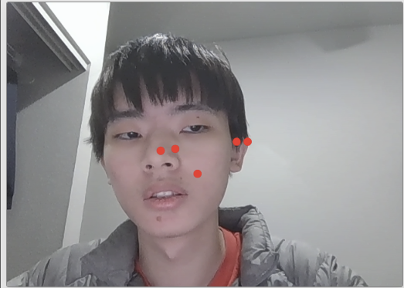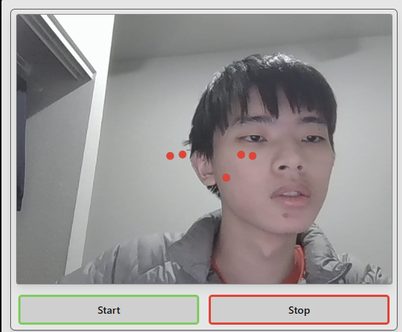
Figure 14.1.4.3: Head Right vs Left Landmark Detection
Improved Landmark Stability
The affine transformation significantly enhanced the stability of facial landmarks during head movements. Transformed landmarks, visualized as red dots, remained consistently aligned with the user’s face despite slight tilts or rotations. This stability validated the effectiveness of the transformation process.
Enhanced User Experience
Stabilized landmarks improved gaze-tracking accuracy, enabling users to interact with the system naturally without maintaining a rigid posture. This enhancement not only improved the intuitiveness of the system but also laid the groundwork for advanced features such as emotion detection and dynamic user interactions.
Quantitative Improvements
Testing demonstrated that the affine transformation maintained alignment accuracy across various lighting conditions and head orientations. The optimized process introduced less than 2 milliseconds of latency per frame, ensuring seamless real-time performance.

Challenges and Potential Future Directions
Despite the successes achieved with affine transformation, several challenges remain to be addressed in future iterations:
- Handling Occlusions:
The process relies on consistently detecting all five key landmarks. Occlusions, such as hands covering the face, can disrupt detection. Integrating predictive algorithms or fallback strategies could mitigate this issue.
- Incorporating Depth Information:
The current 2D transformation could benefit from incorporating 3D depth data, particularly for scenarios involving large head rotations.
- Generalizing Across Diverse Faces:
Although the algorithm performed well during testing, further evaluation on a broader dataset is necessary to ensure robustness across diverse facial features and demographics.
- Reducing Dependency on Specific Landmarks:
Reducing reliance on the nose tip as the primary reference point could improve performance in scenarios with partial occlusions, increasing resilience to environmental challenges.

Conclusion
The implementation of affine transformation in the DETECT project marked a significant step toward achieving accurate and reliable facial landmark detection. By stabilizing key landmarks and mitigating the effects of head movement, this method provided a robust foundation for advanced features such as gaze tracking and emotion detection. While there is still some roughness, the system’s progress demonstrates the potential of combining mathematical transformations with real-time detection technologies to deliver intuitive and high-performance user interfaces.

13.1.4.4 Real-time Graphs and Data Modeling
In the realm of real-time data visualization, D3.js serves as a JavaScript library designed to simplify the creation of dynamic charts and graphs. Its user-friendly API and pre-built chart types make it a popular choice for developers seeking to implement standard visualizations with minimal configuration. However, when integrating with complex systems like MediaPipe, which processes real-time machine learning tasks such as hand tracking or pose estimation, the performance demands can exceed the capabilities of Graph.js. This section delves into the integration of Graph.js with MediaPipe, highlighting the workflows in both Python and JavaScript environments.

Data Processing and Communication
Python Workflow
In Python, MediaPipe processes input data—such as video frames captured via OpenCV—and generates outputs like landmark coordinates. These outputs are then visualized in real-time using libraries like PyQtGraph, which benefits from Python's efficient data processing capabilities and seamless handling of large datasets through NumPy.
JavaScript Workflow
In the JavaScript ecosystem, MediaPipe's WebAssembly modules or its JavaScript API process video or image inputs directly within the browser. The resulting data, often in the form of coordinate information, is fed into Graph.js to render dynamic visualizations. This approach leverages the web's native capabilities for responsive and interactive user interfaces.

Real-Time Updates
Real-Time Visualization in Python
PyQtGraph excels at handling real-time updates in Python applications. Utilizing efficient memory management and tight integration with NumPy, it can rapidly process and visualize data streams. Updates occur at high frequencies, driven by callback functions or timers synchronized with MediaPipe’s processing loop.
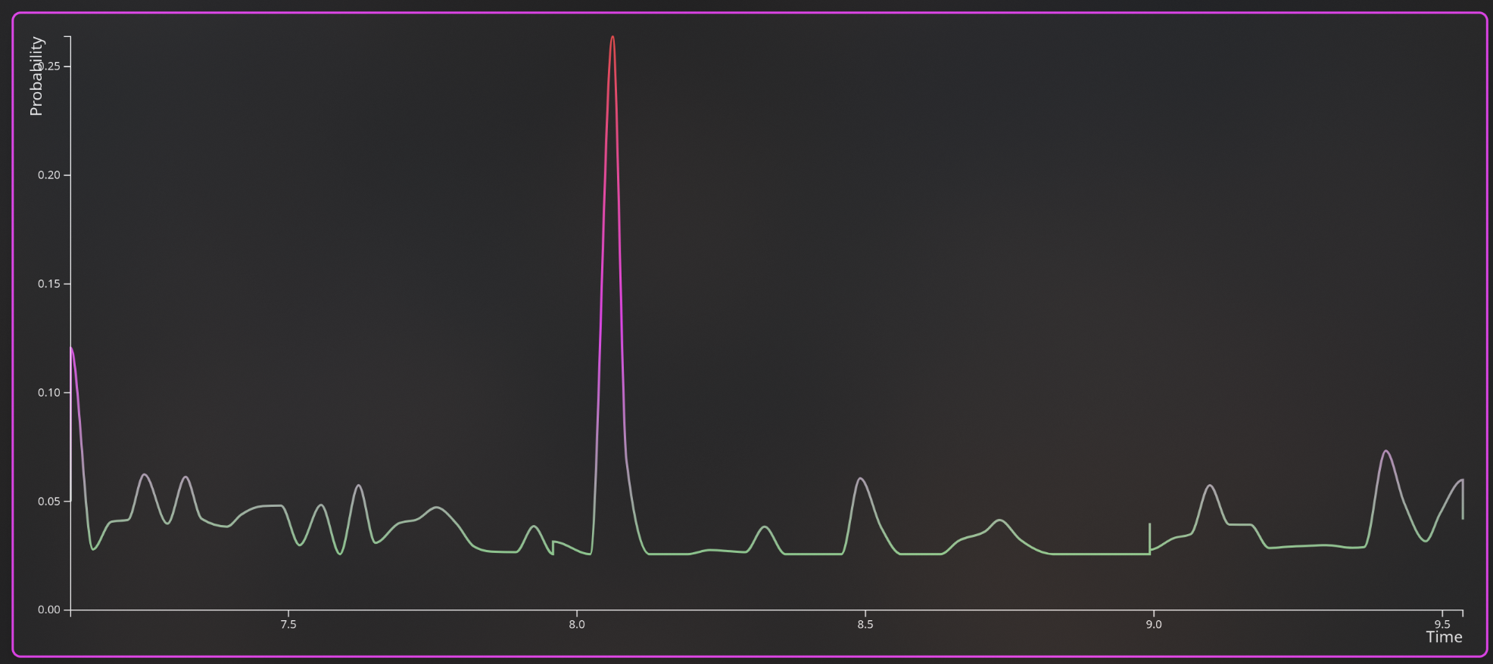
Figure 14.1.4.4.i: Real-Time Graph Demo with Graph.js
Real-Time Visualization in JavaScript
D3.js achieves real-time performance by leveraging JavaScript’s event-driven architecture and the hardware acceleration capabilities of modern browsers. With MediaPipe providing continuous landmark updates, Graph.js visualizes these in real-time, often synchronized with requestAnimationFrame for smooth rendering.

Integration with MediaPipe
Python Integration with MediaPipe
In Python, MediaPipe integrates with OpenCV for video frame capture and processing. Post-inference, results such as facial landmarks or pose detection points are converted into NumPy arrays or dictionaries. PyQtGraph then visualizes these outputs in real-time, facilitating interactive exploration within a desktop application.
JavaScript Integration with MediaPipe
In JavaScript, MediaPipe leverages WebAssembly to perform inference directly in the browser. Input is captured from <video> or <canvas> elements, and the resulting data (e.g., landmark coordinates) is formatted for visualization. Graph.js then displays these outputs in real-time, creating a seamless front-end experience.

Cross-Platform Synchronization
Transitioning from PyQtGraph in Python to Graph.js in JavaScript necessitates careful adaptation of data structures, frame rate management, and rendering logic:
- Data Format Conversion: Python workflows rely on NumPy arrays, while JavaScript utilizes JSON-like structures for compatibility with web libraries.
- Frame Rate Management: Python employs Qt timer callbacks for synchronization, whereas JavaScript relies on setInterval or requestAnimationFrame for smooth rendering.
- Platform-Specific Optimizations: Python’s desktop-centric design offers local processing speed, while JavaScript’s browser environment ensures cross-platform accessibility.
Integrating PyQtGraph functionality with Graph.js enables developers to transition from desktop applications to web-based platforms, enhancing accessibility and scalability. By combining MediaPipe’s real-time machine learning capabilities with JavaScript libraries, developers can create interactive and responsive front-end applications, delivering a seamless user experience for real-time ML-based visualizations.

D3.js Integration for Enhanced Real-Time Performance
As the demand for more sophisticated and high-performance data visualizations grew, the limitations of Graph.js became apparent, particularly in handling real-time data updates and offering extensive customization. This led to the integration of D3.js (Data-Driven Documents), a powerful JavaScript library renowned for creating complex and interactive data visualizations. D3.js provides developers with fine-grained control over the Document Object Model (DOM) and facilitates efficient data binding, making it well-suited for applications requiring high performance and scalability.

Transitioning from Graph.js to D3.js
The shift from Graph.js to D3.js was motivated by the need for enhanced performance and greater control over the visualization process. While Graph.js offers simplicity with its pre-built chart types, it encountered performance bottlenecks when managing the high-frequency data streams generated by MediaPipe. In contrast, D3.js's low-level API allows for meticulous optimization and customization, enabling the development of tailored visualizations that meet specific application requirements.

Key Differences Between Graph.js and D3.js
Graph.js
- Ease of Use: Graph.js provides pre-built chart types like line and bar charts, requiring minimal setup.
- Performance Limitations: It struggles to efficiently update visualizations with high-frequency data streams, leading to performance bottlenecks.
- Limited Customization: Developers are constrained to predefined chart styles and behaviors, limiting flexibility.
D3.js
- Fine-Grained Control: D3.js offers the ability to manipulate individual SVG elements and bind data dynamically, providing extensive customization options.
- Performance Optimization: It is optimized for real-time updates through techniques like data joins, selective updates, and efficient DOM manipulation.
- Advanced Customization: Developers can create highly tailored visualizations, ideal for unique use cases beyond standard charts.

Real-Time Visualization Workflow with D3.js (Continued)
DOM Manipulation
D3.js enables direct control over individual DOM elements, offering flexibility that is critical for dynamically scaling and styling visual components such as pose landmarks or trajectory lines. This level of granularity allows for optimized rendering tailored to real-time data streams from MediaPipe. Unlike Graph.js, which abstracts DOM interaction, D3.js gives developers full access to the visualization pipeline, enabling more efficient updates and precise control over the display.

Benefits of Using D3.js
The transition to D3.js brought several significant advantages for the visualization pipeline:
- Enhanced Performance: By managing updates at a granular level, D3.js handles rapid, high-volume data streams without significant slowdowns. This makes it suitable for real-time applications where performance is critical.
- Scalability: D3.js's modular architecture allows it to support complex visualizations that grow in scale as data increases. This capability ensures that the application remains efficient and responsive even under heavy data loads.
- Advanced Customization: D3.js provides the ability to create bespoke visualizations tailored to specific outputs from MediaPipe, such as interactive overlays for pose detection, trajectory analysis, or gesture tracking.
- Improved Responsiveness: With D3.js, animations and transitions are smoother, enhancing the user experience. This responsiveness is particularly beneficial for applications requiring real-time feedback, such as deception detection systems or gesture-controlled interfaces.
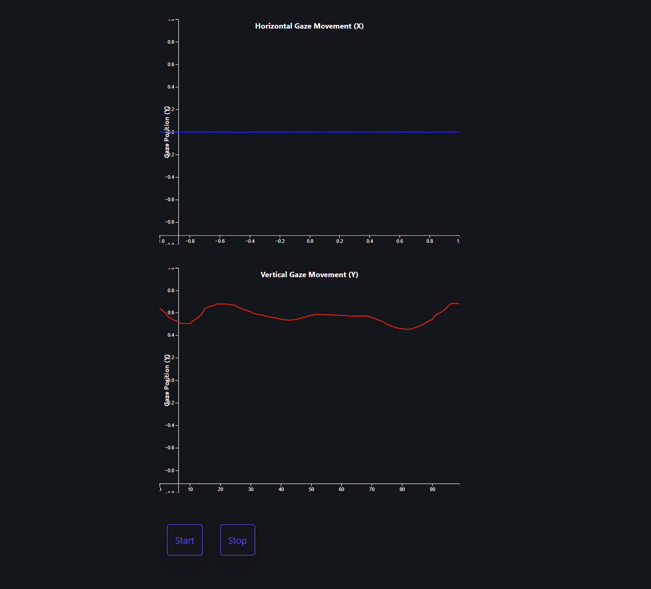
Figure 14.1.4.4.ii: Real-Time Graph Demo with D3.js

Challenges in the Transition
Adopting D3.js required overcoming several challenges:
- Learning Curve: Developers had to familiarize themselves with D3.js’s unique data-binding and DOM manipulation paradigms. This involved understanding how to use its enter, update, and exit patterns for managing dynamic visualizations.
- Redesigning Visualization Logic: Existing workflows built around Graph.js had to be re-engineered to take full advantage of D3.js’s fine-grained control and optimization features. This included revising the logic for handling real-time updates.
- Performance Optimization: While D3.js excels in performance, it required careful tuning to implement selective updates rather than full re-renders, ensuring real-time efficiency without compromising accuracy.
Despite these initial hurdles, the flexibility and performance benefits provided by D3.js far outweighed the challenges.

Summary of D3.js Integration
The integration of D3.js marked a significant improvement in the application’s ability to handle real-time visualizations of MediaPipe outputs. By leveraging D3.js’s strengths in performance optimization, scalability, and customization, the front-end application met the stringent demands of real-time machine learning visualization. The transition reinforced the importance of selecting tools that align with the specific needs of high-performance applications, ensuring that the system could deliver a seamless and interactive user experience.

13.1.5 Expanding Capabilities: Custom Video Uploads
After achieving the core functionality with real-time webcam input, efforts have been directed toward expanding the program's capabilities to include custom video uploads. This feature is particularly important for research, testing, and broader applicability, as it allows the analysis of pre-recorded footage rather than relying solely on live input. Custom video uploads provide users with greater flexibility, enabling them to analyze previously recorded sessions or conduct controlled experiments without the constraints of live video capture.
The addition of custom video upload functionality required significant changes to the way the application processed video data. Unlike real-time webcam feeds, uploaded videos can come in various formats, resolutions, and frame rates, which necessitated a more flexible processing pipeline. The team implemented additional preprocessing steps to handle these variations, ensuring that the video data could be correctly parsed and analyzed. This involved developing algorithms to synchronize video frame rates with the gaze-tracking calculations, as discrepancies between the two could lead to inaccurate analysis. By allowing users to control playback and select specific timeframes for analysis, the team also ensured that the application could be used for detailed examinations of gaze behavior, which is particularly useful for research and training purposes.
To enable the custom video upload feature to work seamlessly with a dropdown menu and modal selection system, both the webcam and video components had to be rendered as client components using Astro’s client:visible directive. This approach ensured that the appropriate component would be loaded dynamically when the component itself is loaded, allowing users to only render the components absolutely necessary. However, this also introduced significant challenges in terms of change management and necessitated a complete redesign of the application structure. The entire page structure had to be reworked to properly hydrate the application, ensuring that all components were loaded and rendered efficiently without causing unnecessary delays or resource usage.

Adapting Video Processing
Implementing this feature required reworking how video data was processed. Unlike live webcam feeds, uploaded videos come in various formats, resolutions, and frame rates, which necessitated a flexible approach to ensure compatibility. The existing gaze-detection logic had to be adapted to work with video files processed entirely on the frontend, without displaying the video to the user. Instead of providing playback options, the system presents a modal where users input a video from local storage, after which the video is processed in the background. An estimated time required for processing is shown to inform users of the expected duration.
To accommodate these requirements, the team implemented a video processing module that allowed for dynamic frame extraction and synchronization. This ensured that gaze data could be accurately calculated regardless of the video's frame rate or resolution. These changes streamlined the analysis workflow while preserving the application's effectiveness as a research tool.

Porting Configuration Options
Furthermore, due to changes in how eye data is analyzed in the web version, not all configuration options from the original Python implementation could be ported. As a result, the available settings were redefined to better align with the updated processing pipeline. The current web-based application offers a streamlined set of user-configurable options: normalization (for affine transformation), min-max scaling, and sensitivity adjustment. These settings are essential for fine-tuning the analysis process within the constraints of the frontend implementation.
Adapting the configuration options required careful consideration of usability and technical feasibility. While the original implementation supported a broader range of settings such as sampling intervals and custom time frames, the web version prioritizes accessibility and performance. The team developed a configuration interface that maintains flexibility while ensuring ease of use, enabling users to tailor the analysis process to their needs without unnecessary complexity.

Performance Optimizations
In addition to expanding functional capabilities, efforts have also been directed toward optimizing the web application's performance. Real-time eye tracking imposes significant computational demands, particularly when processing multiple facial landmarks and performing vector calculations. The primary challenge involved ensuring the application maintained responsiveness even on lower-end devices, which required optimizing both the front-end and back-end components.
Performance optimization involved analyzing various aspects of the application's workflow to identify bottlenecks that could hinder real-time performance. One of the primary focuses was on reducing the computational load of facial landmark detection and vector calculations. This was achieved by implementing more efficient algorithms, reducing the frequency of certain non-critical calculations, and making use of modern browser capabilities such as WebGL to offload computations to the GPU. These strategies were essential for ensuring that the application could run smoothly without compromising the accuracy of the eye-tracking features.
To further enhance performance and provide a more flexible experience, users were provided with the option to choose between different levels of computational complexity. This approach allowed users to decide whether to use more computationally expensive techniques, which provide higher accuracy, or opt for a less resource-intensive mode that may slightly reduce accuracy but enhances responsiveness. For instance, users could disable full facial landmark detection in favor of a simplified gaze approximation model, which offers adequate accuracy for real-time analysis. This flexibility was crucial for ensuring that the application could cater to different usage scenarios and device capabilities, particularly for users with less powerful hardware.

13.2 Go-chi for Efficient and Secure Backend Development
Go-chi enhances Go’s capabilities by providing efficient and secure routing for managing participant sessions and controlling video data flow. Its integration ensures robust data handling protocols, a critical requirement for maintaining user privacy and complying with Institutional Review Board (IRB) guidelines. Additionally, Go-chi supports middleware integration, enabling real-time monitoring of requests and ensuring all application components adhere to operational standards.
Go serves as a strong foundation for high-performance, real-time applications due to its speed, efficiency, and concurrency model. These qualities make it ideal for backend development in projects like DETECT, where continuous real-time data processing is essential. By extending Go’s web capabilities, Go-chi provides tools to handle complex routing, WebSocket connections, and middleware management, enabling scalable and responsive systems. Together, Go and Go-chi create a robust environment for processing eye-tracking data and delivering immediate feedback in real time, ensuring the accuracy and responsiveness necessary for evaluating deception.

13.2.1 User Login Authentication Implementation
To secure the WebSocket API endpoint, user authentication is essential. This can be implemented using bcrypt.

Bcrypt for Password Security
Bcrypt provides a robust solution for securing passwords through cryptographic hashing. By incorporating salts, bcrypt protects against common vulnerabilities such as rainbow table attacks and brute-force attempts.
For users registering directly with DETECT, bcrypt ensures that passwords are securely hashed before being stored in the database. During login, bcrypt verifies the inputted password against the stored hash, ensuring secure authentication. Helper functions in Go can streamline this process:
- Hashing passwords: During registration, passwords are hashed with an appropriate computational cost for added security.
- Verifying passwords: During login, user inputs are validated against the stored hash using bcrypt’s verification methods.
Go-chi facilitates this process by integrating password validation into routing middleware, ensuring security checks are consistently applied. Additionally, Go’s PostgreSQL database support allows efficient storage and retrieval of hashed passwords while maintaining type safety.

13.2.2 WebSocket Implementation
WebSockets enable full-duplex communication between the client and server, allowing continuous data exchange over a single, persistent connection. Unlike traditional HTTP, which is stateless and requires repeated connections, WebSockets are ideal for real-time applications like DETECT, where live data streams must be sent to the client.

WebSocket Integration in DETECT
In DETECT, WebSockets facilitate the real-time transmission of eye-tracking data and model outputs. Metrics such as blink rates, gaze direction, and deception probability are streamed to the frontend, enabling dynamic visualization and immediate user feedback.
To implement WebSockets, the backend leverages the Gorilla WebSocket library, with Go-chi managing routing for dedicated WebSocket endpoints:
- A WebSocket upgrader transitions HTTP connections to WebSocket, handling headers for cross-origin requests if needed.
- A handler function processes connections, streams model outputs as JSON messages, and monitors connection status for errors or interruptions.
Go’s concurrency model, powered by goroutines, ensures efficient management of multiple simultaneous connections. Each WebSocket connection operates in its own goroutine, preventing performance bottlenecks and maintaining responsiveness under high user loads.

Client-Side Integration and Visualization
On the client side, WebSocket communication is implemented using JavaScript to handle real-time updates. Incoming JSON messages are parsed and used to update graphical visualizations dynamically. Metrics such as gaze direction and blink rate are displayed in real time, providing users with actionable insights into the system’s analysis.

Error Handling and Connection Management
Robust error handling ensures the system gracefully manages connection drops or client-side interruptions. Reconnection mechanisms are implemented to maintain seamless data flow and user experience. These safeguards are essential for achieving DETECT’s goal of a responsive, real-time interaction system.

13.3 Frontend Design Prototype
The DETECT frontend prototype is designed with a focus on simplicity, usability, and a visually appealing interface aligned with the themes of exploration and detection. Developed using Astro, a modern front-end framework optimized for performance and developer efficiency, the prototype integrates a sleek and professional black and purple theme to create a captivating and futuristic aesthetic.

13.3.1 General Page Layout Design
The design of a general content page layout for the deception detection application prioritizes consistency, accessibility, and usability across different viewing modes. The provided images showcase both light mode and dark mode versions of the layout, emphasizing adaptability and user comfort. The UI design balances simplicity with functionality, ensuring that users can navigate features effortlessly without being overwhelmed by the application's technical complexity.

Design Plan
The application’s design includes several key pages that work cohesively to deliver a user-friendly experience:
- Landing Page: This page introduces the application, providing visitors with an overview of its features and benefits. The design is visually engaging and aims to captivate first-time users.
- Login/Register Page: These pages allow users to log in seamlessly using traditional email and password authentication. It is designed to be straightforward, enabling quick and secure access.
- Dashboard Layout: After logging in, users are directed to a dashboard that includes general navigation options like user settings, profile management, and past session summaries. This layout, reflected in the provided images, serves as a hub for accessing all functionalities.
This structured approach ensures that users can easily interact with core features while enjoying a cohesive and intuitive interface.

Navigation Layout
The application features a top navigation bar for quick access to essential sections like Home, About, and user Settings improving overall accessibility. A left sidebar provides access to viewing the past saved sessions for future scrutiny and viewing.
The content area at the center mainly displays the previous session graphs or dynamically acts as a space for the main functionality modals to be clearly visible.

Theme Toggle and Personalization
The design incorporates a dynamic theme system, enabling users to switch between multiple color themes dynamically according to user preference. By leveraging CSS variables and Tailwind’s extended color palette, developers can experiment with visual themes and rapidly prototype changes across the entire interface. The themes provided also increase accessibility for the website such as color blind users will have at least one option that they will be able to see clearly due to the high contrast variation.
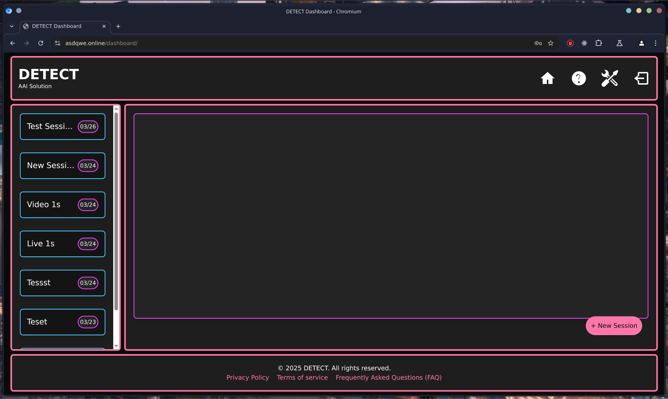
Figure 14.3.1.i: Synthwave Theme Layout

Key Benefits:
- Efficiency: CSS variables allow developers to change themes by modifying a few values, ensuring consistent styling across components.
- Scalability: This modular approach supports multiple themes without adding complexity to the codebase.
- Customization: Tailwind’s extended palette provides a broad range of colors, enabling developers to adapt the application’s appearance to user preferences or branding requirements.
- Personalization: The flexible system promotes a user-focused design, where visual adjustments can be implemented and tested in real time.
By combining CSS variables with Tailwind’s utility-first approach, the design remains both cohesive and adaptable, allowing for creative experimentation while maintaining usability.

Box-Oriented Design and High Contrast
The layout adopts a box-oriented design, visually separating interface sections with defined boundaries. This approach enhances organization and directs user attention to relevant components, reducing cognitive load and simplifying navigation.
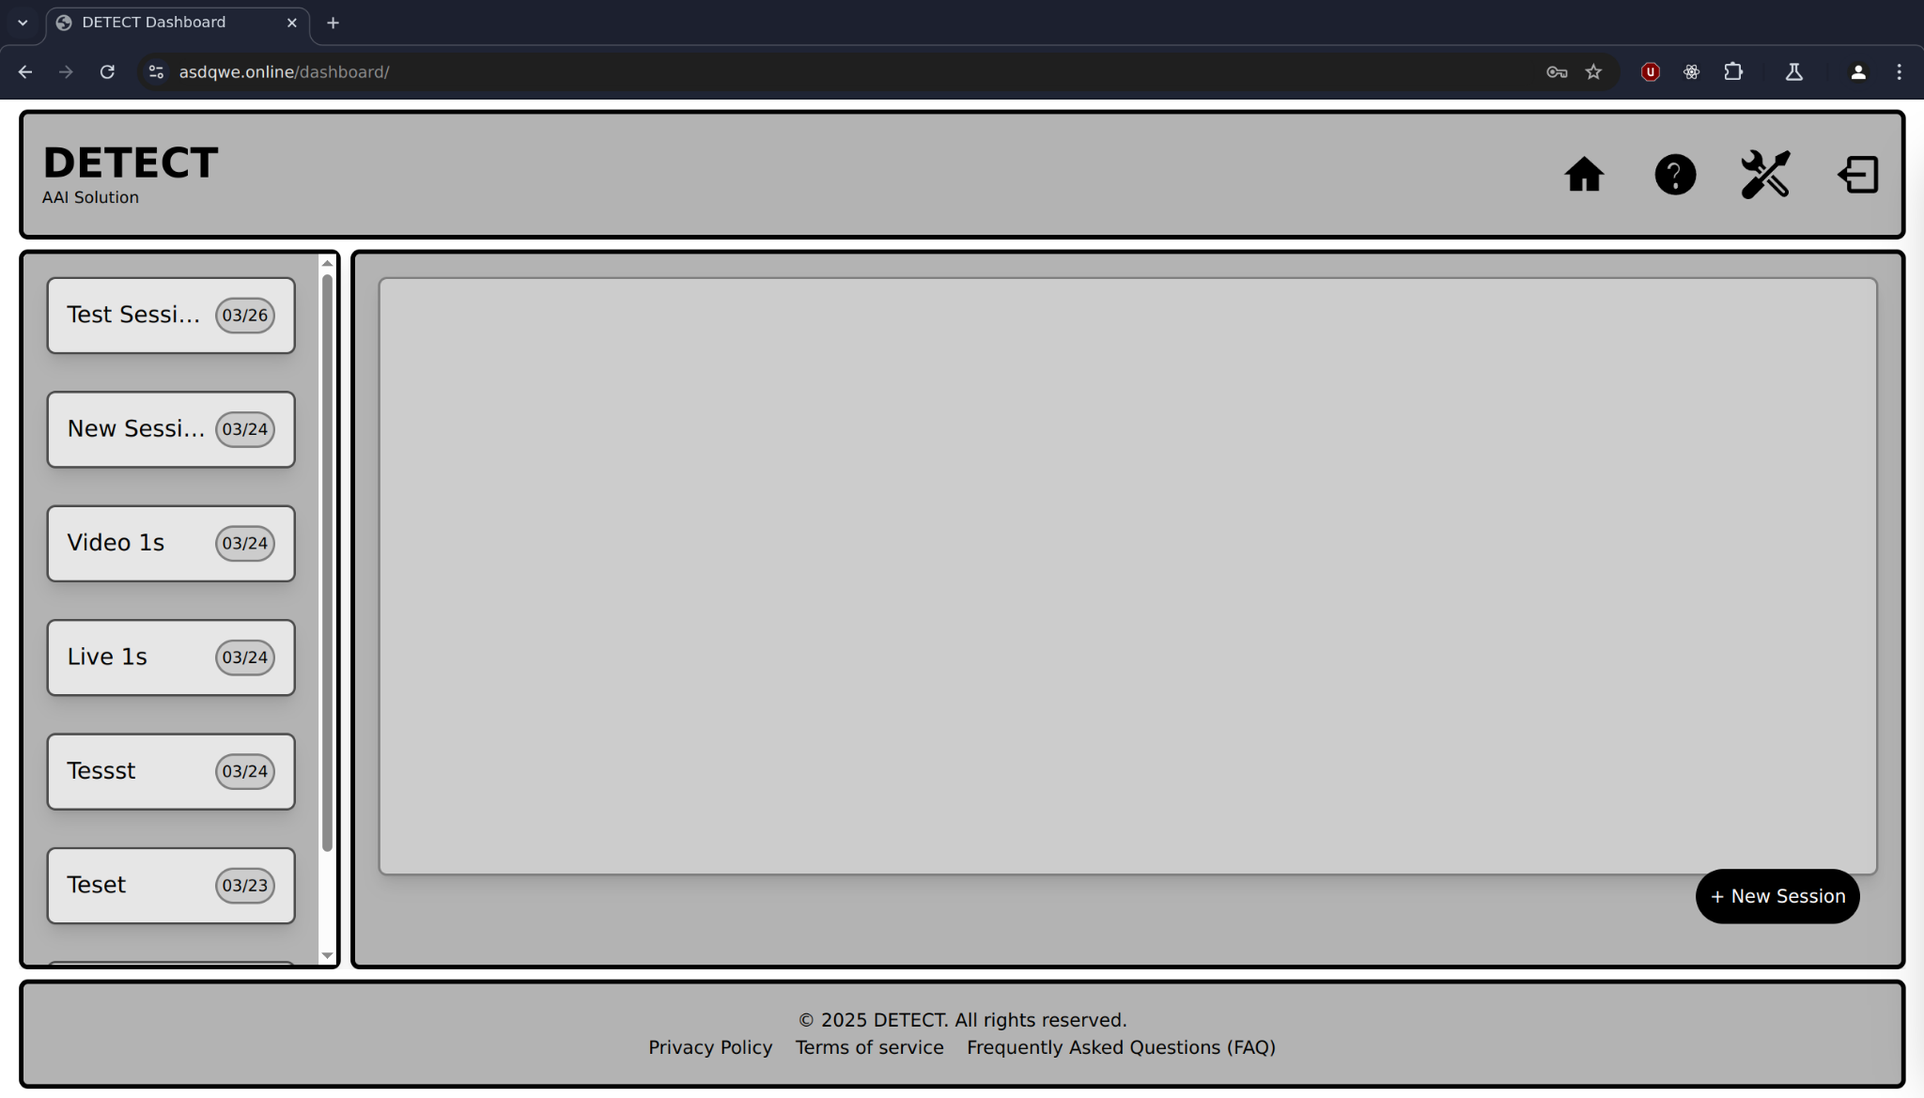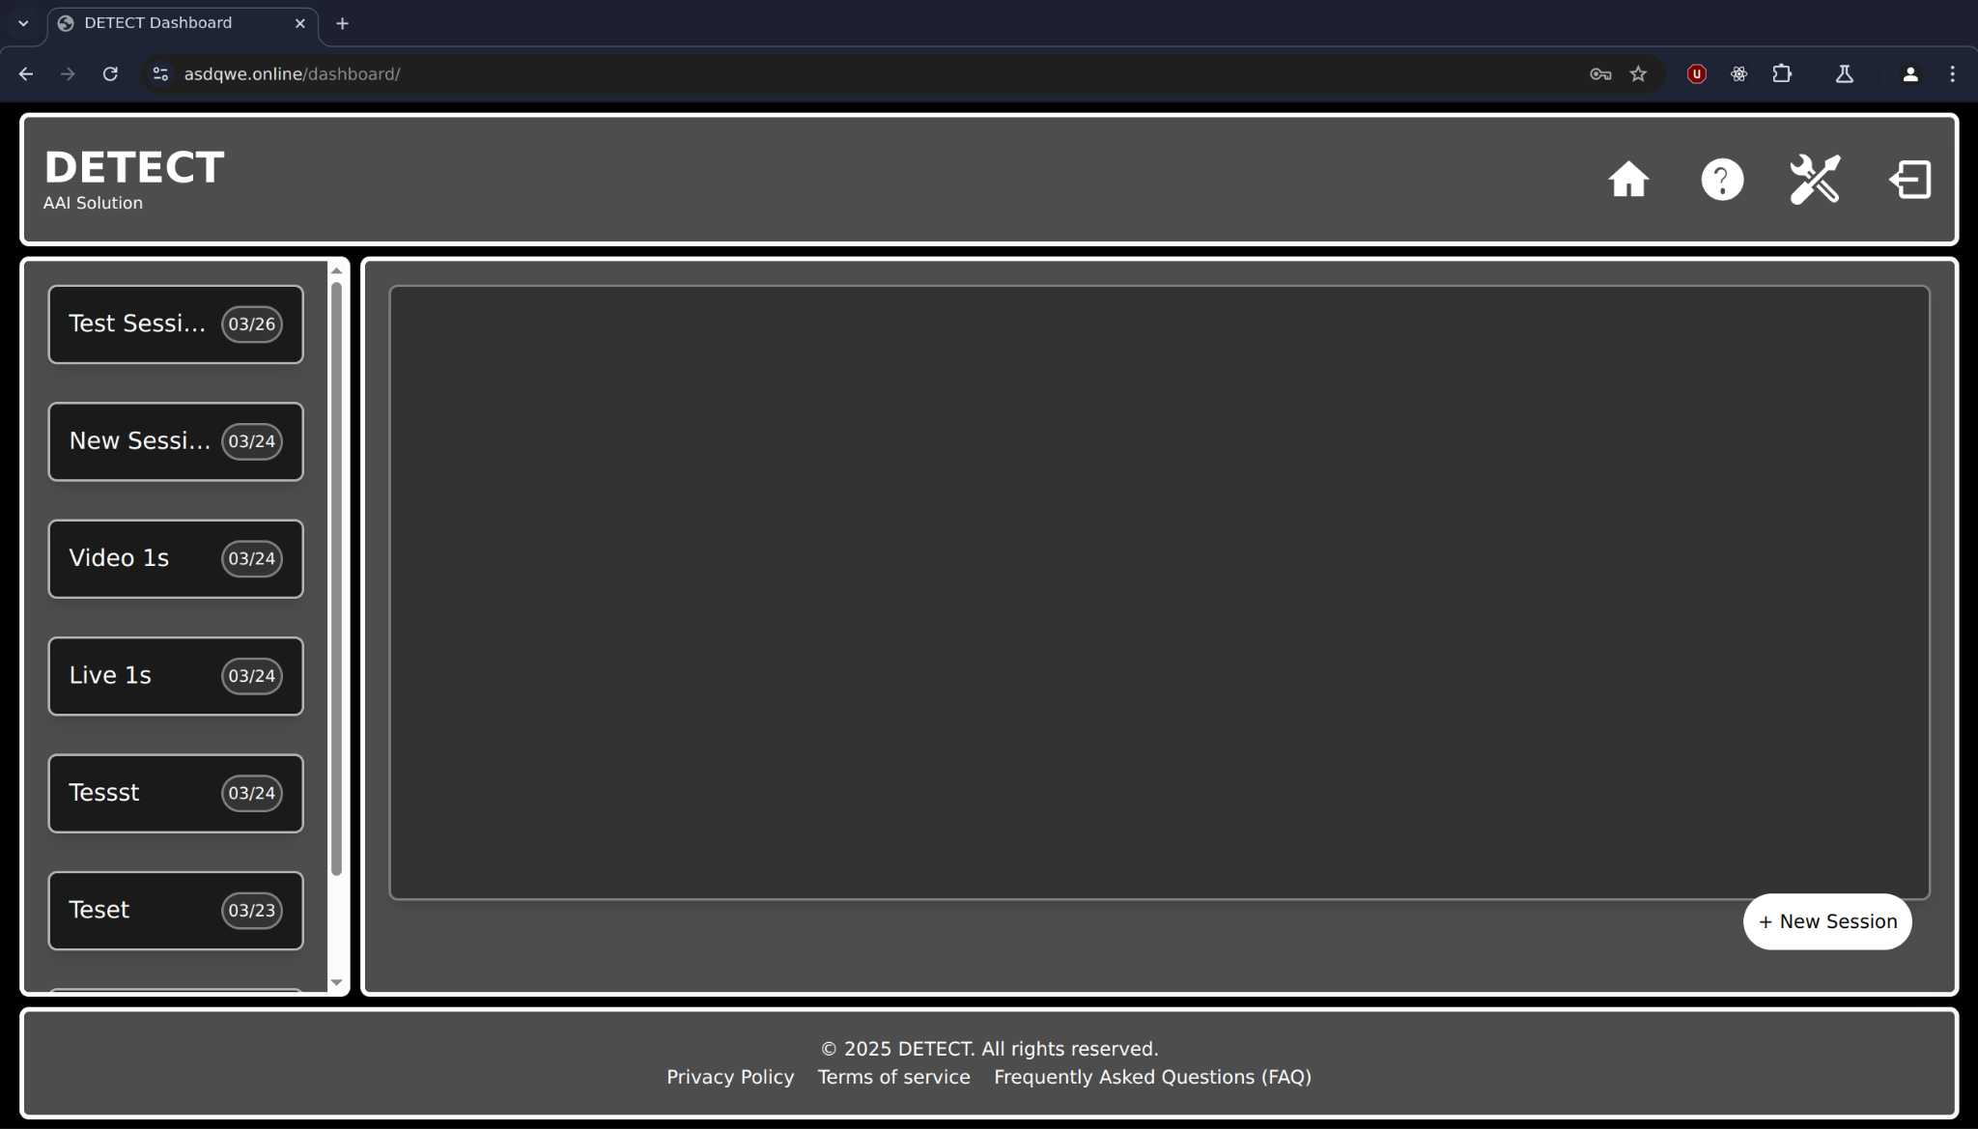
Figure 14.3.1.ii: Basic Layout in High Contrast Light and Dark Themes

Accessibility Enhancements:
- High Contrast Colors: These improve visibility for users with visual impairments, ensuring clear distinctions between interface elements. This accessibility-focused design meets WCAG guidelines, promoting inclusivity and compatibility with assistive technologies.
- Visual Groupings: Clear section delineation supports intuitive navigation, helping users quickly locate and interact with key features.
This focus on accessibility ensures that the application is usable by a diverse audience while maintaining an appealing aesthetic.

Alignment, Spacing, and Visual Hierarchy
The design emphasizes alignment, spacing, and visual hierarchy to create a clean and professional interface. Proper alignment ensures that elements are visually cohesive, while consistent spacing prevents clutter and makes navigation intuitive.

Visual Hierarchy Principles:
- Font Sizes and Weights: Headings, subheadings, and body text are distinguished by varying font sizes, colors, and weights.
- Logical Flow: Information is presented in an order that aligns with user expectations, highlighting important elements while creating a seamless navigation experience.
This attention to design details enhances usability and ensures that users can easily interact with the application’s features.

Responsive Design and Cross-Device Compatibility
To ensure usability across a variety of devices, the layout incorporates responsive design principles. Elements like the navigation bar, sidebar, and content area adjust dynamically based on screen dimensions, providing an optimized experience on both desktop and mobile platforms.

Key Features:
- Dynamic Layout Adjustments: Components adapt to different screen sizes without compromising functionality or aesthetics.
- Cross-Device Compatibility: The application delivers a consistent user experience across devices, ensuring accessibility for all users.
By incorporating these principles, the design accommodates a wide range of users, enhancing accessibility and user satisfaction.
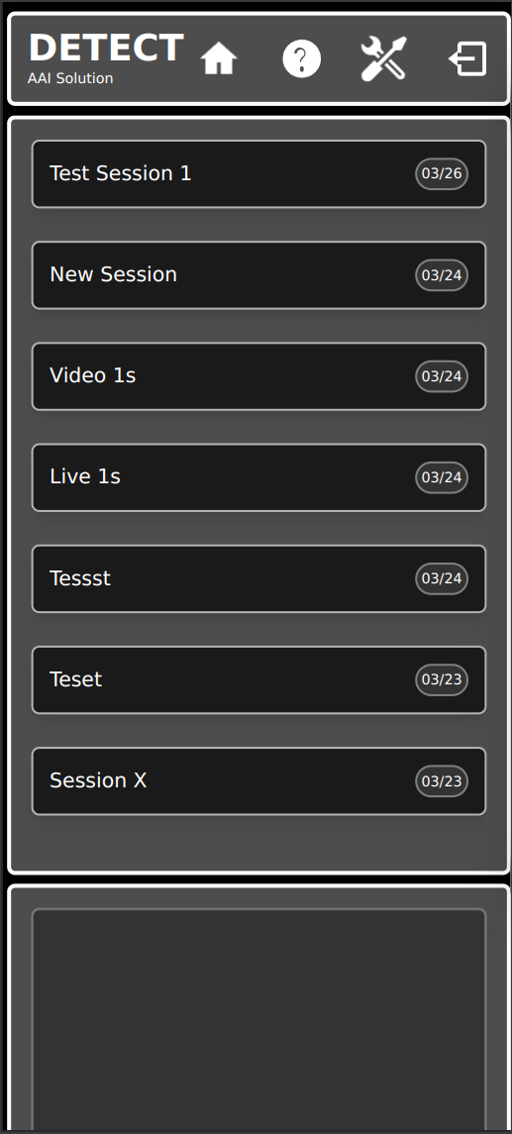
Figure 14.3.1.iii Dashboard page on Mobile device (Pixel 7)

Summary
The design combines a box-oriented layout, high contrast colors, dynamic themes, and responsive principles to create a user interface that is both visually appealing and highly functional. This cohesive approach ensures accessibility, usability, and consistency, meeting the diverse needs of users in various environments. By focusing on flexibility and scalability, the application delivers an adaptable platform capable of evolving with user needs and design trends.

13.3.2 Login/Register Page
The Login Page for the DETECT showcases a minimalist and user-focused design. It stays consistent with the overall theme of the project while emphasizing simplicity and accessibility.
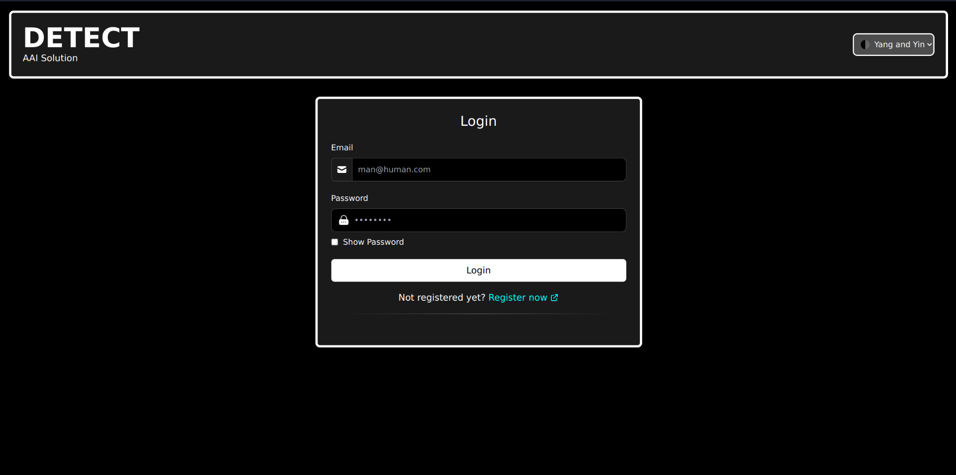
Figure 14.3.2: Login/Register Page
To emphasize simplicity, unnecessary images or animations are excluded, ensuring the login and registration process remains efficient and user-focused. This ensures the pages are optimized for performance across different devices, including smartphones and tablets. The mobile-friendly design guarantees a seamless experience.

13.3.3 Live Video Modal
The Video Analysis and Real-Time Graphs Page serves as a central interface for capturing live video feeds, tracking user eye movements, and displaying real-time data in a visual format. The design complements the overall project theme by maintaining the sleek black and purple aesthetic and emphasizing user interaction with intuitive controls and layout.
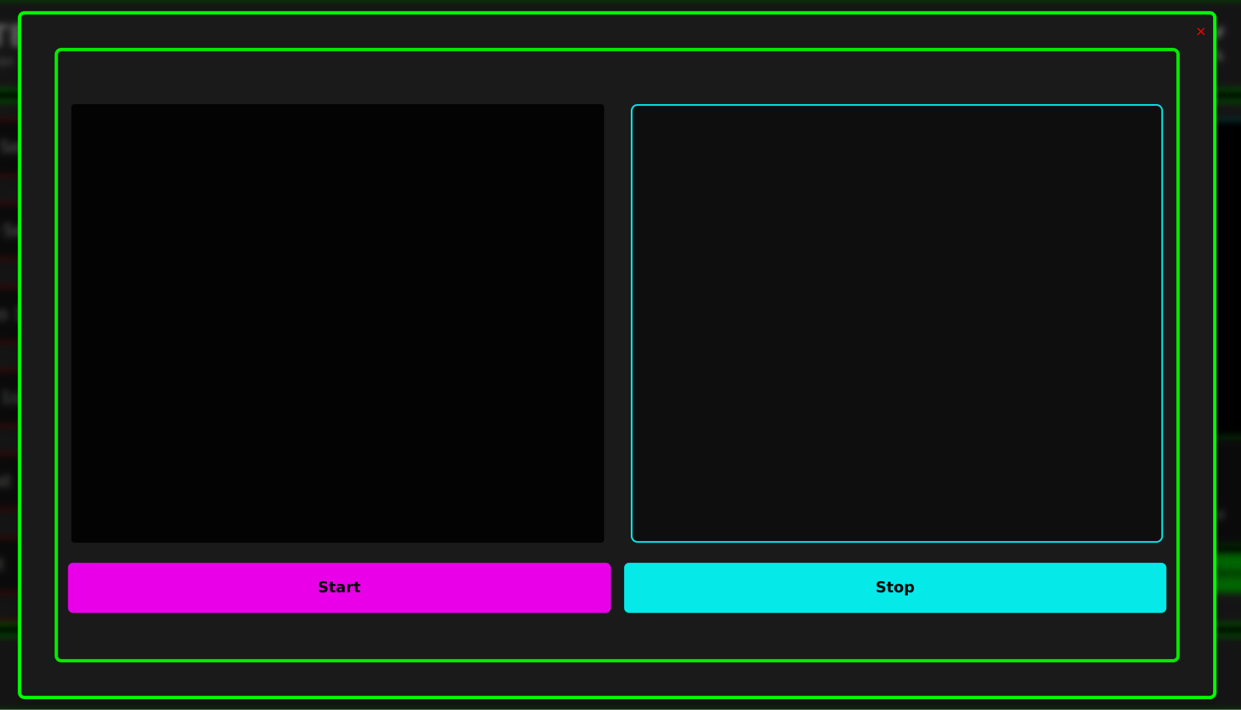
Figure 14.3.3: Live Video Modal

Layout
The layout features two primary panels side by side:
- Live Video Feed Panel (Left): A dedicated space for displaying the live video stream or imported videos for analysis. The inclusion of a placeholder icon enhances clarity for first-time users, aiding in navigation and usability.
- Real-Time Graph Panel (Right): A space for visualizing data in real time, such as eye movement tracking results. This ensures users can monitor data seamlessly while recording or analyzing.
- Start Tracking & Stop Tracking Buttons (Bottom): Core functionalities for activating or pausing the tracking process.
This prototype effectively combines aesthetics with functionality, leveraging Astro’s lightweight framework to deliver a high-performance, scalable interface tailored to DETECT's requirements. With its minimalist design, intuitive layout, and future scalability, this prototype provides a strong foundation for further development and enhancements.

13.3.4 Video Upload Modal
The video upload modal serves as the entry point for users to submit pre-recorded video files for analysis. Upon activation, the modal prompts the user to select a video file from local storage. Once a file is selected, the application begins processing the video on the frontend without displaying it. This design choice simplifies the user interface while ensuring that necessary data can be extracted in the background.
To improve transparency and user experience, the modal provides an estimated processing time based on the selected video’s characteristics. The uploaded video is analyzed frame by frame, with gaze data extracted using the same logic applied to live webcam feeds, adapted for offline processing. No playback functionality is provided within the modal, as the focus remains on efficient data extraction rather than video interaction.
The modal also includes configurable options such as normalization (for affine transformation), min-max scaling, and sensitivity tuning, allowing users to tailor the analysis according to their needs. This setup supports flexible, yet streamlined, usage across different research and practical scenarios.
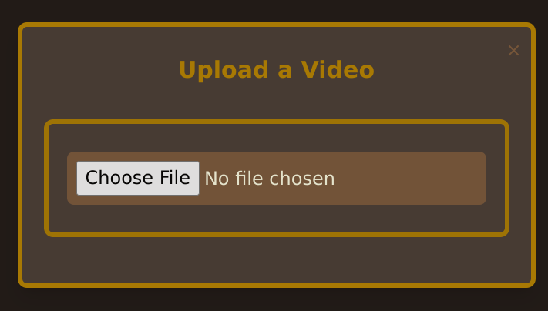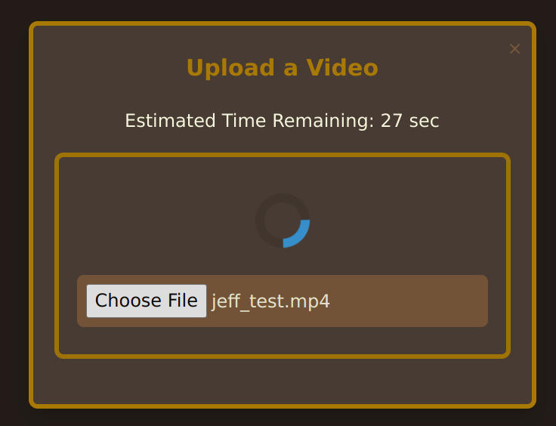
Figure 14.3.4 Video Upload Modal (before and after adding Video)
Layout Overview
The figure below illustrates the two main states of the video upload modal:
- Left: The initial state, where no file has been chosen. A clear “Choose File” button is provided to allow the user to browse and select a video file.
- Right: The post-upload state, displaying the name of the selected file along with a loading spinner and an estimated time remaining for processing. This feedback ensures that users are informed of ongoing analysis without needing to monitor further progress.
These states are encapsulated in a minimal, user-friendly interface that aligns with the application's overall visual and functional design principles.

14. Conclusion and Future Work
The DETECT project has successfully culminated in the development of a fully functional, user-oriented deception detection tool that integrates real-time eye-tracking with a web-based application. The project met its core objectives, including building a robust frontend and backend architecture, optimizing performance across platforms, and laying the groundwork for behavioral analysis using machine learning. Through strategic planning, problem-solving, and consistent collaboration, the DETECT team was able to transform early-stage concepts into a reliable and scalable solution.

14.1 Summary of Achievements
The project achieved all intended milestones. A highly accurate eye-tracking framework was implemented using MediaPipe, with enhanced gaze detection capabilities and stabilized real-time tracking through the resolution of affine transformation inconsistencies. The transition from Python-based components to optimized JavaScript successfully minimized performance overhead, enabling seamless execution within the web environment.
The full-stack architecture—featuring a Go-based backend with WebSocket support and a responsive Astro/Svelte frontend—was deployed to support real-time data transmission and visualization. A trained machine learning model was integrated to enable real-time deception inference based on calibrated eye movement patterns. The system has been tested for usability and demonstrated reliable performance in controlled development environments.

14.2 Challenges Faced
Throughout development, the project encountered and overcame significant technical and logistical hurdles. Early issues with affine transformations misclassifying head movement as tracking noise were resolved, enabling stable and accurate tracking. Tech stack decisions proved initially complex due to uncertainties around the computer vision model requirements but were eventually finalized to support performance and scalability.
Migrating performance-intensive logic from Python to JavaScript required considerable effort and refactoring but ultimately ensured compatibility with browser-based execution. Deployment also posed a significant challenge—limitations on Vercel's serverless architecture prevented persistent WebSocket connections, which are essential for real-time data flow. This was resolved by migrating the deployment to a dedicated DigitalOcean droplet, which provided full control over server configuration and ensured consistent performance for the real-time application.

14.3 Future Directions
While the core system is complete, future iterations of DETECT may focus on expanding functionality and improving data infrastructure. One key enhancement involves incorporating Redis for real-time caching and storage of pupil-tracking data, which would support more efficient session handling and comparative behavioral analysis over time.
Additionally, larger-scale user studies will further validate the system's machine learning model and provide richer datasets for fine-tuning deception detection accuracy. Planned improvements include extending the platform to support additional behavioral metrics—such as blink rate, pupil dilation variability, and micro-expressions—to deepen the analysis of deception-related indicators.
Scalability is also a key consideration for the future. Expanding the system’s capabilities to include multimodal features such as speech recognition, voice stress analysis, and natural language processing could significantly enhance the accuracy and context-sensitivity of deception detection. These additions would transform DETECT into a more comprehensive behavioral analysis platform suitable for diverse real-world applications, from security screening to clinical assessments.

15. References
Bandler, R., & Grinder, J. (1975). The structure of magic I. Science and Behavior Books.
Brennen, T., & Magnussen, S. (2022). The science of lie detection by verbal cues: What are the prospects for its practical applicability? Frontiers in Psychology, 13, Article 835285. https://doi.org/10.3389/fpsyg.2022.835285
DePaulo, B. M., Lindsay, J. J., Malone, B. L., Muhlenbruck, L., Charlton, K., & Cooper, H. (2003). Cues to deception. Psychological Bulletin, 129(1), 74–118. https://doi.org/10.1037/0033-2909.129.1.74
Duchowski, A. T. (2007). Eye tracking applications and techniques. In Advances in human-computer interaction (pp. 7–22).
Ehrlichman, H., & Micic, S. (2012). Saccadic eye movements and memory retrieval. Cognitive Science, 36(4), 647–654. https://doi.org/10.1111/j.1551-6709.2012.01268.x
Ekman, P., Davidson, R. J., & Friesen, W. V. (1991). The facial expression of emotion. In L. A. Pervin (Ed.), Handbook of personality: Theory and research (pp. 84–116). Guilford Press.
Ekman, P. (n.d.). Deception detection. Retrieved April 27, 2024, from Paul Ekman's Official Website
Ganis, G., Kosslyn, S. M., Stose, S., Thompson, W. L., & Yurgelun-Todd, D. (2003). Neural correlates of deception and truth in the study of emotion and cognition. NeuroImage, 19(3), 1249–1263. https://doi.org/10.1016/S1053-8119(02)00595-3
He, L., Song, H., Li, M., & Li, H. (2024). Nonverbal cues to deception: Insights from a mock crime scenario in a Chinese sample. Frontiers in Psychology, 15, Article 1331653. https://doi.org/10.3389/fpsyg.2024.1331653
Holmqvist, K., Nyström, M., & Mulvey, F. (2011). Eye tracking: A comprehensive guide to methods and measures. Oxford University Press.
Iacono, W. G., & Ben-Shakhar, G. (2019). The polygraph and lie detection: The state of the art. Current Directions in Psychological Science, 32(5), 395–401. https://doi.org/10.1177/09637214231173095
Krishnamurthy, S., et al. (2023). Automated lie detection: Current advancements and future prospects. Journal of Forensic Psychology, 12(3), 245–260.
Marchak, F. M. (2013). Detecting false intent using eye blink measures. Frontiers in Psychology, 4, Article 736. https://doi.org/10.3389/fpsyg.2013.00736
Markey, P. M., Lee, S., & Hartwig, M. (2022). Detecting lies: The role of nonverbal cues and cognitive load. Journal of Criminal Psychology, 35(2), 57–75. https://doi.org/10.1007/s11896-022-09568-3
Rumble, M. (2023, November 3). The language of lying eyes: Signs you shouldn’t ignore. Retrieved from Lying Detector Test
Schuetzler, R. M. (2012). Countermeasures and eye tracking deception detection. Information Systems and Quantitative Analysis Faculty Proceedings & Presentations, 28. Retrieved from DigitalCommons@UNO
Sprabary, A. (n.d.). Eye movement and lying: Genuine or junk science? All About Vision. Retrieved from https://www.allaboutvision.com/resources/human-interest/can-eyes-give-away-lying/
Vrij, A. (2008). Detecting lies and deceit: Pitfalls and opportunities. Wiley.
Vrij, A., Granhag, P. A., Ashkenazi, T., Ganis, G., Leal, S., & Fisher, R. P. (2022). Verbal lie detection: Its past, present and future. Brain Sciences, 12(12), 1644. https://doi.org/10.3390/brainsci12121644
Vrij, A., Oliveira, J., Hammond, A., & Ehrlichman, H. (2012). Saccadic eye movement rate as a cue to deceit. Manuscript submitted for publication.
Wiseman, R., Watt, C., ten Brinke, L., Porter, S., Couper, S.-L., & Rankin, C. (2012). The eyes don’t have it: Lie detection and neuro-linguistic programming. PLoS ONE, 7(7), e40259. https://doi.org/10.1371/journal.pone.0040259
Eyeware. (n.d.). What is eye tracking? Eyeware. Retrieved October 23, 2024, from https://eyeware.tech/blog/what-is-eye-tracking/
Tobii. (n.d.). Heat maps and gaze plots. Tobii. Retrieved October 23, 2024, from https://connect.tobii.com/s/article/heat-maps-and-gaze-plots?language=en_US
Debue, N., & van de Leemput, C. (2023). Investigating the application of eye-tracking technology in educational settings: A systematic review. Frontiers in Psychology, 14, Article 10691255. https://doi.org/10.3389/fpsyg.2023.10691255
SR Research. (n.d.). About eye tracking. SR Research. Retrieved October 23, 2024, from https://www.sr-research.com/about-eye-tracking/
MediaPipe: A framework for perceiving and processing reality. Google Research. (n.d.). https://research.google/pubs/mediapipe-a-framework-for-perceiving-and-processing-reality/

